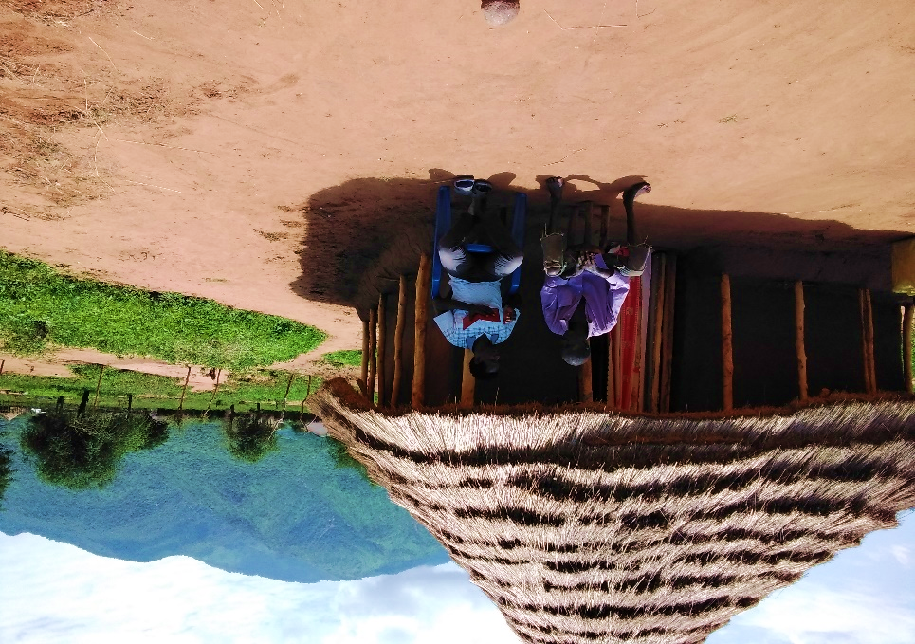  
Baseline Household Survey REPUBLIC OF SOUTH SUDAN

Source: MESP South Sudan team, photograph taken during field household data collection by enumerator in Budi county – 2021.

December 2021

BASELINE HOUSEHOLD SURVEY REPUBLIC OF SOUTH SUDAN

December 2021

Contracted under AID-668-I-13-00001, Task Order 4

**DISCLAIMER**

This report is made possible by the support of the American people through the United States Agency for International Development (USAID). The contents are the sole responsibility of the Management Systems International and do not necessarily reflect the views of USAID or the United States Government.

# Acknowledgements

The report is written by Daniel Killian, Sean Kelly, and Carolyn Fonseca.

The authors wish to thank Diana Daibes, Pita Florence, Sule Gideon, Brian Hilton, Joel Jansuk, Peter Khaemba, and Julie Uwimana at USAID/South Sudan for their support throughout the development, data collection, and reporting on this baseline household survey.

In addition, the authors want to recognize the Charles Mona and Julius Sebit of South Sudan’s National Bureau of Statistics who provided advice on the sample design and collaborated in the first stage sample selection of enumeration areas in the 13 counties.

We also wish to acknowledge colleagues at Management Systems International (MSI) who contributed to this effort since 2020 including James Adekei, Gladys Aligo, Adam Bloom, Hadassah Chandia, Karim Chemali-Cruz, Israel Clement, Kevin Davison, Abdullah Ferdous, Dave Hinkle, Eruaga Jackson, Kocks Johnson, Amzah Juma, Frank Kabadula, Jessica Kaku, Sarah Kiden, Richard Koma, Sarah Krautbauer, Elizabeth Lado, Betty Lokure, Kozoa Mawa, Jacob Milley, Marle Moses, Nicholas Mugenyi, Lesia Nikitova, Tyler Phillips, Angelo Riek, Michael Salla, Tim Shifflett, Natasha Stadler, Jim Statman, Nitika Tolani, Alex Wani, and Greg Weissman. Finally, we are grateful to the immense effort of the 33 supervisors who managed the data collection conducted by 249 enumerators in 13 counties of South Sudan. These teams worked in incredibly difficult and insecure environments. Without their efforts, none of the information presented in this report would be possible.

# Contents

Acknowledgements 3

Contents 4

Figures 5

Tables 5

Equations 7

Acronyms 7

Abstract 8

Executive Summary 9

Introduction 11

Background 12

Methods 15

Design 15

Sample 16

Limitations and sources of Bias 18

COVID-19 and human subject research 18

Findings 19

Food Security 20

Personal Agency 22

Social Cohesion 23

Shocks and Stresses 25

Social Norms 27

Resilience 30

Conclusions and Recommendations 35

Conclusions 35

Recommendations 36

Bibliography 37

Annexes 42

Annex A. Methodological Details 42

Annex B. Detailed Findings 45

Annex C. Detailed Indicators 62

Annex D. Literature Review 112

# Figures

Figure 1. Resilience Themes and Indicators 11

Figure 2. Thirteen Counties and Their Enumeration Areas 16

Figure 3. Data Collection Process 17

Figure 4. Shock Exposure Index 26

Figure 5. Absorptive Resilience Capacity and Ability to Recover, Predicted Output 33

Figure 6. Absorptive Resilience Capacity and Food Insecurity, Predicted Output 34

Figure 7. Components of Absorptive Capacity and Food Insecurity, Predicted Output 34

Figure 8. Dietary Diversity Factors 47

Figure 9. Most Common Shocks by County 50

Figure 10. Acceptability of Negative Social Norms by County 52

Figure 11. Integrated Model of Resilience as Presented by Constas et. al. 2020 114

Figure 12. Household Strucuture and Risk Management 114

Figure 13. Conceptual Framework of Resilience, Bene et al (2016) 115

Figure 14. Effects of COVID and CHILD Marriage 122

Figure 15. Social Capital, Standard Hypothesis Versus Adaptation Protracted Crisis 126

Figure 16. Experiences and Perceptions of Violence and Safety in South Sudan 128

# Tables

Table 1. Overall Summary of Key Baseline Indicators and Metrics by Theme. 9

Table 2. Indicator Summary 19

Table 3. Summary of Food Security Indicators 20

Table 4. Questions for the FIES 20

Table 5. Foods Consumed in Previous 24 Hours 21

Table 6. Household Food Consumption Profiles 21

Table 7. Summary of Personal Agency Indicators 22

Table 8. Aspirations Index, Constituent Items 22

Table 9. Locus of Control Index, Constituent Items 23

Table 10. Summary of Social Cohesion Indicators 24

Table 11. Bonding Social Capital, Constituent Items 24

Table 12. Bridging Social Capital, Constituent Items 24

Table 13. Summary of Shocks and Stresses Indicators 25

Table 14. Household Shocks Profiles 27

Table 15. Summary of Social Norms Indicators 27

Table 16. Acceptability of SGBV 28

Table 17. Acceptability of Cattle Raiding 28

Table 18. Acceptability of Early Marriage 29

Table 19. Correlations with Social Norms 30

Table 20. Resilience Measures, Full Approach 31

Table 21. Resilience Measures, Light Approach 31

Table 22. High Resilience Capacity and High Shocks and Conflict by County 35

Table 23. Stages of Sample Selection and Selection Method 42

Table 24. Sample Targets for Data Collection 43

Table 25. Household Sample Achieved During Data Collection 43

Table 26. Foods Consumed by HDDS Quartile 45

Table 27. Household Food Consumption Profiles, Factor Loadings 46

Table 28. Aspirations Items, Principal Component Loadings 47

Table 29. Locus of Control Items, Principal Component Loadings 48

Table 30. Bonding Social Capital, Factor Loadings 48

Table 31. Bridging Social Capital, Factor Loadings 49

Table 32. Mean Shock Severity 50

Table 33. Shocks Severity, Factor Loadings 51

Table 34. Independent Variables Correlated with Social Norms 54

Table 35. Group Membership, Frequencies 55

Table 36. Group Membership, Factor Loadings 55

Table 37. Group Membership Profiles 56

Table 38. Group Membership, Factor Loadings 56

Table 39. Early Warning Systems, Frequencies 57

Table 40. Early Warning Systems, Factor Loadings 57

Table 41. Early Warning Profiles 58

Table 42. Early Warning Systems Participation, Factor Loadings 58

Table 43. Emergency Action Planning, Frequencies 59

Table 44. Emergency Action Planning, Factor Loadings 59

Table 45. Resilience Model Output, Ability To Recover 59

Table 46. Resilience Model Output, Food Insecurity 60

Table 47. Components of Resilience Model Output, Food Insecurity 60

Table 48. Consolidated Indicator Summary 62

Table 49. Food Security Indicators Disaggregated Results 64

Table 50. Personal Agency Indicators Disaggregated Results 66

Table 51. Social Cohesion Indicators Disaggregated Results 68

Table 52. Shocks and Stresses Indicators Disaggregated Results 70

Table 53. Social Norms Indicators Disaggregated Results 72

Table 54. Indicator 1 Disaggregated Results 74

Table 55. Indicator 3 Disaggregated Results 76

Table 56. Indicator 4 Disaggregated Results 78

Table 57. Indicator 5 Disaggregated Results 80

Table 58. Indicator 6 Disaggregated Results 82

Table 59. Indicator 10 Disaggregated Results 84

Table 60. Indicator 15 Disaggregated Results 86

Table 61. Indicator 17 Disaggregated Results 88

Table 62. Indicator 18 Disaggregated Results 90

Table 63. Indicator 19 Disaggregated Results 92

Table 64. Indicator 20 Disaggregated Results 94

Table 65. Indicator 21 Disaggregated Results 96

Table 66. Indicator 22 Disaggregated Results 98

Table 67. Indicator 23 Disaggregated Results 100

Table 68. Indicator 24 Disaggregated Results 102

Table 69. Indicator 25 Disaggregated Results 104

Table 70. Indicator 26 Disaggregated Results 106

Table 71. Indicator 28 Disaggregated Results 108

Table 72. Absorptive Capacity Disaggregated Results 110

Table 73. Comparison of TANGO and FAO Resilience Definitions 113

# Equations

Equation 1. Sample Size Calculation 42

# Acronyms

COVID-19 Coronavirus Disease

EA Enumeration Area

FAO Food and Agricultural Organization of the United Nations

FFP Food for Peace

FIES Food Insecurity Experience Scale

GIS Geographic Information System

HDDS Household Dietary Diversity Score

IDMC Internal Displacement Monitoring Centre

IPC Integrated Food Security Phase Classification

MESP South Sudan Monitoring and Evaluation Support Project

MSI Management Systems International

NBS National Bureau of Statistics

PMP Performance Management Plan

RCI Resilience Capacity Index

RIMA II Resilience Index Measurement and Analysis II

SGBV Sexual and Gender-Based Violence

USAID U.S. Agency for International Development

# Abstract

USAID/South Sudan’s four-year Strategic Framework has a goal to reduce humanitarian need by promoting community resilience in targeted areas through a focused scenario-based approach rooted in evidence and humanitarian/development assistance. As part of efforts to ensure effective measurement of results articulated in the strategy, the South Sudan Monitoring and Evaluation Support Project (MESP) was tasked with completing a baseline survey. MESP conducted a household survey in two phases in 2021 (April and November). Data captured baseline indicators for 13 counties with key metrics grouped by themes, reflective of resilience parameters. These themes were food security, personal agency, social cohesion, shocks/stresses, and social norms. With a team of 249 enumerators and 33 supervisors, a total of 7,872 household surveys were collected.

Overall absorptive capacity resilience scored at 32.5. Results from the models found well-being outcomes (ability to recover from shocks) increased with increased in resilience capacity. Regarding food insecurity, the data suggested respondents are under severe food insecurity (Food Insecurity Experience Scale (FIES) score 7.6) with moderate dietary diversity of cereals and leafy greens with some fish for 90% of the sample (Household Dietary Diversity Score (HDDS) score of 6.4). Increase in food prices and flooding were found to be the most severe shocks, with over a fourth of households reporting as vulnerable to shocks. Water, cattle raiding for revenge, and sexual- gender-based violence (SGBV) were the most common types of conflict, with cattle raiding perceived as the most damaging. The social cohesion score was 39 out of 100 where bonding (mutual-aid relationships with non-relatives within villages) was found to be more critical that bridging (mutual-aid relationships with relatives across villages). Aspirations scored at 76.6 out of 100 and increased with exposure to shocks/conflict. Across the sample 91 percent stated support for girls’ education, 75 percent found cattle raiding acceptable, 61 percent found SGBV justified, and 73 percent felt early marriage was needed due to economic pressures. Shocks and conflict associated with increased support for harmful practices, while education associated with reduced support. In conclusion, the baseline study highlighted several key metrics and provided suggestions for future analysis and future data collection efforts including incorporation of coping strategies, capturing qualitative data around household dynamics, and exploring in more depth differences across gender/groups.

# Executive Summary

As part of efforts to ensure effective measurement of results articulated in the strategy, the South Sudan Monitoring and Evaluation Support Project (MESP) – with help from South Sudan’s National Bureau of Statistics (NBS) conducted a household survey to gather baseline data. This effort, at the request of the USAID/South Sudan mission, was focused on collecting valid and robust indicators outlined in the Mission Performance Management Plan (PMP) and the community roadmap.

The sample focused on 13 target counties - Akobo, Baliet, Budi, Duk, Jur River, Kapoeta North, Leer, Mayendit, Panyijar, Pibor, Ulang, Uror and Wau. Within each county, enumeration areas (EAs) were selected based on the information provided by NBS. In an environment of severe data collection challenges, the household baseline study employed a two-stage sample design to select EAs, and then randomly select households within EAs. Data collection took place in two time periods, with the first in April of 2021(six counties), and the second period in November (seven counties) of the same year. A total of 249 enumerators and 33 supervisor participated in the collection of 7,872 household survey covering 476 EAs across the 13 priority counties.

Data analysis focused on a set of 28 indicators – most of which were USAID/South Sudan performance indicators – as well as themes reflective of resilience. These themes were food security, personal agency, social cohesion, shocks/stresses, and social norms. Additional data incorporated into resilience modeling included informal safety nets, early warning systems, and emergency action planning. Table 1 provides the overall results for key indicators/metrics by theme.

Table . Overall Summary of Key Baseline Indicators and Metrics by Theme.

|  |  |  |  |
| --- | --- | --- | --- |
| Theme | Indicator/Metric | Scale | Overall |
| Food Security | Food Insecurity Experience Scale (FIES) | 0 to 8 | **7.6** |
| Household Dietary Diversity Scale (HDDS) | 0 to 12 | **6.4** |
| Personal Agency | Personal Agency | 0 to 100 | **74.1** |
| Aspirations index | 0 to 100 | **76.6** |
| Locus of Control | 0 to 100 | **71.4** |
| Shocks and Stresses | Incidence of Shocks | 0 to 16 | **7.4** |
| Exposure to Shocks and Stresses | 0 to 128 | **49.2** |
| Incidence of Conflict | Percentage | **38%** |
| Social Cohesion | Bonding Social Capital | 0 to 100 | **43.3** |
| Bridging Social Capital | 0 to 100 | **34.6** |
| Social Cohesion | 0 to 100 | **39.0** |
| Social Norms | Acceptance of SGBV | Percent Acceptable | **61%** |
| Acceptance of Cattle Raiding | Percent Acceptable | **75%** |
| Acceptance of Girls’ Education | Percent Acceptable | **91%** |
| Acceptance of Early Marriage | Percent Acceptable | **73%** |
| Resilience | Absorptive Capacity | 0 to 100 | **32.5** |

Across the thirteen counties, the average mean score for resilience (absorptive capacity) was 32.5. For 12 of 13 counties, households were severely food insecure (FIES 7.6), had limited dietary diversity (HDDS 6.4), and reported a social cohesion score of 39 (with higher internal bonding then bridging scores). Regarding social norms, 91 percent of household respondents stated support for girls’ education. However, higher numbers also found early marriage and SGVB acceptable practices, 73 percent, and 61 percent respectively. Even though cattle raiding was found to the highest contributor to violence, most households found this behavior acceptable as a revenge practice (75 percent).

This year alone, 2021 produced some of the most significantly flooding South Sudan had even incurred. The data reflects this showing flooding and increase of food prices as the two most commonly stated shocks. While incidence was high, reported severity of shocks was more moderate (49 on a 0-128 scale); this may reflect households’ ongoing and familiar experience with shocks. Even with all the shocks and severity of these, households reported a 74.1 on measures of personal agency, generally indicating a positive outlook on the future. Measures such as social cohesion and personal agency was higher where shocks and conflict was also higher, suggesting an interpretation of these resilience capacities to also be coping mechanisms in the face of shocks and stresses.

Resilience capacities were aggregated to an omnibus measure of absorptive resilience capacity. Increases in resilience capacity predict an increase in the perceived ability to recover from a shock, and a decrease in food insecurity. Informal safety nets and access to humanitarian assistance were found to be the strongest components of absorptive resilience capacity in improving well-being outcomes.

Based on these findings, this study concludes that USAID/South Sudan has a valid baseline with which to measure performance against its 2020-2024 strategy. In addition to performance indicators, the mission also has an additional set of measures relating to resilience capacity, as well as simple modeling identifying the relationship between strengthened resilience capacity and improved well-being such as a reduction in food insecurity. Food insecurity was found to be a stronger outcome measure of humanitarian support than dietary diversity. Levels of bonding social capital is slightly higher than bridging social capital, though this may also reflect negative forms of bonding social capital such as initiating cattle raids. Measures such as social cohesion and personal agency may be considered coping strategies as well as resilience capacities.

Based on findings and conclusions, this study offers the following suggestions for consideration:

* Initiate follow-up studies to add qualitative context and build a learning agenda
* Add food security as a PMP indicator, if feasible
* Collect data on coping strategies as a critical informational step in understanding the pathways from a shock or stress to household actions to mitigate and recover from those challenges
* Incorporate outcome monitoring into beneficiary surveys

The mission MELS activity may be considered a vehicle through which to initiative follow-up data collection, analysis, and learning.

# Introduction

USAID/South Sudan’s four-year Strategic Framework has a goal to reduce humanitarian need by promoting community resilience in targeted areas through a focused scenario-based approach rooted in evidence and humanitarian/development assistance. This Strategic Framework posits that by increasing the engagement of individuals and communities in development, the development investments will be more relevant, sustainable, and effective. The intense level of engagement and coordination required by this approach and resource parameters dictate a focused, sub-national footprint. Limited resources require a targeted approach to specific communities/areas in need. As part of efforts to ensure effective measurement of results articulated in the strategy, the South Sudan MESP – with help from South Sudan’s NBS – conducted a household survey to gather baseline data. This effort focused on the indicators outlined in the PMP and the community roadmap.

The purpose this baseline survey was to obtain reliable representative baseline indicator data at the household level in 13 target counties - Akobo, Baliet, Budi, Duk, Jur River, Kapoeta North, Leer, Mayendit, Panyijar, Pibor, Ulang, Uror and Wau. The key metrics were grouped by themes, reflective of resilience parameters. These themes were food security, personal agency, social cohesion, shocks/stresses, and social norms. The key metrics were grouped by themes, reflective of resilience parameters shown in Figure 1.

Figure . Resilience Themes and Indicators



**Social Norms**

* Acceptance of Sexual and Gender-Based Violence
* Acceptance of Cattle Raiding
* Acceptance of Girls’ Education
* Acceptance of Early Marriage

**Food Security**

* Food Insecurity Experience Scale
* Household Dietary Diversity Scale

**Social Cohesion**

* Bonding Social Capital
* Bridging Social Capital

**Personal Agency**

* Aspirations
* Locus of Control

**Shocks and Stresses**

* Shock Incidence, Types
* Shock Exposure
* Conflict Incidence, Types

The audience of the baseline survey report will be the USAID/South Sudan Mission and its partners, USAID/Africa Bureau, and USAID/Washington. USAID will use the baseline survey findings to assess progress towards achievement of the outcomes included in its 2020-2024 strategy. This report proceeds with additional background on resilience, study methods, findings, conclusions, and recommendations.

# Background

As stated in the introduction of the baseline report, USAID/South Sudan’s four-year Strategic Framework is focused on helping households and communities in 13 selected counties[1]. The strategy is designed to help their communities move beyond a recurring need for humanitarian aid by increasing their ability to recover from shocks – by improving resilience. Achieving and or sustaining resilience is a complex balance of a household’s absorptive, adaptive, and transformative capacity to shocks/stresses (D’Errico and Smith, 2020).

*Resilience*

“The ability of people, households, communities, countries, and systems to mitigate, adapt to, and recover from shocks and stresses in a manner that reduces chronic vulnerability and facilitates inclusive growth” (USAID, 2012)

This baseline study defines resilience as a compositive bundle of variables across key themes/dimensions. These themes often comprise food security conditions, societal norms/views, social capital measurements, and other community characteristics (i.e., such as aspirations, views of the government, conflict/stress events and conditions). The operationalization of resilience in this baseline follows the technical guidance provided in the 2018 TANGO methodology guide.

This baseline study requested by USAID and implemented under the MSI South Sudan MESP activity, was designed to capture current levels of key metrics reflective of resilience of the targeted communities – baseline metrics for USAID’s current PMP. This background section provides a brief literature review of past and current research for key baseline themes: food security, social cohesion, shocks and stresses, personal agency, and social norms. For a more extensive literature review see Annex D. Literature Review.

To identify key empirical work and other potential supporting documents, the team took a snowball approach. As a starting point, the team used the articles which informed the methods of the baseline and with these other relevant journal articles/reports were identified (see Annex D for more information about the approach and literature review document). Over 80 articles were identified across the various themes.

Broadly defined, resilience “is the capacity that ensures adverse stressors and shocks do not have long-lasting adverse development consequences” (d’Errico and Smith, 2020). d’Errico and Smith (2020) provide a summary of definitions, measurements, and comparison of the two common composite resilience constructs in international development: 1) TANGO International and 2) Food and Agricultural Organization of the United Nations (FAO) resilience measurements (FAO, 2016; TANGO, 2018). These two views of resilience are similar in that they both encompass metrics around the household’s ability to recover/resist shocks or stresses (d’Errico and Smith 2020). This baseline study uses the TANGO construct for resilience (further justification and information about the justification for the selection of TANGO can be found in the methods section of the final report) with additional components from the FAO variables on food security. FAO includes dietary diversity in their resilience model (FAO, 2016). The construct of this metric is important to understand as it affects the strengths and weaknesses of the findings of this study. TANGO is also the metric for Feed the Future resilience measurements (TANGO, 2018).

As stated in d’Errico and Smith’s (2020) paper, FAO’s definition is “the capacity of a household to bounce back to a previous level of well-being (for instance food security) after a shock” (FAO 2016, p. 1). TANGO has relied on the USAID definition of resilience stated as “the ability of people, households, communities, countries, and systems to mitigate, adapt to, and recover from shocks and stresses in a manner that reduces chronic vulnerability and facilitates inclusive growth” (USAID 2012).

Resilience studies have been done in Uganda and Tanzania (d’Errico et. al.., 2018), Niger (Béné, Riba, and Wilson, 2020), Ethiopia (Melketo et. al., 2021), Malawi (Murendo et. al., 2020), Palestine (Alinovi et. al., 2008; 2009), Gaza (Brück et. al., 2019), Central America (Sibrian et. al., 2021), and Bangladesh (Al-Maruf et. al., 2021; Bene and Haque, 2021). Various themes appear in the literature including resilience related to agropastoral and cross border issues (for Kenya Sudan Ethiopia and Uganda - FAO, 2019), conflict and resilience (Maxwell et. al., 2017; Brück et. al., 2019), and disasters with a focus on climate change and resilience (Jonnes and Tanner, 2017). Other emerging areas include discussions around resilience with respect to political capacities, equity, and justice (Ensor et. al., 2021a; Ensor et. al., 2021b) as well as connecting psychosocial factors to resilience (Béné et. al., 2019).

Measurements of resilience for South Sudan are limited due to the challenging environment. In the FAO 2019 cross border study, resilience values for South Sudan ranged between 19 (Maban) and 42 (Aweil East) with an overall sample average of the Resilience Capacity Index (RCI) of 31. The study found males had higher resilience scores (33) compared to females (29). The FAO recently published their baseline study for South Sudan using the Resilience Index Measurement and Analysis II (RIMA-II)[2] approach (FAO, 2021). The FAO 2021 study found an overall resilience value of 35, with no significant difference between their control and treatment (35.2 and 35.3 respectively). However, they did find significant differences between men and women, with men having slightly higher capacity scores (32.6 and 36.7 respectively). The study focused on a few specific counties which showed variance in resilience capacity metrics. The FAO (2021) study captured a HDDS score of size and found severe food insecurity scores for most respondents. The primary sources of income for their respondents were the “sale of cereals, vegetables and other crops (93 percent), casual labor related to agriculture (36 percent) and casual labor related to non-agricultural activities (22 percent)” (FAO, 2021). When it came to responses around shocks, 42 percent stated crop failure and poor harvests, 36 percent said livestock diseases and death, 30 percent mentioned serious illness and death of household heads, and 26 percent stated unemployment and shortage of food within the household.

Growing empirical work suggests household dynamics, perceptions, and views about the future, are linked to resilience and the ability to adapt to future shocks (Béné et. al., 2016; Rao et. al., 2020). As stated by Béné et. al. (2016) and their resilience report for Feed the Future, donors are realizing the significance of psycho-social factors on individual/household/community resilience levels. The resilience metrics are now more complex with both traditional metrics (assets, livelihood strategies, social capital) as well as more subjective (and difficult to attain) indicators (risk perception, aspirations, motivations) (Béné et. al., 2016). Béné et. al. (2019) discusses how responses to shocks are not just influenced by influenced by individuals’ aspirations by also by “…collective level risk aversion, or sense of self-efficacy” (Jones and Tanner 2015; Clare et al. 2018; Béné et al. 2019).

Studies for South Sudan have primarily captured tangible data around common household welfare measures like income/assets, knowledge/skills, and institution capacity/governance variables (FAO, 2021). In their quasi-experimental baseline study, the team using the RIMA II FAO resilience methodology, captured mostly tangible metrics (i.e., FIES food insecurity index, HDDS dietary diversity index, income sources, social capital, access to services, reported household shocks, and resilience capacity index). The data encompasses multiple counties across South Sudan but was limited in social variables. Another FAO report which included South Sudan, Ethiopia, Uganda, and Kenya (FAO, 2019) found assets – specifically level of education of household members and diversification of sources of income to be determinant of resilience. Additionally, this study (FAO 2019) found those working in crops were more likely to be more resilient. What these FAO studies do not include are the effects of internal dynamics of a household and community on resilience.

To better understand the components of resilience for an individual, household, and or community, the literature recommends studies include more subjective elements like self-esteem, risk perceptions, and adaptive preferences (Béné et. al., 2016; Béné et. al., 2019). Béné et. al. (2019) discusses the importance of understanding psychosocial views, such as attitudes about violence or conflict, gender roles, as well self-efficacy (the belief in one owns capacity) to help explain resilience behaviors (Béné et. al., 2019).

The social cohesion across a community (bonding) may permit additional sources of support when food is severely insecure. This in turn results in a higher capacity for households to be resilient to shocks and stresses, particularly short-term ones. Although resilience studies often include social capital as one of the more tangible metrics (Béné et. al., 2016), the models do not often capture the strength of the bonds (social capital bonding and bridging), thus the degree of trust. Vervisch, Valssenroot and Braeckman (2013) ethnographic’ s study in Burundi showed how “…social capital portfolios adapt to a protracted crisis…[with] the effect of changing livelihood policies, institutions, and processes”. Taking an actor-oriented livelihood framework, Vervisch et. al. (2013) presented a different perspective on social cohesion, discussing direction and bond depth as well as access. A household may have bonds with other members of the community, but this does not imply the access and or benefits from these linkages are strong and/or equal across members.

In 2021, South Sudan reported “biblical” flooding across most of the country (Ward 2021). As of December 2020, Internal Displacement Monitoring Centre (iDMC) reported more than 1,436,000 were internally displaced due to disasters (iDMC 2021). Although flooding and drought are not new types of stresses to South Sudanese communities (record flooding reported for 2020 with over 443,000 displacement events), the scale and length of these events in 2021 was compounded by the existing conflict (IDMC reported more than 271,000 conflict/violence events in 2020) and COVID. The severity of these natural disasters led to of loss livestock and agriculture products, both primary income sources for most South Sudan families. Thus, food prices increased and access to food decreased.

South Sudan households reported severe food insecurity for 2021 (USAID 2020) with over 1.4 million women/children suffering from acute malnutrition, and 7.24 million people faced acute food insecurity from April to July 2021 (WFP 2021). Food insecurity was not the only significant stress in 2021. Donor groups reported increases in Sexual and Gender Based Violence (SGBV) events often including violence towards women by a partner, violence towards and abuse of children within a household, and violent incidents outside the home from increased conflict (i.e., cattle raiding, fighting, other) (IOM, 2019; OCHA, 2021; Kim et. al., 2020; Mercy Corps, 2018). In 2019, IOM conducted a survey capturing “gender-based violence knowledge, attitudes and practices survey in South Sudan”. The results (shown in Figure 6) outline the high percentage of rape, violence, and abuse across vulnerable populations often within a household and by family members (i.e., spouse).

“Some 8.3 million people in South Sudan are estimated to be in need of humanitarian assistance in 2021. These include 8,000,000 nationals and 310,000 refugees and asylum seekers. This is an 800,000 increase in absolute numbers from the 7.5 million people in need in 2020. The increase in needs is largely driven by the rising food insecurity.”

[The World Bank](https://www.worldbank.org/en/country/southsudan/overview#1)

Food insecurity is a **prevailing condition for most South Sudanese** households and a complex issue related to conflict and shocks (Brück et. al., 2019; FAO, UNICEF, WFP, and WHO, 2021; Lokosang et. al., 2014). The FAO places South Sudan amongst the top 10 most insecure countries in the globe showing more than 60% of the population (7.2 million people) classified in Crisis (IPC 3 or above[3]). Although some data exists for South Sudan, it is often limited to averages for the county or across the country. Recently, the FAO presented data at the county level for South Sudan in two studies, 2019 and 2021 (FAO 2019 and 2021). In both reports, South Sudan was rated as having severe food insecurity. FAO 2021 reported 68 percent of all counties were rated as “serious” or worse between November 2020 and March 2021; most counties were in acute food insecure either as in a state of emergency and/or famine.

In summary, the measurement of resilience can include both tangible and intangible factors, for which the recent literature suggests the psychosocial components should be part of resilience calculations (Knippenberg, E., Jensen, N., & Constas, M., 2019). Additionally, quantitative data alone cannot paint a complete picture of the complexity of these resilience components. Social cohesion may measure the stated views of bonding and bridging for a household; however, this metric does not clarify whether these connections are equal for all household members. As shown in the FAO 2019 and 2021 studies, women and men appear to have different levels of resilience, and this in part could be due to these often abstract characteristics in a household regarding power distribution, community norms, and access to resources.

# Methods

## Design

The purpose of the study was to conduct a household survey that would gather baseline data at the household level for indicators included in Mission’s four-year strategy to enable future measurement and prediction and allow for evidence-based decision making, learning and adapting. Upon conclusion of data collection, the study team calculated a margin of error of 3.5 percent for a univariate statistic.[4] Margins of error across county ranged from 6-20 percent, indicating a strong clustering effect in the data. Sample sizes remain sufficient for statistical inference and documenting differences across county or other disaggregates of interest. However, future data collection should bear in mind this high degree of homogeneity in the data.

The study did not have any specific research questions beyond the indicators enumerated in the scope of work, but did include an expanded array of analytical techniques for exploratory analysis and resilience modeling. The implementation of the study occurred in two phases. Phase 1 happened from February 2021 to June 2021 featuring Akobo, Budi, Duk, Leer, Pibor, and Uror counties; Phase 2 took place from July 2021 to November 2021 in Baliet, Jur River, Kapoeta North, Mayendit, Panyijar, Ulang, and Wau counties.

## Sample

The domain of interest for the sample was the county, specifically the mission’s 13 priority counties. USAID required reliable data at the county-level, where most humanitarian and development interventions are implemented. For purposes of this study, counties were defined as domains, the analytical sub-groups from which representative and reliable data were collected. The sample permits results that are generalizable at the county-level.

The household baseline study employed a two-stage sample design to select EAs and then households within EAs. In the first stage of sample selection, EAs were selected from a sampling frame of all EAs in each of the thirteen counties. The EAs were first developed by South Sudan’s NBS for its 2008 Census. The thirteen counties represent critical focus areas for USAID under the current strategy (Figure 2).

Figure . Thirteen Counties and Their Enumeration Areas

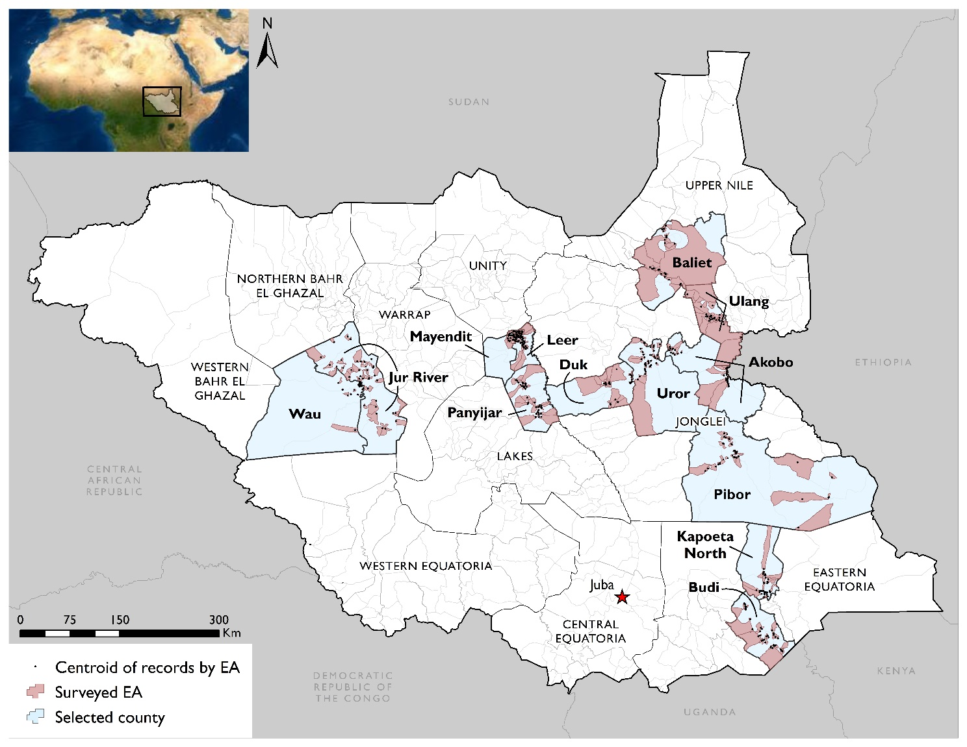

The selected EAs formed clusters from which the household samples were selected in the second stage, using systematic sampling. For additional details about the sampling design see Annex A. Methodological Details.

In total, the sample achieved 96 percent of its total target across the thirteen counties of interest for a final count of 7,872 survey entries (one survey interview of the head of household). Within each county, the sample target achieved ranged between a low of 82 percent in Duk and a high of 99 percent in Baliet and Ulang counties. See Annex A for details on the sample achieved in each of the thirteen counties.

The data were collected in two phases. The first phase occurred in six counties of Akobo, Budi, Duk, Leer, Pibor, and Uror from March to June 2021. The second phase happened in seven counties of Baliet, Jur River, Kapoeta North, Mayendit, Panyijar, Ulang, and Wau from September to November 2021. Each phase used the same approach to training and data collection as described in the figure below. Data collection used tablet-based data collection on the application Fulcrum. For more detailed information on data collection processes, please see Annex A.

Figure . Data Collection Process

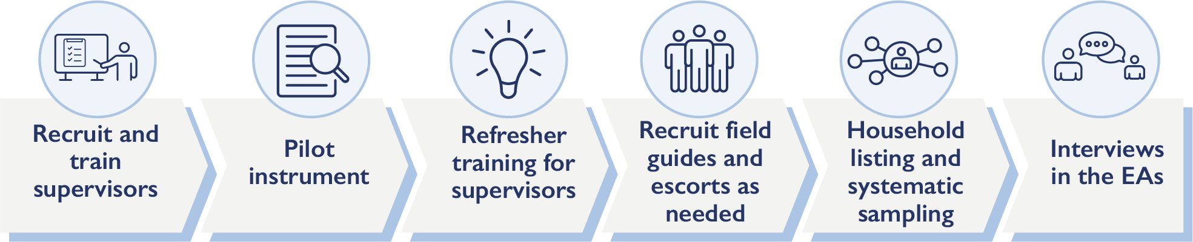

## Limitations and sources of Bias

The sample is representative and generalizable at the county-level. Since only 13 counties were included in the study, the results cannot be aggregated to higher levels such as the county of South Sudan, any of South Sudan’s three regions, or the country’s constituent states. While the data allows for the calculation of statistics levels lower than the county – payam, boma, or EA – results at these lower levels are not generalizable as the sample size at these lower levels is too small. The study also has measurement error inherent in most social science research that involves interviewing people.

* *Acquiescence bias.* Respondents in the households provide answers to questions that they think the interviewer wants to hear or answers that are socially desirable.
* *Comprehension bias.* Respondents understand differently a concept or idea in a question or its response options than the survey instrument intended.
* *Recall/recency bias.* Respondents provide information outside the timeframe specified in a question.
* *Avoidance bias.* Respondents answer a question on a sensitive topic with an answer that is not their true opinion, but rather a safe answer that will not subject them to harm.

## COVID-19 and human subject research

Supervisors and enumerators received training on Coronavirus disease (COVID-19). The training included a description of the virus that causes COVID-19, the common symptoms of the disease, populations for concern, and measures to mitigate the spread of COVID-19. In particular, training on mitigation stressed hand washing with soap and water for 20 seconds, use of hand sanitizer with at least 60 percent alcohol, avoiding close contact with people who are sick, social distancing at least one meter and preferably two meters, disinfecting frequently touched objects, and wearing a mask. In addition, MESP provided supervisors and enumerators with personal protective equipment – i.e., gloves, sanitizers, and face masks – for data collection.

The study design and its instrument were submitted to USAID South Sudan for review and approval. The study design and instrument were ultimately approved. During the administration of household survey, the enumerators interviewed the head of the household or an adult older than 18 years. Enumerators read the text from the consent section displayed on tablet which explained the survey and requested informed consent before proceeding to the administration of the survey. All participants surveyed provided their verbal consent, which was documented in the survey.

# Findings

The findings from the baseline survey are presented first with summary of the overall values for the indicators under each of the resilience themes – food security, agency, social cohesion, shocks and stresses, and social norms. The chapter then provides detailed information under each of these themes ending with a section presenting the results of the resilience model that incorporates the resilience themes.

Table . Indicator Summary

|  |  |  |
| --- | --- | --- |
| **Food Security** | **Scale** | **Overall** |
| Food Insecurity Experience Scale | 0 to 8 | 7.6 |
| Household Dietary Diversity Scale | 0 to 12 | 6.4 |
| **Personal Agency** | **Scale** | **Overall** |
| Personal Agency | 0 to 100 | 74.1 |
| Aspirations index | 0 to 100 | 76.6 |
| Locus of Control | 0 to 100 | 71.4 |
| **Shocks and Stresses** | **Scale** | **Overall** |
| Incidence of Shocks | 0 to 16 | 7.4 |
| Exposure to Shocks and Stresses | 0 to 128 | 49.2 |
| Incidence of Conflict | Percentage | 38% |
| **Social Cohesion** | **Scale** | **Overall** |
| Bonding Social Capital | 0 to 100 | 43.3 |
| Bridging Social Capital | 0 to 100 | 34.6 |
| Social Cohesion | 0 to 100 | 39.0 |
| **Social Norms** | **Scale** | **Overall** |
| Acceptance of SGBV | Percent Acceptable | 61% |
| Acceptance of Cattle Raiding | Percent Acceptable | 75% |
| Acceptance of Girls’ Education | Percent Acceptable | 91% |
| Acceptance of Early Marriage | Percent Acceptable | 73% |
| **Resilience** | **Scale** | **Overall** |
| Absorptive Capacity | 0 to 100 | 32.5 |

The annex includes detailed information for each indicator disaggregated by location (urban/rural), male- and female-headed household, and county. See Annex C. Detailed Indicators.

## Food Security

The two indicators for food security are the FIES and the HDDS. The FIES measures the households’ experience with food insecurity using a recall period of one year, while the HDDS measures the households’ dietary diversity by categorizing questions on foods eaten into 12 food groups. On average, the FIES is 7.6 for the 13 counties – equating to severe food insecurity. Meanwhile, the HDDS has a mean of 6.4 for the 13 counties – meaning that households on average consumed approximately six different foods in the previous 24 hours. The most common foods were cereals and leafy green vegetables. Consumption of meat was the strongest indicator for predicting that the household has high dietary diversity overall (cross-reference).

Table . Summary of Food Security Indicators

|  |  |  |  |  |  |  |
| --- | --- | --- | --- | --- | --- | --- |
| **Theme: Food Security** | **Scale** | **Overall** | **Rural** | **Urban** | **Male-headed** | **Female-headed** |
| Food Insecurity Experience | 0 to 8 | 7.6 | 7.6 | 7.5 | 7.5 | 7.5 |
| Food Insecurity Experience | Categorical | Severe | Severe | Severe | Severe | Severe |
| Household Dietary Diversity | 0 to 12 | 6.4 | 5.6 | 8.0 | 6.3 | 6.1 |

### Food Insecurity Experience Scale (FIES)

The FIES is composed of eight questions. The logic of the questions is that each question is a scenario that indicates an increasing severity of food insecurity. Ideally, the percentage of respondents who say yes to the questions should decrease from questions 1 through 8. Instead, the percentages are roughly the same for all eight questions: 94% or 95% responded yes. Nonetheless, the item response theory analysis confirmed that the fourth question (skipped a meal) delineates mild and moderate food insecurity and the seventh question (did not eat) differentiates between moderate and severe food insecurity. This finding is consistent with FAO’s methodology for the FIES.

Table . Questions for the FIES

|  |  |  |  |  |  |  |  |  |
| --- | --- | --- | --- | --- | --- | --- | --- | --- |
| **Category** | **Mild** | | | **Moderate** | | | **Severe** | |
| Raw Score | 1 | 2 | 3 | **4** | 5 | 6 | **7** | 8 |
| Question | Worried about not enough to eat | Unable to eat healthy | Reduced dietary diversity | **Skipped a meal** | Ate less than needed | No food in household | **Did not eat** | Went a day without eating |
| Percent Selected Yes | 95% | 95% | 95% | 94% | 95% | 95% | 95% | 94% |

In every county except Wau, the average food insecurity is rated as severe. Pibor county has the highest average of 7.9 out of 8, while Wau is the lowest at 6.4 meaning food insecurity is moderate. Food insecurity is higher in areas with a higher incidence of higher shocks and conflict, and lower among households with more education.

### Household Dietary Diversity Scale (HDDS)

The HDDS has 17 questions that map to 12 food categories. Respondents are asked to discuss the food eaten in the household in the previous 24 hours. After the discussion, enumerators mark the food groups that correspond to the foods eaten in the household. The following table shows a ranking of which foods were most eaten in the previous 24 hours.

Table . Foods Consumed in Previous 24 Hours

| **Food Group** | **Percentage of Households** |
| --- | --- |
| Cereals | 85% |
| Leafy greens | 67% |
| Seafood | 61% |
| Oil and fats | 57% |
| Milk products | 54% |
| Domesticated meat | 54% |
| Spices/condiments | 51% |
| Legumes | 49% |
| Organ meat | 43% |
| Bush meat | 41% |
| Vitamin A vegetables | 41% |
| Eggs | 40% |
| Other vegetables | 35% |
| Sweets | 33% |
| Other fruits | 33% |
| Roots/tubers | 26% |
| Vitamin A fruits | 19% |

The number of foods consumed in the previous 24 hours is summed to create an index variable on a scale of 0-12[5]. The overall value across the 13 counties was 6.4, ranging from 4.0 in Budi to 9.4 in Pibor. Urban households, and households with fewer members than average, reported a higher dietary diversity. Factor analysis of all foods shows that the food consumption patterns falls into six discrete groupings, or what may be considered a ‘consumption profile’. These consumption profiles are described below.

Table . Household Food Consumption Profiles

|  |  |  |
| --- | --- | --- |
| **Factor** | **Factor Description** | **Total Variance Captured** |
| ML3 | Meat, bush meat, organ meat, eggs, seafood | 0.18 |
| ML5 | Vitamin A fruits, other fruits, ruts/tubers, sweets | 0.13 |
| ML6 | Oil/fats, milk products | 0.12 |
| ML1 | Vitamin A vegetables, roots/tubers | 0.11 |
| ML2 | Seafood (fish) | 0.09 |
| ML4 | Spices, cereals, other vegetables | 0.07 |

Of these consumption profiles, the consumption of meat is the most effective rapid indicator for considering the household to also have a high dietary diversity. See Table 26 in the Detailed Findings for details on construction of the consumption profiles.

## Personal Agency

Personal Agency is a latent variable that comprises the sub-indices of aspirations and locus of control. Aspirations measures households’ outlook on life, for which a number closer to 100 means outlook is more positive. Locus of control measures the degree to which households have control over their lives in terms of acting on their aspirations. A number closer to 100 demonstrates a greater degree of control. The overall results show that aspirations (76.6) are higher than locus of control (71.4), meaning that households have greater aspirations than they are capable of acting on. Therefore, households’ level of agency (74.1) is their aspirations which are lowered by their locus of control.

Table . Summary of Personal Agency Indicators

|  |  |  |  |  |  |  |
| --- | --- | --- | --- | --- | --- | --- |
| **Personal Agency** | **Scale** | **Overall** | **Rural** | **Urban** | **Male-headed** | **Female-headed** |
| Personal Agency | 0 to 100 | 74.1 | 72.8 | 77.0 | 71.8 | 72.7 |
| Aspirations | 0 to 100 | 76.6 | 75.1 | 79.7 | 75.6 | 74.6 |
| Locus of Control | 0 to 100 | 71.4 | 70.2 | 74.1 | 67.5 | 70.7 |

### Aspirations

The Aspirations index comprises six survey items. These items and their overall frequencies are presented below.

Table . Aspirations Index, Constituent Items

| **Item** | **Description** | **Percent** |
| --- | --- | --- |
| 629 | Each person is responsible for his/her own success or failure in life | 75% |
| 630 | To be successful one needs to work very hard rather than rely on luck | 77% |
| 634 | What is going to happen will happen (reverse-coded) | 32% |
| 635 | Many things turn out to be a matter of good or bad fortune (reverse-coded) | 29% |
| 632 | Hopeful for children's future | 78% |
| 633 | Desire for children to graduate from secondary school | 87% |

Note that respondents were generally optimistic in their responses. There were two reverse-coded items that required disagreement rather than agreement – for these measures the level of support for the index is much lower. This is considered at least partly due to acquiescence and comprehension bias, in which respondents readily signal agreement with a general proposition offered to them, and also failed to recognize the reverse-coded questions.

These items are summed to create an index with a mean of 3.8 out of 6. The items also undergo factor analysis to create a variable with a mean of zero and standard deviation of one. This factor variable is then rescaled 0-100 to restore a level of interpretability. The mean value of the rescaled factor variable is 76.6. See Aspirations in the Detailed Findings for details regarding construction of the rescaled factor variable.

### Locus of Control

The locus of control index comprises three statements with which respondents agree or disagree on a six-point scale. Overall frequencies of agreement (selecting 4-6 on the response scale) is below.

Table . Locus of Control Index, Constituent Items

| **Item** | **Description** | **Percent** |
| --- | --- | --- |
| 636 | I can mostly determine what will happen in my life | 68% |
| 637 | When I get what I want, it is usually because I worked hard for it | 88% |
| 638 | My life is determined by my own actions | 84% |

As with aspirations, respondents generally report an intrinsically-motivated locus of control in which they have some control in their lives to pursue their aspirations. Counting any level of agreement as a value of one and zero for any level of disagreement, these items may be summed to create a simple index with a mean value of 2.4 out of 3. The items also undergo factor analysis to create a variable with a mean of zero and standard deviation of one. This factor variable is then rescaled 0-100 to restore a level of interpretability. The mean value of the rescaled factor variable is 72.7. See Locus of Control in Detailed Findings for details regarding construction of the rescaled factor variable.

## Social Cohesion

Social cohesion is an index variable that comprises two sub-indices of bonding social capital and bridging social capital. Bonding social capital measures the level that households can depend on relatives or non-relatives within their communities, while bridging social capital measures the level that households can depend on family or non-family outside of their communities. Social cohesion is a composite of the bonding and bridging social capital.

In total, bonding social capital is higher than bridging social capital, which indicates that households on average can depend more on people within their communities than outside their communities. For social cohesion, this finding implies that social cohesion is lowered by the bridging social capital.

Table . Summary of Social Cohesion Indicators

|  |  |  |  |  |  |  |
| --- | --- | --- | --- | --- | --- | --- |
| **Theme: Social Cohesion** | **Scale** | **Overall** | **Rural** | **Urban** | **Male-headed** | **Female-headed** |
| Bonding Social Capital | 0 to 100 | 43.3 | 44.6 | 40.6 | 38.6 | 43.5 |
| Bridging Social Capital | 0 to 100 | 34.6 | 37.9 | 27.7 | 25.5 | 33.4 |
| Social Cohesion | 0 to 100 | 39.0 | 41.3 | 34.1 | 32.0 | 38.3 |

Within the counties, social cohesion is the lowest in Wau (17.2) and the highest in Budi (67.8). In every county except one, the bonding capital is higher than the bridging capital. The one exception is Leer in which bridging eclipses bonding.

### Bonding Social Capital

The bonding social capital index comprises four items asking about the respondent’s ability to lean on relatives or non-relatives within their village, and whether the household could serve as a support for when relatives or non-relatives needed support. The following table shows the overall frequencies for these items.

Table . Bonding Social Capital, Constituent Items

| **Item** | **Description** | **Percent** |
| --- | --- | --- |
| 490 | Able to lean on relatives in community | 54% |
| 491 | Able to help relatives in community | 41% |
| 494 | Able to lean on non-relatives in community | 37% |
| 495 | Able to help non-relatives in community | 29% |

Note the drop in mutual aid as one goes from relatives to non-relatives within the community. Respondents are also more likely to report being able to lean on others, but not as able to help others who may need support. These variables are combined into a single index variable and then rescaled 0-100, with a mean of 43.3. The value less than 50 suggest that bonding social capital in the USAID key counties is moderate. See Bonding Social Capital in the Detailed Findings section for additional detail on the index variable construction.

### Bridging Social Capital

The bridging social capital index comprises the same items as above, but applied to those outside the respondent’s immediate community. The following table shows the overall frequencies.

Table . Bridging Social Capital, Constituent Items

| **Item** | **Description** | **Percent** |
| --- | --- | --- |
| 492 | Able to lean on relatives outside community | 42% |
| 493 | Able to help relatives outside community | 31% |
| 496 | Able to lean on non-relatives outside community | 35% |
| 497 | Able to help non-relatives outside community | 27% |

These items show the same general pattern as the bonding social capital index, but at slightly lower levels. These items are combined into a single index variable and rescaled 0-100, with a mean of 34.6. Bridging social capital is lower than bonding social capital, and may be considered low to moderate. See Bridging Social Capital in the Detailed Findings section for additional detail on construction of the index variable.

The social cohesion index is itself an index variable, constructed from the sub-indices of bonding and bridging social capital. See Detailed Findings for additional detail on the index construction.

## Shocks and Stresses

The shocks and stresses facing households is the critical environment that challenges households to absorb the shock, adapt to mitigate the future risk of shocks, or successfully transform the household’s environment to avoid facing a shock altogether. The indicators for shocks and stresses are incidence of shocks, shock exposure, and incidence of conflict. The incidence of shocks measures the number of shocks out of a list of 16 shocks that households experienced in the previous year. The shock exposure is an index that incorporates the households’ shocks experienced along with severity in terms of impact on household food consumption and economic situation. The incidence of conflict is the percentage of households that report experiencing a conflict in the previous six months.

The incidence of shocks is considered high with a mean of 7.4 shocks, meanwhile, the shock exposure is moderate with a mean of 49.2. Overall, 38 percent of households reported experiencing a conflict in the previous six months, with a higher incidence among urban households, male-headed households, and in the counties of Pibor and Akobo (cross-reference).

Table . Summary of Shocks and Stresses Indicators

|  |  |  |  |  |  |  |
| --- | --- | --- | --- | --- | --- | --- |
| **Theme: Shocks and Stresses** | **Scale** | **Overall** | **Rural** | **Urban** | **Male-headed** | **Female-headed** |
| Incidence of Shocks | 0 to 16 | 7.4 | 7.5 | 7.2 | 6.9 | 6.2 |
| Exposure to Shocks and Stresses | 0 to 128 | 49.2 | 51.0 | 45.4 | 44.4 | 41.4 |
| Incidence of Conflict | Percentage | 38% | 32% | 49% | 45% | 34% |

### Shocks

Nearly all households (97 percent) experienced at least one shock in the past year, while the mean value was 7.4 shocks experienced per household in the past year. While the number of shocks experienced is informative regarding the challenges households face, a better measure incorporates the perceived severity of a shock as well as its incidence.[6] Severity was defined on an 8-point scale based on household reports of the extent to which a given shock affected the household’s economic situation and the household’s ability to feed all of its members. These severity scores could then be used to rank the effect of one shock relative to another, and also summed to provide an overall measure of exposure to a set of shocks.

Table 25 in the Detailed Findings shows the mean severity for each of 16 shocks. After sorting the schedule of shocks according to their effect on household welfare, the two most severe shocks were increase in food prices (5.7) and floods (5.3), followed by shocks relating to drought. Food prices and flooding were reported as moderately severe, while all other shocks were reported to be of low to moderate severity.

Summing the shock severity value for each of 16 shocks produces an index of exposure ranging from 0-128, with a mean value of 49.2. This may be considered a moderate degree of shock exposure. The following figure shows the distribution of score values.

Figure . Shock Exposure Index

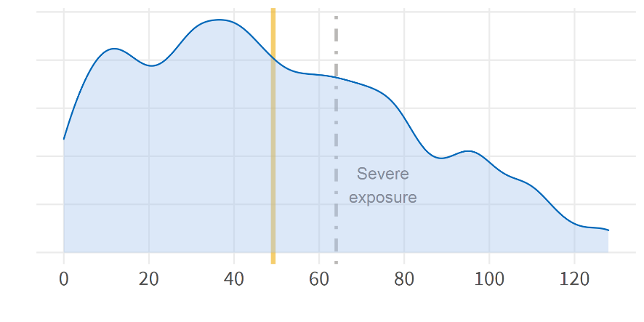

Most households report a total value of shock exposure that is less than 80, with a longer tail extending from 80 to 128. Values exceeding 64 may be considered to be severe, while values exceeding 80 may be considered extremely severe. Figure 9 in the Detailed Findings shows the mean shock exposure for each county, as well as the two most severe shocks for each county. Duk has the highest exposure at 75 and Wau has the lowest at 16. In nine of the counties, floods were one of the top two shocks demonstrating how widespread flooding was in these counties of South Sudan, but also the severity of these floods. Drought appeared as one of the top two severe shocks in Jur River and Kapoeta North. Note that because drought is concentrated in only two counties, it may have a greater magnitude of severity relative to flooding which was more geographically dispersed.

Factor analysis of all shocks suggests that the patterns of which shocks fall upon a household falls into five discrete groupings, or what may be considered a ‘shocks profile’. These shocks profiles are described below.

Table . Household Shocks Profiles

|  |  |  |
| --- | --- | --- |
| **Factor** | **Factor Description** | **Total Variance Captured** |
| ML2 | Crop disease/pests/theft, agricultural inputs | 0.18 |
| ML1 | Livestock inputs/disease/theft, unable to sell | 0.17 |
| ML3 | Erosion, loss of land, flood, food prices | 0.14 |
| ML5 | Illness and death | 0.08 |
| ML4 | Theft | 0.05 |

The strongest shocks profile relates to crops (ML2) and livestock (ML1), followed by shocks relating to flooding (ML3), illness and death (ML5), and finally theft (ML4). These five profiles capture 63 percent of the total variance of all 16 shocks. Measures of model fit (Tucker Lewis Index 96 percent, RMSEA .04) meet desired benchmarks. See Table 32 in the Detailed Findings for the factor loadings of each individual item.

### Stresses - Conflict

In the 13 counties, 38 percent of households reported that they experienced a conflict in the previous six months. Of the households that experienced a conflict, the most common type of conflict was water (68 percent). Following water was conflicts tied to cattle (60 percent), revenge (57 percent), and cattle raiding (57 percent). The questionnaire considered these discreet response options. For example, cattle would mean a conflict between individuals about their cows, whereas a cattle raid would be people from one community raiding cattle from a neighboring community. Revenge would mean revenge killing. However, the clustering of the responses of these three suggests that households view this response options as similar or related. As will be detailed in the social norms section, the primary justification for cattle raids is revenge. Finally, sexual and gender-based violence (57 percent) is a notable type of conflict.

Among the counties, Pibor has the highest incidence of conflict with 67 percent of households reporting a conflict in the last six months. Conflict related to cattle, cattle raids, and revenge is quite diffuse, accounting for the top type of conflict in eight counties: Akobo, Duk, Kapoeta North, Leer, Mayendit, Panyijar, Pibor, and Ulang. Meanwhile, conflict over water as the primary conflict is concentrated in Uror and Wau.

## Social Norms

The four social norms of interest pertain to acceptability of SGBV, cattle raiding, girls’ education, and early marriage. The overall results show that all of these norms have high levels of acceptability in the 13 counties, but girls’ education is the most universally accepted at 91 percent.

Table . Summary of Social Norms Indicators

|  |  |  |  |  |  |  |
| --- | --- | --- | --- | --- | --- | --- |
| **Theme: Social Norms** | **Scale** | **Overall** | **Rural** | **Urban** | **Male-headed** | **Female-headed** |
| Acceptability of SGBV | Percent | 61% | 60% | 65% | 57% | 60% |
| Acceptability of Cattle Raiding | Percent | 75% | 73% | 80% | 77% | 75% |
| Acceptability of Girls' Education | Percent | 91% | 90% | 92% | 90% | 89% |
| Acceptability of Early Marriage | Percent | 73% | 71% | 77% | 74% | 73% |

### Sexual- and Gender-Based Violence

Overall, 61 percent of households indicated that SGBV was acceptable. Within the 61 percent, SGBV most often justified as acceptable in the context of a relationship married or unmarried (22 percent) or time of conflict (23 percent).

Table . Acceptability of SGBV

|  |  |
| --- | --- |
| In your opinion, under what circumstances is sexual and gender-based violence acceptable? | |
| **Response Option** | **Percent** |
| Never | 39% |
| Within a relationship - not married | 7% |
| Within a relationship - married | 15% |
| In a time of conflict | 23% |
| Within a family to resolve a dispute | 6% |
| Within a marriage to resolve a dispute | 7% |
| Other | 3% |

Ulang has the greatest acceptance of SGBV at 82 percent. Within that county, the households indicate that SGBV is acceptable in time of conflict (25 percent), within a family to resolve a dispute (21 percent), and within a marriage to resolve a dispute (19 percent). Figure 10 in Annex B illustrates the variation of acceptability of SGBV by county. Budi has the lowest acceptance of SGBV at 19 percent. There are three distinct groups of counties in terms of accepting SBGV. The seven high-acceptance counties exceed 60 percent finding the practice acceptable. The middle-acceptance counties are four with acceptance between 50 percent and 60 percent. Baliet and Budi are the counties with relatively low-acceptance of SGBV, less than 50 percent.

### Cattle Raiding

Overall, 75 percent of households indicated that cattle raiding was acceptable. Within the 75 percent, cattle raiding was most often justified as acceptable for revenge (46 percent) and to gain money or cows for bride price (16 percent).

Table . Acceptability of Cattle Raiding

|  |  |
| --- | --- |
| In your opinion, under what circumstances is cattle raiding acceptable? | |
| **Response Option** | **Percent** |
| For revenge | 46% |
| To gain money/cows for bride price | 16% |
| To feed your household | 10% |
| To feed your community | 3% |
| Never acceptable | 25% |

Figure 10 in Annex B shows the variation of acceptability of cattle raiding by county. Pibor has the greatest acceptance of cattle raiding at 98 percent. There are five counties with very high acceptance (i.e., greater than 85 percent) of cattle raiding: Akobo, Duk, Kapoeta North, Pibor, and Uror. Budi has the lowest acceptance of cattle raiding at 33 percent.

### Girls’ Education

Girls’ education has near total acceptance with 91 percent of households agreeing girls should have the same education opportunities as boys. It is notable that this level of acceptance does not mean that girls actually receive the same opportunities or enroll and attend school on par with boys. All counties are above 90 percent acceptance of girls education except Jur River (74 percent) and Wau (87 percent).

### Early Marriage

In the 13 counties, 73 percent of households indicated that early marriage was acceptable. Within the 73 percent, early marriage was most often justified as acceptable to gain money or cows for bride price (34 percent) and to feed a household (29 percent). Per Green and Stiefvater (2019), early marriage may be seen not a norm in itself, but rather a reflection of a set of underlying social norms that include the transition from adolescent to adult, the age structure of the surrounding society, religious belief, gender inequality, and sex-differentiated roles in pursuing livelihoods.

Table . Acceptability of Early Marriage

|  |  |
| --- | --- |
| In your opinion, under what circumstances is early marriage acceptable? | |
| **Response Option** | **Percent** |
| For revenge | 6% |
| To gain money/cows for bride price | 34% |
| To feed your household | 29% |
| To feed your community | 4% |
| Never acceptable | 27% |

Figure 10 in Annex B illustrates the variation of acceptability of early marriage by county. Pibor has the greatest acceptance of cattle raiding at 98 percent. There are four counties with very high acceptance (i.e., greater than 80 percent) of cattle raiding: Akobo, Duk, Kapoeta North, and Pibor. These are four of the five counties with very high acceptance of cattle raiding. The descriptive results would suggest a relationship between the cattle raiding and early marriage, given that the counties with the highest acceptance are almost the same and respondents to the survey most often justified acceptability of early marriage as a way to get money or cows for bride price. Budi has the lowest acceptance of early marriage at 24 percent.

### Correlations with Social Norms

Ordinary least squares regressions examining the correlations of independent variables to the acceptability of social norms revealed three findings across the four norms. First, none of the variables were correlated with the acceptance of girls’ education. Second, primary and secondary education relative to no education is correlated with less acceptance of cattle raiding, early marriage, and SGBV. Third, negative events such as shock exposure and conflict incidence are correlated with increased acceptance of cattle raiding, early marriage, and SGBV. In addition, participation in social groups in the community is also correlated with increased acceptance of these negative norms.

Table . Correlations with Social Norms

|  |  |  |  |  |
| --- | --- | --- | --- | --- |
| **Variable** | **Cattle Raiding** | **Early Marriage** | **SGBV** | **Girls’ Education** |
| Locality |  |  |  |  |
| Road Distance | **+** | **+** |  |  |
| Education – Primary | **-** | **-** |  |  |
| Education – Secondary | **-** |  | **-** |  |
| Education – Tertiary |  |  |  |  |
| Early Marriage in Household | **+** |  |  |  |
| Household Size | **-** | **-** |  |  |
| Shock Exposure Index | **+** | **+** | **+** |  |
| Group Participation | **+** | **+** | **+** |  |
| Conflict Incidence | **+** | **+** |  |  |

Note: All correlations marked as ( + ) or ( - ) are statistically significant (p < 0.05)

More complete regression results including coefficients and p-values are found in Table 33 in Annex B.

## Resilience

The United States Agency for International Development (USAID) defines resilience as the ability of people, households, communities, countries, and systems to mitigate, adapt to and recover from shocks and stresses in a manner that reduces chronic vulnerability and facilitates inclusive growth (USAID 2013). TANGO (2018) offers guidance for operationalizing the USAID approach. The Food and Agricultural Organization (FAO) has a methodology for measuring resilience which adds measures such as dietary diversity as a complement to food insecurity (FAO 2016), and there is also a conditional moments approach presented in Cisse and Barrett (2018). See the detailed literature review (Annex D. Literature Review) for more in-depth discussion.

For USAID-funded activities, resilience is operationalized as a set of capacities that mediate the interaction of shocks and stresses on a measure of household well-being (TANGO 2018). Common well-being measures include household income, wealth, poverty status, food insecurity, child wasting, or self-perceived ability to recover from shocks or stresses. Shocks and stresses are measured across a range of specific events (shocks) or risks (stresses) and aggregated to a single measure of exposure.

Following TANGO (2018), capacities are measured along three primary indices of absorptive, adaptive, and transformative resilience capacity. Absorptive resilience capacity is the ability to minimize exposure to shocks and stresses through preventative measures and appropriate coping strategies to avoid permanent, negative impacts. Adaptive capacity is the ability to make proactive and informed choices about alternative livelihood strategies based on an understanding of changing conditions. Transformative capacity is the governance mechanisms, policies, regulations, infrastructure, community networks, and formal or informal social protection mechanisms that constitute the enabling environment for systemic change. Each of these capacities comprises its own set of sub-indices. The following table shows the primary measures for each type of capacity.

Table . Resilience Measures, Full Approach

|  |  |  |
| --- | --- | --- |
| **Absorptive** | **Adaptive** | **Transformative** |
| Access to informal safety nets | Bridging social capital | Access to formal safety nets |
| Bonding social capital | Linking social capital | Access to markets |
| Access to cash savings | Social network index | Access to communal natural resources |
| Access to remittances | Education/training | Access to basic services |
| Asset ownership | Livelihood diversification | Access to infrastructure |
| Shock preparedness and mitigation | Exposure to information | Access to livestock services |
| Access to insurance | Adoption of improved practices | Bridging social capital |
| Access to humanitarian assistance | Asset ownership | Linking social capital |
|  | Availability of financial services | Collective action |
|  | Aspirations/confidence to adapt/locus of controls | Social cohesion |
|  |  | Gender equitable decision-making index |
|  |  | Participation in local decision-making |
|  |  | Local government responsiveness |
|  |  | Gender index |

In the South Sudan context, interest is mainly in the measure of absorptive resilience capacity. The current study follows what TANGO (2018) refers to as the ‘resilience light’ approach, in that only a subset of the measures identified above are used to construct the indices. The following table indicates the measures used along with their baseline values.

Table . Resilience Measures, Light Approach

|  |  |  |
| --- | --- | --- |
| **Measure of Absorptive Capacity** | **Survey item(s)** | **Mean value** |
| Access to informal safety nets | Group membership  (items 501a-p) | 35.2 |
| Bonding social capital | Mutual aid within community  (items 490-91, 494-95) | 43.3 |
| Access to remittances | Income source  (item 401r) | 5.7% |
| Shock preparedness and mitigation | Early warning systems  (items 607a-k) | 35.2 |
| Shock preparedness and mitigation | Emergency action plans  (items 610-612) | 19.2 |
| Access to humanitarian assistance | Aware of donor activity  (item 504) | 44.3% |
| **Overall absorptive capacity** | | **32.5** |

Access to remittances and awareness of donor activity are single-item measures, while safety nets and shock preparedness are additional sub-indices that are not included as part of the main themes presented above. See Detailed Findings for additional detail on the construction of these additional sub-indices. The overall measure of absorptive capacity is a composite measure that is standardized to have a mean of zero and standard deviation one, and then rescaled to a range of 0-100. The overall mean value of 32.5 suggests that absorptive resilience capacity is low to moderate.

A model of resilience posits that a well-being outcome is affected by shocks and stresses, and that the effect of negative shocks is mitigated by the household’s resilience capacity. This study estimates the mitigating effect of absorptive resilience capacity on two well-being outcomes: perceived ability to recover from a shock, and food insecurity.[7]

### Perceived Ability to Recover

At the conclusion of the module on shocks, the household survey asks if the household feels that its current and future ability to meet its food needs is worse than before the shock, the same as before the shock, or better than before the shock. These responses are coded 1-3, where worse-off is assigned a value of one and better-off is assigned a value of three, and summed across current ability and future ability to generate a variable ranging from 2-6. Values exceeding four may be considered the desired outcome in which the household reports being able to recover from the shocks it faced in the previous year. A binary version of this variable assigns the value one to the scale points 4-6, zero otherwise. This outcome is then regressed against shocks, stresses, and resilience capacity, while also controlling for household size, sex of the head of household, urban or rural locality, and county.

See Table 30 in the Detailed Findings for model output using the ordered scale of 2-6. The predicted effects of the model are presented below. In order to ease interpretation, the model summarized below uses the binary value of ability to recover from shocks.

Figure . Absorptive Resilience Capacity and Ability to Recover, Predicted Output

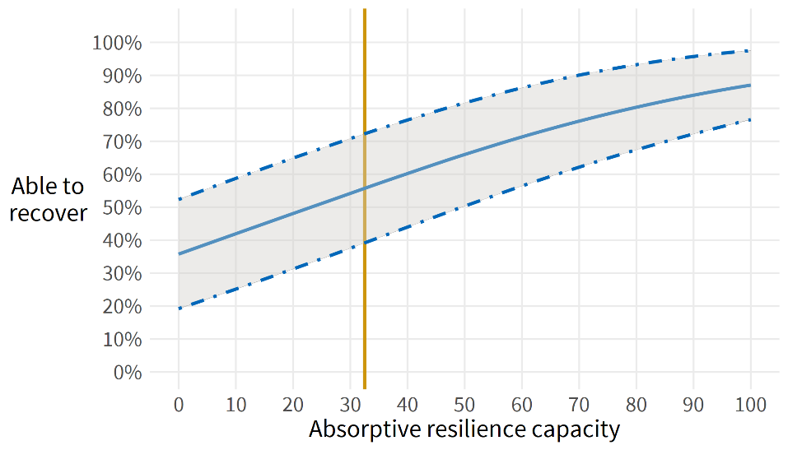

Note the mean values of 32.5 for resilience capacity and 57 percent for ability to recover from shocks. A one standard deviation increase in absorptive resilience capacity (approximately 20 points on the 0-100 scale) is associated with an increase in the perceived ability to recover from shocks by roughly 9.1 percentage points.

### Food Insecurity

While perceived ability to recover from shocks speaks directly to resilience capacity, it does not directly measure the well-being outcomes desired by USAID, and may be considered more of an intermediate outcome along the way to a longer-term measure of household welfare. A more direct and longer-term measure of household welfare often uses food insecurity. In this study, food insecurity is measured using the FAO methodology of a summed index asking about hunger over the past year, or using specific items along the scale to create mild, moderate, or severe categories of food insecurity. A secondary measure asks about household hunger over the past month, though there was little difference in the incidence or severity of hunger across these two time frames. The most discriminating item demarcating degrees of food insecurity was found to be the item asking if anyone in the household went to bed hungry in the past month.

See Table 33 in the Detailed Findings for model output. The predicted effects of absorptive resilience capacity on food insecurity are presented below. A one standard deviation increase in absorptive capacity (approximately 20 points on the 0-100 scale) is associated with a 5.1 percentage point reduction in the probability of reporting that anyone in the household went to bed hungry in the past month.[8]

Figure . Absorptive Resilience Capacity and Food Insecurity, Predicted Output

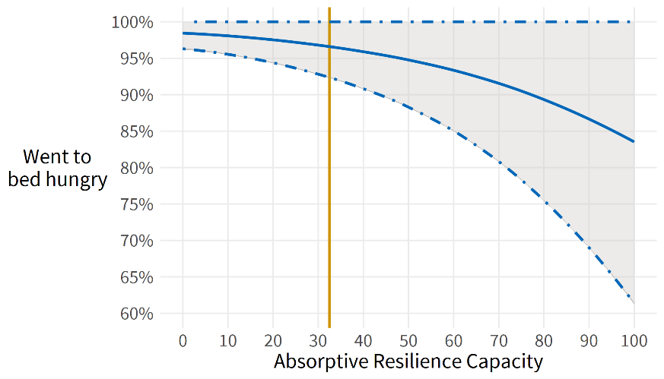

Note how the mitigating effect of absorptive resilience capacity doesn’t take hold until the household reaches a capacity score of approximately 50, but also that levels of food insecurity remain high even at high values of absorptive resilience capacity. This reflects the trenchant nature of the humanitarian issues facing communities in South Sudan, most notably due to widespread flooding, and in a few places drought.

Absorptive resilience capacity may be disaggregated to investigate which components of the aggregate index may be driving the relationship between resilience capacity and the development outcome. See Table 34 in Detailed Findings for full model output in tabular form, whereas the following figure shows the summary effects for all sub-components of absorptive capacity.

Figure . Components of Absorptive Capacity and Food Insecurity, Predicted Output

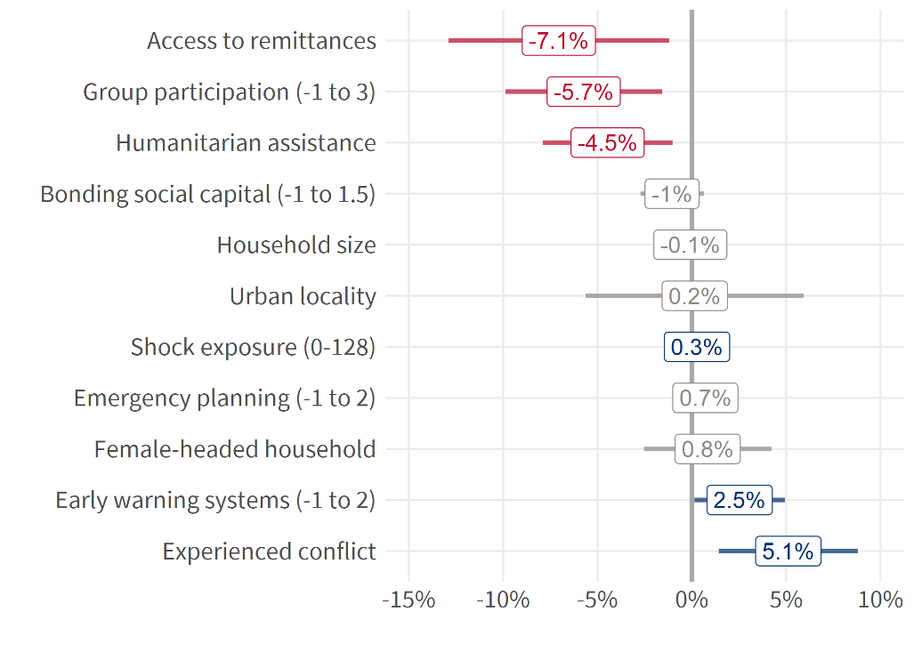

Any value in red signifies a statistically significant finding that predicts lower values of food insecurity, while values in blue signifies a statistically significant finding that predicts higher values of food insecurity. Values in grey are not statistically significant. Disaggregated findings suggest that informal safety nets (as measured by community group participation) and humanitarian assistance have substantive effects in reducing food insecurity. As expected, the experience of shocks and conflict increases food insecurity. Note that the presence of early warning systems is associated with higher food insecurity, suggesting that early warning systems may be appropriately targeted to areas most in need.[9]

# Conclusions and Recommendations

## Conclusions

USAID has a valid baseline for South Sudan. Using the baseline, USAID has initial values for the 28 indicators outlined in the scope of work. USAID can use these baseline values to measure progress over time for its 2020-2024 country strategy if it conducts subsequent data collections.

USAID has additional baseline measures for resilience capacities. The baseline calculated measures for personal agency, social cohesion, and absorptive capacity. USAID could incorporate these additional measures into its PMP as contextual indicators or a learning agenda.

An Increase in resilience capacity IS associated with improved well-being. Two measures of well-being are the ability to recover from shocks and food insecurity. An increase in resilience as measured by absorptive capacity is correlated with an increase in household’s ability to recover as well as household’s food security.

Food insecurity is a better measure of humanitarian assistance outcomes than dietary diversity. Food security as measured by the FIES is better than the HDDS in the context of South Sudan. The FIES indicates severe food insecurity perceived by households in 12 of the 13 target counties. Meanwhile, the HDDS suggests households have a moderate or high amount of dietary diversity in all 13 counties. Given the weak positive correlation between the FIES and HDDS (which should be stronger), FIES is a better measure of food security than the HDDS for these 13 counties of South Sudan.

Resilience capacity measures are higher with higher incidence of shocks and conflict. Social cohesion is highest (above 40) in Akobo, Baliet, Budi, Duk, Kapoeta North, Leer, and Pibor; personal agency is highest (above 80) in Baliet, Budi, Duk, Kapoeta North, and Pibor. At the same time, conflict is highest (above 30 percent) in Akobo, Duk, Kapoeta North, Pibor, and Uror; exposure to shocks and stresses is highest (above 50) in Duk, Kapoeta North, Pibor, Ulang, and Uror. Akobo, Duk, Kapoeta North, and Pibor suggest that personal agency and social cohesion are possible coping strategies against conflict and shocks and stresses.

Table . High Resilience Capacity and High Shocks and Conflict by County

|  |  |  |  |  |
| --- | --- | --- | --- | --- |
| **County** | **High Personal Agency** | **High Social Cohesion** | **High Conflict** | **High Shocks and Stresses** |
| Akobo |  |  |  |  |
| Baliet |  |  |  |  |
| Budi |  |  |  |  |
| Duk |  |  |  |  |
| Jur River |  |  |  |  |
| Kapoeta North |  |  |  |  |
| Leer |  |  |  |  |
| Mayendit |  |  |  |  |
| Panyijar |  |  |  |  |
| Pibor |  |  |  |  |
| Ulang |  |  |  |  |
| Uror |  |  |  |  |
| Wau |  |  |  |  |

## Recommendations

Conduct Follow-Up Studies for Resilience, Coping and Well-Being. Subsequent studies can examine the variations across counties for resilience, coping strategies, and well-being. Studies could also consider the disparities in bonding and bridging social capital or gather additional information on social norms related to education, household power distribution, access to food, and informal safety nets.

Collect Additional Data on Food Security and Coping Strategies. The baseline suggests that additional data are required to understand food security and personal agency and social cohesion as coping strategies. USAID South Sudan could add food security as a PMP indicator. The Mission could also use the new South Sudan Monitoring, Evaluation, Learning, and Support activity to incorporate outcome monitoring into beneficiary surveys.

**Where feasible, take opportunities to strengthen baseline data collection.** Examples of potential opportunities for future data collection include the following:

* + ***Food security***: 1) collect variables on satiation, food consumption quantity, and track across multiple seasons; 2) conduct interviews with diverse households both food secure and insecure in both urban and rural areas; 3) ensure the questions regarding dietary diversity are specific to women as well as men – current literature suggests specific questions for women different that in the HDDS index, related to childbearing nutritional needs.
  + ***Social norms***: future data collection should include qualitative data such as interviews and focused groups to capture complex household dynamics not easily done through surveys. Various aspects can be explored through qualitative methods including: 1) identification and comparison of mental models for household members, whether these difference between men and women, older and younger members; 2) capturing information about household perceptions on risk, strategies to address the different types of shocks/stresses, and gender roles.
  + ***Social capital/cohesion***: The current instrument measures social cohesion strictly in terms of mutual aid across relatives/non-relatives and within villages/across villages. An expanded measure of social capital/cohesion could incorporate measures of the potential for collective action within and across villages, and generalized trust both within and across villages, and across demographic boundaries such as tribe or ethnicity.

# Bibliography

(APA), A. P. A. (2009). Psychology and global climate change: Addressing a multi-faceted phenomenon and set of challenges. American Psychological Association Task Force on the Interface Between Psychology and Global Climate Change.

Ajak, J. D. A. and K. Demiryurek (2021). "Familiarizing livestock advisory services to reduce cattle raiding in South Sudan." 2021 9(1): 6.

Al-Maruf, A., J. C. Jenkins, A. Bernzen and B. Braun (2021). "Measuring Household Resilience to Cyclone Disasters in Coastal Bangladesh." Climate 9(6): 97.

Alinovi, L., E. Mane and D. Romano (2008). "Towards the measurement of household resilience to food insecurity: applying a model to Palestinian household data." Deriving food security information from national household budget surveys. Food and Agriculture Organization of the United Nations, Rome, Italy: 137-152.

Alinovi, L., E. Mane and D. Romano (2009). "Measuring household resilience to food insecurity: application to Palestinian households." EC-FAO Food Security Programme Rom: 1-39.

Béné, C., T. Frankenberger, T. Griffin, M. Langworthy, M. Mueller and S. Martin (2019). "‘Perception matters’: New insights into the subjective dimension of resilience in the context of humanitarian and food security crises." Progress in Development Studies 19(3): 186-210.

Béné, C., Frankenberger, T., Langworthy, M., Mueller, M. & Martin, and S. (2016). The Influence of Subjective and Psycho-social Factors on People’s Resilience: Conceptual Framework and Empirical Evidence Technical Report Series No. 2: Strengthening the Evidence Base for Resilience in the Horn of Africa. Nairobi, Kenya: A joint International Livestock Research Institute (ILRI) and TANGO International publication. a. p. o. t. C. Report prepared by the Technical Consortium. International Livestock Research Institute (ILRI) and TANGO International

Béné, C. and M. A. B. M. Haque (2021). "Strengthening the Resilience of Vulnerable Communities: Results from a Quasi-experimental Impact Evaluation in Coastal Bangladesh." The European Journal of Development Research.

Béné, C., A. Riba and D. Wilson (2020). "Impacts of resilience interventions – Evidence from a quasi-experimental assessment in Niger." International Journal of Disaster Risk Reduction 43: 101390.

Bithou, M. (2020). "Investigating the impact of child abduction and cattle raiding among the Dinka, Nuer and Murle communities in Jonglei State, South Sudan." International Journal of Peace and Development Studies 11(2): 9-14.

Bostrom, A., R. E. Morss, J. K. Lazo, J. L. Demuth, H. Lazrus and R. Hudson (2016). "A Mental Models Study of Hurricane Forecast and Warning Production, Communication, and Decision-Making." Weather, Climate, and Society 8(2): 111-129.

Brück, T., M. d’Errico and R. Pietrelli (2019). "The effects of violent conflict on household resilience and food security: Evidence from the 2014 Gaza conflict." World Development 119: 203-223.

Catley, A. (2018). "Livestock and livelihoods in South Sudan."

Clare, A., R. Graber, L. Jones and D. Conway (2017). "Subjective measures of climate resilience: What is the added value for policy and programming?" Global Environmental Change 46: 17-22.

Constas, M. A., M. d’Errico and R. Pietrelli (2020). "Core Indicators for Resilience Analysis: Toward an Integrated Framework to Support Harmonized Metrics."

Cordero-Ahiman, O. V., J. L. Vanegas, C. Franco-Crespo, P. Beltrán-Romero and M. E. Quinde-Lituma (2021). "Factors That Determine the Dietary Diversity Score in Rural Households: The Case of the Paute River Basin of Azuay Province, Ecuador." International journal of environmental research and public health 18(4): 2059.

d'Errico, M. and L. Smith (2020). "Comparison of FAO and TANGO measures of household resilience and resilience capacity."

d’Errico, M., D. Romano and R. Pietrelli (2018). "Household resilience to food insecurity: evidence from Tanzania and Uganda." Food Security 10(4): 1033-1054.

Ensor, J., H. Tuhkanen, M. Boyland, A. Salamanca, K. Johnson, F. Thomalla and L. Lim Mangada (2021a). "Redistributing resilience? Deliberate transformation and political capabilities in post-Haiyan Tacloban." World Development 140: 105360.

Ensor, J. E., T. Mohan, J. Forrester, U. K. Khisa, T. Karim and P. Howley (2021b). "Opening space for equity and justice in resilience: A subjective approach to household resilience assessment." Global Environmental Change 68: 102251.

FAO (2016). Resilience Index Measurement and Analysis - II. FAO. Rome.

FAO (2019). Resilience analysis of pastoral and agro-pastoral communities in South Sudan’s cross-border areas with Sudan, Ethiopia, Kenya and Uganda. FAO. Rome: 28.

FAO (2021a). Analysing Resilience for Better Targeting and Action - Food and Nutrition Security Resilience Programme in South Sudan Baseline Report, September 2021. FAO.

FAO (2021b). Minimum Dietary Diversity for Women An updated guide for measurement: from collection to action.

FAO, I., UNICEF, WFP and WHO (2021). The state of food security and nutrition in the world. Rome, Italy: 240.

Gibson, R. S., U. R. Charrondiere and W. Bell (2017). "Measurement Errors in Dietary Assessment Using Self-Reported 24-Hour Recalls in Low-Income Countries and Strategies for Their Prevention." Advances in Nutrition 8(6): 980-991.

Guyu, D. F. and W.-T. Muluneh (2015). "Wild foods (plants and animals) in the green famine belt of Ethiopia: Do they contribute to household resilience to seasonal food insecurity?" Forest Ecosystems 2(1): 34.

Idris, I. (2018). Livestock and conflict in South Sudan. K. D. H. R. 484. Brighton, UK, Institute of Development Studies.

Internal Displacement Monitoring Centre (iDMC). South Sudan Country Information. Last accessed Dec 2021. [Link](https://www.internal-displacement.org/countries/south-sudan).

IOM (2019). Gender-based violence knowledge, attitudes and practices survey in South Sudan. IOM.

Integrated Food Security Phase Classification (IPC) (2021). Acute Food Insecurity Situation for October – November 2020 and Projections for December 2020 - March 2021 and April – July 2021. Last accessed Dec, 2021. [Link](https://www.ipcinfo.org/ipc-country-analysis/details-map/fi/c/1153003/?iso3=SSD).

Jewett, R. L., S. M. Mah, N. Howell and M. M. Larsen (2021). "Social Cohesion and Community Resilience During COVID-19 and Pandemics: A Rapid Scoping Review to Inform the United Nations Research Roadmap for COVID-19 Recovery." International Journal of Health Services 51(3): 325-336.

Jones, L. and T. Tanner (2017). "‘Subjective resilience’: using perceptions to quantify household resilience to climate extremes and disasters." Regional Environmental Change 17(1): 229-243.

Kennedy, G., T. Ballard and M. Dop (2013). Guidelines for measuring household and individual dietary diversity. F. a. A. O. o. t. U. N. (FAO).

Kim, J., Alex Humphrey, Anastasia Marshak, Nyuon Moses Gathuoy, Vaidehi Krishnan (2020). The Currency of Connections: Why Do Social Connections Matter for Household Resilience in South Sudan? M. Corps. Washington, D.C.

Knippenberg, E., N. Jensen and M. Constas (2019). "Quantifying household resilience with high frequency data: Temporal dynamics and methodological options." World Development 121: 1-15.

Lokosang, L. B., S. Ramroop and T. Zewotir (2014). "Indexing household resilience to food insecurity shocks: The case of South Sudan." Agrekon 53(2): 137-159.

Madut, K. K. (2020). "Determinants of Early Marriage and Construction of Gender Roles in South Sudan." SAGE Open 10(2): 2158244020922974.

Maxwell, D., Stites, E., Robillard, S. C., Wagner, M. (2017). Conflict and Resilience: A Synthesis of Feinstein International Center Work on Building Resilience and Protecting Livelihoods in Conflict-related Crises. Boston: and T. U. Feinstein International Center. December.

Melketo, T., M. Schmidt, M. Bonatti, S. Sieber, K. Müller and M. Lana (2021). "Determinants of pastoral household resilience to food insecurity in Afar region, northeast Ethiopia." Journal of Arid Environments 188: 104454.

Mercy Corps, M. (2018). Priming resilience with intra-household change: Addressing gender norms. M. Corps.

Misselhorn, A. (2009). "Is a focus on social capital useful in considering food security interventions? Insights from KwaZulu-Natal." Development Southern Africa 26(2): 189-208.

Murendo, C., G. Kairezi and K. Mazvimavi (2020). "Resilience capacities and household nutrition in the presence of shocks. Evidence from Malawi." World Development Perspectives 20: 100241.

Nandi, R., S. Nedumaran and P. Ravula (2021). "The interplay between food market access and farm household dietary diversity in low and middle income countries: A systematic review of literature." Global Food Security 28: 100484.

Niles, M. T., B. F. Emery, S. Wiltshire, M. E. Brown, B. Fisher and T. H. Ricketts (2021). "Climate impacts associated with reduced diet diversity in children across nineteen countries." Environmental Research Letters 16(1): 015010.

OCHA (2021). Humanitarian Response Plan South Sudan. H. P. C. OCHA. March 2021.

Oxfam (2019). Born to be Married: Addressing early and forced marriage in Nyal, South Sudan.

Pereira, A., S. Handa and G. Holmqvist (2021). "Estimating the prevalence of food insecurity of households with children under 15 years, across the globe." Global Food Security 28: 100482.

Quist, A. (2020a). Human Security Survey 2020 Annual Summary Report Unity State, South Sudan. PAX.

Quist, A. (2020b). Human Security Survey 2020 Annual Summary Report Unity State, South Sudan. PAX.

Rao, N., C. Singh, D. Solomon, L. Camfield, R. Sidiki, M. Angula, P. Poonacha, A. Sidibé and E. T. Lawson (2020). "Managing risk, changing aspirations and household dynamics: Implications for wellbeing and adaptation in semi-arid Africa and India." World Development 125: 104667.

Ray, D. (2006). "Aspirations, poverty, and economic change. Understanding Poverty."

Sibrian, R., M. d’Errico, P. Palma de Fulladolsa and F. Benedetti-Michelangeli (2021). "Household Resilience to Food and Nutrition Insecurity in Central America and the Caribbean." Sustainability 13(16): 9086.

TANGO (2016). Shocks, Resilience Capacities and Response Trajectories Over Time. T. International.

TANGO (2018). Methodological Guide: A Guide for Calculating Resilience Capacity. A. a. L. R. A. A.

UNICEF (2021a). United Nations Children’s Fund, COVID-19: A threat to progress against child marriage. UNICEF. New York.

UNICEF (2021b). Gender Based Violence in South Sudan: Briefing Note. March, 2021. [Link](https://www.unicef.org/southsudan/media/7646/file/GBV%20Briefing%20note_2021%20Q1_FINAL.pdf%20.pdf).

USAID (2012). Building Resilience to Recurrent Crisis: USAID Policy and Program Guidance.

USAID (2020). Food Assistance Fact Sheet. March 30, 2020. Last accessed Dec, 2021. [Link](https://www.usaid.gov/sites/default/files/documents/1866/FFP_Fact_Sheet_South_Sudan.pdf).

USAID (2019). USAID/South Sudan Gender-Based Violence Prevention and Response Roadmap.

Vervisch, T. G., K. Vlassenroot and J. Braeckman (2013). "Livelihoods, power, and food insecurity: adaptation of social capital portfolios in protracted crises—case study Burundi." Disasters 37(2): 267-292.

Ward, Clarissa. 2021. “The world’s newest nation is both drying up and drowning.” CNN, Last accessed Dec, 2021. [Link](https://www.cnn.com/2021/12/06/africa/south-sudan-floods-climate-cmd-intl/index.html).

Wheaton, W. (2021). The power of perception: social cohesion, child protection and access to education in conflict-affected communities in South Sudan, University of Massachusetts Amherst.

World Food Programme (2021). Situation Report #297, 26 Nov 2021. Last accessed Dec, 2021. [Link](https://api.godocs.wfp.org/api/documents/6ed63abb42504516b299b7010470ab88/download/?_ga=2.222367963.1919768620.1639673571-1963392194.1639100886).

# Annexes

## Annex A. Methodological Details

### Sample Design

The selected EAs formed clusters from which the household samples were selected in the second stage, using systematic sampling.

Table . Stages of Sample Selection and Selection Method

|  |  |  |
| --- | --- | --- |
| **Stage** | **Stage 1** | **Stage 2** |
| **Unit of Selection** | Enumeration Areas | Households |
| **Selection Method** | Stratified Probability Proportionate to Size | Systematic |

MESP collaborated with NBS to select sample EAs in Stage 1 from the 2008 sampling frame of the Population and Housing Census. Although the NBS updated various demographic indicators every year through statistical projections, the projections were limited to states, counties, and payams. MESP did not have updated information about the total number of households at EA level to calculate the required sample intervals and to select random samples of households for Stage 2. To address this challenge, the survey team conducted a household listing for each selected EA.

The sample size for each county was determined by calculating sample sizes for several relevant indicators using the following formula and basing the decision on the one which gives the largest sample size.

Equation . Sample Size Calculation

$$n= \frac{z^{2}. p . \left(1-p\right). deff}{d^{2}. \left(1-r\right)}$$

Where:

n = required sample size (number of sample households)

z = value in the normal distribution that provides 95% level of confidence (z=1.96)

p = prevalence rate of the key or relevant indicator (% of households consumed 0-2 food group; p = 0.38)

r = rate of non-response (r=0.10, or 10%)

deff = design effect (deff = 1.5)

d = desired margin of error (d=0.05 or 5%)

Within each county, the target sample size was 629 households. The total sample size for the household survey was estimated as the number of counties (domains) times the maximum sample size required for each county (i.e., 629 x 13 = 8,177 households). The number of households to select from each EA was 17 households and the total number of EAs to selected from each county was 37.

Table . Sample Targets for Data Collection

|  |  |  |  |
| --- | --- | --- | --- |
| **County** | **Household Target** | **EA Target** | **Household Target/EA** |
| Akobo | 629 | 37 | 17 |
| Baliet | 629 | 37 | 17 |
| Budi | 629 | 37 | 17 |
| Duk | 629 | 37 | 17 |
| Jur River | 629 | 37 | 17 |
| Kapoeta North | 629 | 37 | 17 |
| Leer | 629 | 37 | 17 |
| Mayendit | 629 | 37 | 17 |
| Panyijar | 629 | 37 | 17 |
| Pibor | 629 | 37 | 17 |
| Ulang | 629 | 37 | 17 |
| Uror | 629 | 37 | 17 |
| Wau | 629 | 37 | 17 |
| Total | 8,177 | 481 | - |

Table . Household Sample Achieved During Data Collection

|  |  |  |  |
| --- | --- | --- | --- |
| **County** | **Household**  **Sample Target** | **Household**  **Sample Collected** | **Percentage of Sample Achieved** |
| Akobo | 629 | 625 | 99% |
| Baliet | 629 | 626 | 99% |
| Budi | 629 | 620 | 99% |
| Duk | 629 | 518 | 82% |
| Jur River | 629 | 611 | 97% |
| Kapoeta North | 629 | 603 | 96% |
| Leer | 629 | 620 | 99% |
| Mayendit | 629 | 606 | 96% |
| Panyijar | 629 | 618 | 98% |
| Pibor | 629 | 564 | 91% |
| Ulang | 629 | 626 | 99% |
| Uror | 629 | 616 | 98% |
| Wau | 629 | 619 | 98% |
| Total | 8,177 | 7,872 | 96% |

### Data Collection Processes

The study recruited two to three supervisors in each county. Supervisors oversaw, instructed, and led teams of enumerators. These supervisors were hired and trained during four-day supervisor trainings. The training covered the background of the household survey, review of the sample design, household listing and data collection procedures, how to use the data collection application Fulcrum, overview of supervisor and enumerator responsibilities, MSI safety and security protocols, and COVID-19 prevention protocols. These topics took the first day and a half of the training. The remaining two and a half days concentrated on reviewing the content of each section of instrument and practicing the instrument within pairs or groups of supervisors. Following the supervisor trainings, the supervisors executed pilot data collection. The purpose of the pilot was to verify that quality and understandability translations and allow the supervisors to become comfortable with administering the questionnaire.

After the pilots, the supervisors returned for refresher trainings and then deployed to the counties. They organized four-day enumerator trainings and one-day of practice administration for enumerators. The enumerators were responsible for gathering complete and accurate information for all selected households in the EA. During the enumerator trainings, the supervisors trained the enumerators on the same content as the supervisor trainings.

Once the enumerators were trained in each county, supervisors constituted teams for two activities: household listing and baseline data collection.

The household listing was the first activity that an enumeration team needed to complete within an EA. The outcome of the household listing was a count of the inhabited households in the EA after physically visiting the clusters of households in the EA. The existing data for the number of households in each EA was outdated since the 2008 census. The household listing was fundamental for the sample design and required for obtaining accurate, credible estimates from the data analysis.

After the household listing, the baseline data collection used the household survey within each EA. The primary outcomes of the data collection were complete data from each household and achievement of the target of 17 households per EA. During the data collection, enumerators visited and interviewed households, obtaining informed consent from eligible respondents who were 18 years or older.

To ensure data quality, supervisors executed a series of procedures to monitor data quality during data collection. The aim was to avoid the risk of fraudulent surveys or surveys that were not administered following the approved sampling procedures. Supervisors performed spot checks of enumerators and wrote daily narrative reports of their observations. In addition, the quality control from supervisors, MSI home office and MESP ran daily quality control checks. These checks included time stamps to check whether enumerators were administering the survey too slowly or too fast, Geographic Information System (GIS) data to verify whether interviews were conducted within the designated EAs, and review of entries to minimize missing data from the Identification Information and Household Schedule sections as well as to identify any duplicate entries, any entries with similar data across a range of questions, and the number of households per EA.

### Instrument

The study developed a household survey instrument based on input from USAID Mission staff in South Sudan. The instrument incorporated modules from previous MSI household questionnaires in South Sudan, USAID’s Feed the Future Zone of Influence Survey, the FAO modules on household dietary diversity and food insecurity experience, and modules from TANGO International’s Resilience and Resilience Capacities Household Questionnaire. The instrument contained eight sections: 1. Consent, 2. Identification Information, 3. Household Schedule, 4. Household Income and Consumption, 5. Household Involvement in the Community, 6. Conflict and Resilience, 7. Health, and 8. Social Practices in the Community. The instrument was designed and piloted to collect quantitative data for indicators in the Mission’s country strategy. For a full copy of the instrument see the separate document Additional Annex.

The instrument was first developed in English and then translated into 16 languages: 1. Anyuak, 2. Azande, 3. Balanda Bor, 4. Balanda Viri, 5. Buya, 6. Classical Arabic, 7. Didinga, 8. Dinka, 9. Jie, 10. Juba Arabic, 11. Luo, 12. Murle, 13. Ndogo, 14. Nuer, 15. Shilluk, and 16. Toposa. The study hired qualified translators to translate the instrument into the languages. Once translated, MSI Client Solutions put these versions of the instrument onto Fulcrum, the application used for electronic data collection. After adding the new translations to Fulcrum, these translated instruments were piloted to ensure the quality and understandability of the translations.

## Annex B. Detailed Findings

### Food Security

Dividing the HDDS results into quartiles and concentrating on the foods that 50 percent or more of households in each quartile claim to eat, reveals what diets look like across the 13 counties. In the first quartile (HDDS 0 to 3), households tend to eat cereals. In the second quartile (HDDS 4 to 6), the households typically eat dark leafy green vegetables and fish, in addition to cereals. In the third quartile (HDDS 7 to 9), household diets include the items from the second quartile, but also add meat, eggs, legumes, nuts, seeds, milk and milk produces, oils and fats, and condiments and spices. In the fourth quartile (HDDS 10 to 12), all food items are present. The average diet (HDDS of 6.4) consists of cereals, dark leafy green vegetables, and fish.

Table . Foods Consumed by HDDS Quartile

|  |  |  |  |  |  |
| --- | --- | --- | --- | --- | --- |
| **FIES Food Group** | **Food Question** | **HDDS**  **0 to 3** | **HDDS**  **4 to 6** | **HDDS**  **7 to 9** | **HDDS**  **10 to 12** |
| **Yes** | **Yes** | **Yes** | **Yes** |
| 1. Cereals | Cereals | 67% | 84% | 93% | 98% |
| 2. White tubers and roots | White roots and tubers | 6% | 16% | 23% | 65% |
| 3. Vegetables | Vitamin A rich vegetables and tubers | 10% | 29% | 49% | 83% |
| Dark leafy green vegetables | 35% | 69% | 76% | 89% |
| Other vegetables | 8% | 27% | 42% | 66% |
| 4. Fruit | Vitamin A rich fruits | 1% | 10% | 19% | 50% |
| Other fruits | 2% | 16% | 37% | 84% |
| 5. Meat | Organ meat | 4% | 27% | 58% | 91% |
| Flesh meat | 15% | 40% | 72% | 95% |
| Bush meat | 9% | 27% | 57% | 78% |
| 6. Eggs | Eggs | 4% | 24% | 50% | 90% |
| 7. Fish/Seafood | Fish/Seafood | 20% | 53% | 79% | 97% |
| 8. Legumes, nuts, and seeds | Legumes, nuts, and seeds | 5% | 29% | 74% | 98% |
| 9. Milk and milk products | Milk and milk products | 22% | 40% | 69% | 92% |
| 10. Oils and fats | Oils and fats | 6% | 49% | 82% | 98% |
| 11. Sweets | Sweets | 3% | 15% | 40% | 82% |
| 12. Condiments and spices | Condiments and spices | 15% | 35% | 67% | 92% |

The table above offers a descriptive sense of which foods are more common at different levels of overall dietary diversity. More advanced dimension reduction routines help identify specific groupings of items that could be considered a sub-group within a larger set of items. An analytical routine known as factor analysis examines the correlation structure of a set of items to identify which items have shared variance, and may be therefore interpreted as belonging to a common latent variable, or factor. Factor analysis of the 16 food consumption items identifies six discrete groupings, or factors, that describe specific profiles of food consumption. These factors are described in the report body; factor loadings are produced below.

Table . Household Food Consumption Profiles, Factor Loadings

| **Item** | **Food Group** | **ML3** | **ML5** | **ML6** | **ML1** | **ML2** | **ML4** | **Discrimination** |
| --- | --- | --- | --- | --- | --- | --- | --- | --- |
| 403 | Cereals | -0.065 | -0.047 | 0.045 | 0.238 | 0.174 | 0.474 | 0.72 |
| 404 | Roots/tubers | 0.045 | 0.497 | -0.062 | 0.446 | -0.158 | 0.063 | 1.17 |
| 405 | Vitamin A vegetables | 0.020 | -0.006 | 0.014 | 0.983 | 0.037 | -0.019 | 1.29 |
| 406 | Leafy greens | -0.061 | 0.041 | 0.313 | 0.309 | 0.049 | 0.152 | 0.97 |
| 407 | Other vegetables | 0.052 | 0.365 | -0.005 | 0.067 | 0.232 | 0.417 | 1.40 |
| 408 | Vitamin A fruits | 0.050 | 0.757 | -0.045 | 0.095 | 0.065 | 0.074 | 1.65 |
| 409 | Other fruits | 0.174 | 0.544 | 0.305 | 0.059 | 0.000 | -0.237 | 1.89 |
| 410 | Organ meat | 0.640 | 0.172 | 0.231 | 0.012 | -0.034 | -0.119 | 2.39 |
| 411 | Domesticated meat | 0.990 | -0.067 | -0.058 | 0.030 | -0.004 | 0.050 | 2.32 |
| 412 | Bush meat | 0.679 | 0.037 | 0.105 | -0.060 | 0.092 | -0.033 | 1.72 |
| 413 | Eggs | 0.589 | 0.116 | -0.032 | 0.083 | 0.188 | 0.043 | 2.06 |
| 414 | Seafood | 0.027 | -0.003 | 0.016 | 0.019 | 0.979 | -0.020 | 1.25 |
| 415 | Legumes | 0.223 | 0.143 | 0.199 | 0.215 | 0.138 | 0.235 | 2.03 |
| 416 | Milk products | 0.174 | 0.057 | 0.653 | 0.000 | 0.071 | -0.200 | 1.42 |
| 417 | Oil and fats | 0.011 | -0.035 | 0.808 | 0.049 | 0.068 | 0.170 | 1.76 |
| 418 | Sweets | 0.065 | 0.424 | 0.132 | -0.048 | 0.196 | 0.333 | 1.53 |
| 419 | Spices/condiments | 0.171 | 0.101 | 0.331 | 0.014 | -0.094 | 0.532 | 1.29 |

In the table above, each number, or loading, represents a correlation between the specific food item and its underlying factor. Loadings exceeding 0.4 are considered a sufficient correlation to describe the factor. Factors are ordered according to how much of the total variance each captures. Thus, ML3 captures more of the total variance than any other factor and could be considered a stronger or more predictive factor than the other factors. The ‘Discrimination’ column is the result of complementary modeling using item response theory, and which agrees with the factor analysis in identifying the most predictive foods on the scale. Collectively, all factors account for 69 percent of the total variance of all items. The overall fit of the model (Tucker Lewis Index is 88 percent), and the mean error (RMSEA) is 0.1.

The factor loadings can then be used to create new variables representing those factors. The figure below plots each factor against a simple index that is the sum of all foods eaten in the past 24 hours – the Household Dietary Diversity Scale. Note how only the consumption profile of eating meat is predictive of the entire summed scale.

Figure . Dietary Diversity Factors

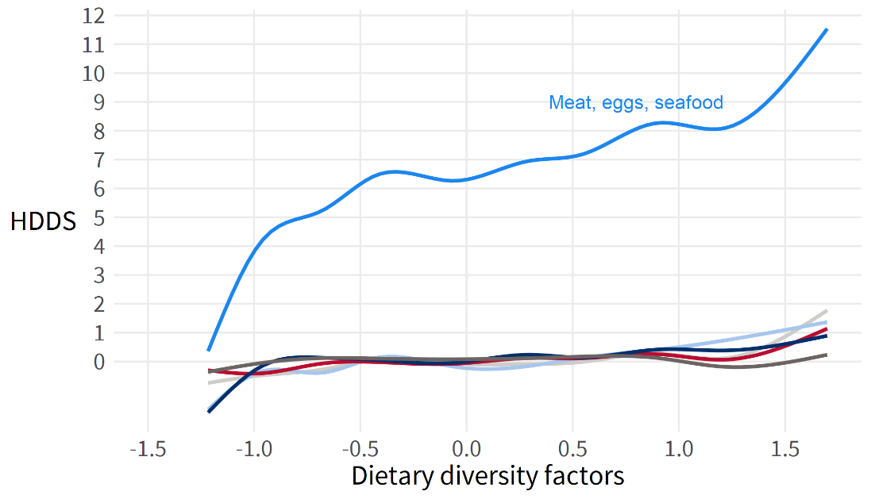

Return to Household Dietary Diversity.

### Personal Agency

#### Aspirations

Parallel analysis identifies the existence of three factors and a single principal component representing the six aspirational items defined in Tango (2018). The following table shows the principal component loadings, as well as the difficulty and discrimination parameters from item response theory.

Table . Aspirations Items, Principal Component Loadings

| **Item** | **Description** | **PC1** | **Difficulty** | **Discrimination** |
| --- | --- | --- | --- | --- |
| 629 | Each person is responsible for his/her own success or failure in life | 0.437 | -4.206 | 0.236 |
| 630 | To be successful one needs to work very hard rather than rely on luck | 0.464 | -9.172 | 0.120 |
| 634 | What is going to happen will happen (reverse-coded) | -0.684 | -0.479 | -7.961 |
| 635 | Many things turn out to be a matter of good or bad fortune (reverse-coded) | -0.564 | -0.659 | -1.453 |
| 632 | Hopeful for children's future | 0.668 | -3.440 | 0.397 |
| 633 | Desire for children to graduate from secondary school | 0.561 | -6.468 | 0.276 |

Note that the loadings do not strongly identify an underlying measurement construct, nor does the item response analysis identify any particular items with a strong discrimination. The aspirations index is not a fully validated construct based on the data.

#### Locus of Control

Parallel analysis suggests the existence of a single factor or principal component representing the three items on locus of control. The following table shows the principal component loadings and parameters from item response theory.

Table . Locus of Control Items, Principal Component Loadings

| **Item** | **Description** | **PC1** | **Difficulty** | **Discrimination** |
| --- | --- | --- | --- | --- |
| 636 | I can mostly determine what will happen in my life | 0.796 | -0.639 | 1.88 |
| 637 | When I get what I want, it is usually because I worked hard for it | 0.827 | -1.139 | 4.01 |
| 638 | My life is determined by my own actions | 0.827 | -1.040 | 2.66 |

Note that the item with the highest discrimination is item 637, agreement with the statement that achievements are earned through hard work.

#### Personal Agency Latent Variable

Personal agency is measured through another analytical round in which the measurement constructs of aspirations and locus of control are used to create another measurement construct of personal agency. Parallel analysis of the aspirations and locus of control indices suggests a single underlying measurement construct. A factor analysis estimates a loading of 0.68 for each item, capturing 46 percent of the variance of the two sub-indices.

### Social Cohesion

#### Bonding Social Capital

Parallel analysis suggests the presence of two factors indicating the break across relatives and non-relatives. The following table presents factor loadings resulting from a factor analysis capturing a single broad measurement construct that includes both relatives and non-relatives.

Table . Bonding Social Capital, Factor Loadings

| **Item** | **Description** | **ML1** | **Difficulty** | **Discrimination** |
| --- | --- | --- | --- | --- |
| 490 | Able to lean on relatives in community (Bonding) | 0.980 | -0.0912 | 14.94 |
| 491 | Able to help relatives in community (recode) (Bonding) | 0.978 | 0.0211 | 6.65 |
| 494 | Able to lean on non-relatives in community (Bonding) | 0.748 | 0.0225 | 21.40 |
| 495 | Able to help non-relatives in community (recode) (Bonding) | 0.788 | 0.1256 | 14.73 |

#### Bridging Social Capital

Parallel analysis suggests the presence of two factors or one principal component. The following table presents loadings for a factor analysis capturing a single measurement construct.

Table . Bridging Social Capital, Factor Loadings

| **Item** | **Description** | **ML1** | **Difficulty** | **Discrimination** |
| --- | --- | --- | --- | --- |
| 492 | Able to lean on relatives outside community (Bridging) | 0.983 | -0.032 | 24.66 |
| 493 | Able to help relatives outside community (recode) (Bridging) | 0.971 | 0.099 | 6.02 |
| 496 | Able to lean on non-relatives outside community (Bridging) | 0.785 | 0.007 | 21.47 |
| 97 | Able to help non-relatives outside community (recode) (Bridging) | 0.820 | 0.109 | 14.82 |

#### Social Cohesion Latent Variable

Social cohesion is measured through another analytical round in which the measurement constructs of bonding and bridging social capital are used to create the final measurement construct of social cohesion. Parallel analysis of the bonding and bridging social capital indices suggests a single underlying measurement construct. A factor analysis estimates a loading of 0.85 for each item, capturing 73 percent of the variance of the two sub-indices.

### Shocks and Stresses

The shock severity is the sum of two ordinal variables on a 4-point scale, asking about the severity of the shock on the household’s economic situation and food consumption. The ordinal scale progresses from Not Severe (1), to Somewhat Severe (2), Severe (3), and Extremely Severe (4). Shocks that were not reported by the household were coded as 0. As a result, the severity of the shock will be scaled by its incidence.[10] Note further that by the nature of the scale, frequencies jump from 0 (no incidence of the shock) to two (responding Not Severe on both ordinal items). Mean values above four may be considered severe, while mean values above six may be considered extremely severe. The following table reports the mean value of reported severity for each shock.

Table . Mean Shock Severity

| **Shock** | **Mean severity (0-8)** |
| --- | --- |
| Increase in food prices | 5.69 |
| Floods | 5.27 |
| Livestock disease | 3.56 |
| Erosion | 3.53 |
| Drought | 3.20 |
| Loss of land | 3.18 |
| No livestock inputs | 3.13 |
| Unable to sell | 3.09 |
| Theft | 3.07 |
| Livestock theft | 2.87 |
| Illness in household | 2.51 |
| Crop disease | 2.50 |
| No crop inputs | 2.50 |
| Crop pests | 2.37 |
| Death in household | 1.57 |
| Crop theft | 1.46 |

Figure . Most Common Shocks by County

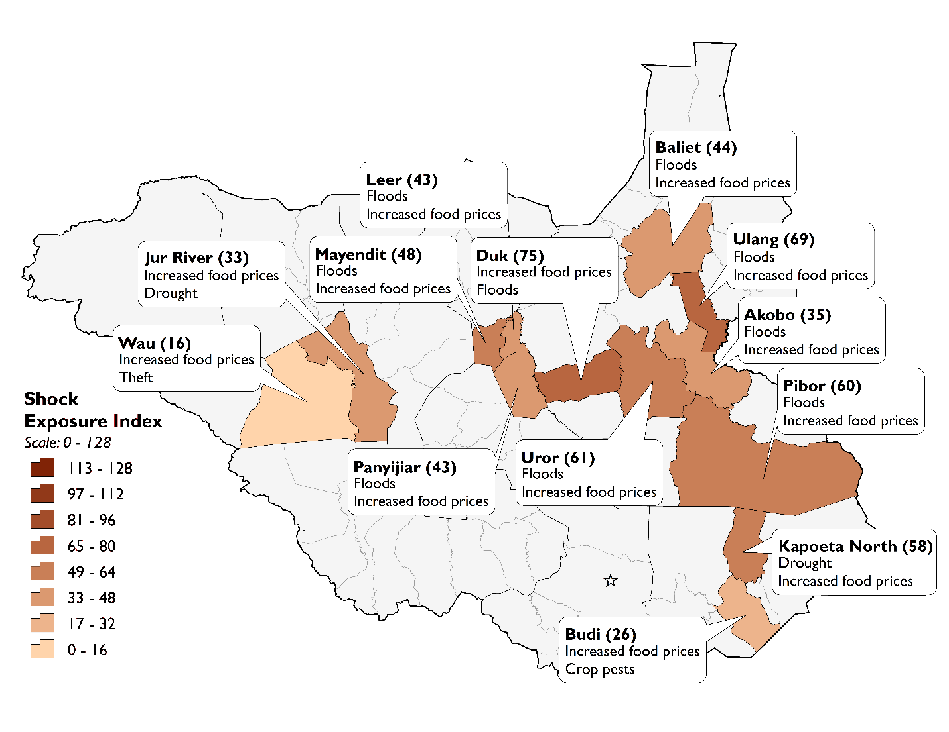

The following factor loadings are based on the 0-8 severity scale.

Table . Shocks Severity, Factor Loadings

| **Shock** | **ML2** | **ML1** | **ML3** | **ML5** | **ML4** |
| --- | --- | --- | --- | --- | --- |
| Floods | -0.02 | 0.06 | 0.62 | 0.00 | -0.02 |
| Drought | 0.24 | 0.05 | 0.22 | -0.01 | 0.16 |
| Erosion | 0.02 | 0.00 | 0.89 | 0.00 | -0.03 |
| Loss of land | -0.02 | -0.03 | 0.84 | 0.00 | 0.06 |
| Increase in food prices | 0.06 | 0.05 | 0.49 | 0.04 | 0.00 |
| Theft | -0.05 | 0.07 | 0.14 | 0.04 | 0.64 |
| No crop inputs | 0.82 | 0.04 | -0.02 | -0.02 | 0.04 |
| Crop disease | 0.94 | 0.01 | 0.01 | 0.01 | -0.06 |
| Crop pests | 0.92 | -0.01 | 0.01 | 0.01 | -0.03 |
| Crop theft | 0.55 | -0.02 | -0.02 | 0.05 | 0.38 |
| No livestock inputs | 0.00 | 0.93 | 0.01 | -0.07 | 0.03 |
| Livestock disease | 0.02 | 0.93 | 0.00 | 0.01 | -0.07 |
| Livestock theft | 0.01 | 0.63 | -0.04 | 0.16 | 0.19 |
| Unable to sell | 0.02 | 0.65 | 0.07 | 0.18 | 0.02 |
| Illness in household | -0.01 | 0.07 | 0.00 | 0.79 | -0.04 |
| Death in household | 0.03 | -0.05 | 0.02 | 0.69 | 0.04 |

Return to Shocks and Stresses.

### Social Norms

Cattle raiding, early marriage, and SGBV are negative social norms which overall are broadly accepted. The figure below illustrates the acceptability of each norm by county. The county-by-county variation for each were discussed in the Findings section.

Figure 10. Acceptability of Negative Social Norms by County



A series of regressions examined the independent variables correlated with acceptability of cattle raiding, early marriage, SGBV, and girls’ education. All four regressions used the same 10 independent variables: locality (i.e., urban relative to rural), road distance in miles, primary education relative to no education, secondary education relative to no education, tertiary education relative to no education, an early marriage in the household, household size, shock exposure, household group participation, and experience of conflict in the last six months. In the table below, the statistically significant correlations between the independent variables and the outcomes are highlighted in green.

Eight variables have statistically significant correlations to the acceptability of cattle raiding. Road distance has a positive correlation. As the households’ distance from roads in their EAs increase the acceptability of cattle raiding increases. Primary education and secondary education relative to no education have negative correlations meaning that households in which the highest level of education is primary or secondary find cattle raiding less acceptable than households in which the highest level of education is none. If a household has an early marriage within it, then this is correlated with greater acceptance of cattle raiding. For household size the correlation is negative in which as household size increases the acceptability of cattle raiding decreases. Shock exposure and conflict incidence have positive correlations meaning as households’ exposure to shocks and incidence of conflict increases these are correlated with greater acceptability of cattle raiding. Group participation also has a positive correlation. In this case, households that participate in a community social group are correlated with greater acceptance of cattle raiding than households that do not participant in any community social group.

There were six variables with statistically significant correlations to the acceptability of early marriage. Road distance has a positive correlation. As the households’ distance from roads in theirs EAs increase the acceptability of early marriage increases. Primary education relative to no education has a negative correlation meaning that households in which the highest level of education is primary find early marriage less acceptable than households in which the highest level of education is none. For household size the correlation is negative in which as household size increases the acceptability of early marriage decreases. Shock exposure and conflict incidence have positive correlations meaning as households’ exposure to shocks and incidence of conflict increases these are correlated with greater acceptability of early marriage. Group participation also has a positive correlation. In this case, households that participate in a community social group are correlated with greater acceptance of early marriage than households that do not participant in any community social group.

There were three variables with statistically significant correlations to the acceptability of SGBV. Secondary education relative to no education has a negative correlation meaning that households in which the highest level of education is secondary find SGBV less acceptable than households in which the highest level of education is none. Shock exposure has a positive correlation meaning as households’ exposure to shocks increases it is correlated with greater acceptability of SGBV. Group participation also has a positive correlation. In this case, households that participate in a community social group are correlated with greater acceptance of SGBV than households that do not participant in any community social group.

None of the variables were correlated with acceptability of girls’ education.

Table 34. Independent Variables Correlated with Social Norms

|  |  |  |  |  |  |  |  |  |
| --- | --- | --- | --- | --- | --- | --- | --- | --- |
| **Independent Variable** | **Cattle Raiding** | | **Early Marriage** | | **SGBV** | | **Girls' Education** | |
| **Coeff.** | **P-value** | **Coeff.** | **P-value** | **Coeff.** | **P-value** | **Coeff.** | **P-value** |
| Locality | 0.04 | 0.22 | 0.01 | 0.75 | 0.07 | 0.05 | 0.02 | 0.18 |
| Road Distance | 0.01 | 0.00 | 0.01 | 0.00 | 0.00 | 0.55 | 0.00 | 0.86 |
| Education - Primary | -0.12 | 0.00 | -0.05 | 0.05 | 0.01 | 0.79 | -0.04 | 0.08 |
| Education - Secondary | -0.09 | 0.00 | -0.04 | 0.32 | -0.09 | 0.02 | -0.05 | 0.08 |
| Education - Tertiary | -0.03 | 0.42 | 0.05 | 0.21 | 0.04 | 0.39 | -0.02 | 0.35 |
| Early Marriage | 0.07 | 0.03 | 0.03 | 0.36 | 0.04 | 0.35 | -0.04 | 0.22 |
| Household Size | -0.01 | 0.00 | -0.02 | 0.00 | 0.00 | 0.43 | 0.00 | 0.53 |
| Shock Exposure | 0.00 | 0.00 | 0.00 | 0.00 | 0.00 | 0.00 | 0.00 | 0.79 |
| Group Participation | 0.20 | 0.00 | 0.19 | 0.00 | 0.11 | 0.02 | 0.01 | 0.49 |
| Experience Conflict | 0.13 | 0.00 | 0.10 | 0.00 | -0.01 | 0.58 | -0.02 | 0.29 |

### Informal Safety Nets

Informal safety nets as a component of absorptive resilience capacity is captured in the current study by membership in community-based groups (survey items 501a-p). The following table shows the frequencies of group participation.

Table . Group Membership, Frequencies

| **Item** | **Group** | **Percent** |
| --- | --- | --- |
| 501g | Religious | 67% |
| 501j | Youth | 63% |
| 501i | Women | 62% |
| 501n | Cattle herding | 59% |
| 501o | Cattle protection | 58% |
| 501h | Mothers | 55% |
| 501p | Small animal herding | 46% |
| 501b | Grazing land users | 40% |
| 501a | Water users | 40% |
| 501k | Sports | 37% |
| 501m | Cattle raiding | 36% |
| 501l | Disaster planning | 28% |
| 501c | Community natural resources | 25% |
| 501f | Mutual help | 20% |
| 501d | Credit/microfinance | 9% |
| 501e | Savings | 8% |

Participation in religious and youth groups are most common, while savings and credit groups are least common. Parallel analysis suggests the presence of five distinct factors, or what may be termed group membership profiles. The following table shows the individual factor loadings that determined the assignment of group membership to a group membership profile.

Table . Group Membership, Factor Loadings

| **Group** | **ML3** | **ML4** | **ML2** | **ML1** | **ML5** | **Difficulty** | **Discrimination** |
| --- | --- | --- | --- | --- | --- | --- | --- |
| Water users | 0.02 | 0.08 | 0.20 | 0.08 | 0.40 | 0.54 | 0.91 |
| Grazing land users | 0.56 | -0.01 | 0.01 | 0.07 | 0.35 | 0.48 | 2.27 |
| Community natural resources | 0.02 | 0.04 | 0.02 | 0.03 | 0.91 | 1.29 | 1.56 |
| Credit/microfinance | 0.19 | -0.09 | 0.66 | 0.06 | 0.17 | 2.05 | 1.38 |
| Savings | -0.02 | 0.03 | 1.00 | 0.02 | -0.03 | 2.55 | 1.05 |
| Mutual help | -0.06 | 0.16 | 0.35 | -0.11 | 0.43 | 1.95 | 0.95 |
| Religious | 0.09 | 0.51 | 0.09 | 0.22 | -0.10 | -0.91 | 1.13 |
| Mothers | 0.01 | 0.88 | -0.04 | -0.02 | 0.10 | -0.05 | 1.43 |
| Women | 0.00 | 0.97 | 0.04 | 0.00 | -0.03 | -0.32 | 1.41 |
| Youth | 0.27 | 0.39 | -0.08 | 0.42 | 0.05 | -0.33 | 1.94 |
| Sports | -0.04 | 0.02 | 0.05 | 0.98 | 0.01 | 0.32 | 1.05 |
| Disaster planning | 0.34 | 0.05 | 0.01 | 0.37 | 0.21 | 0.92 | 1.66 |
| Cattle raiding | 0.86 | -0.05 | -0.02 | 0.07 | 0.01 | 0.71 | 2.40 |
| Cattle herding | 0.99 | 0.05 | 0.01 | -0.07 | -0.01 | 0.04 | 6.24 |
| Cattle protection | 0.99 | 0.01 | 0.02 | -0.07 | 0.02 | 0.04 | 5.49 |
| Small animal herding | 0.76 | 0.04 | 0.06 | 0.17 | -0.07 | 0.21 | 2.64 |

The strongest group membership profile relates to animal herding and protection (ML3). Taken together, the five group membership profiles capture 75 percent of the total variance of membership across all 16 groups. The following table shows the share of total variance each profile accounts for.

Table . Group Membership Profiles

|  |  |  |
| --- | --- | --- |
| **Factor** | **Factor Description** | **Total Variance Captured** |
| ML3 | Cattle herding/protection/raiding, animal herding | 0.26 |
| ML4 | Women’s group, mothers’ group, religious group | 0.16 |
| ML2 | Savings group, credit group | 0.12 |
| ML1 | Sports group, youth group | 0.11 |
| ML5 | Natural resource management, self-help, water, land management | 0.11 |

Measures of model fit (Tucker Lewis Index 86 percent, RMSEA .14) are good but do not meet desired benchmarks.

In order to generate the overall measure of group membership, the five group membership profiles are again entered into a factor analysis in order to extract a single broad measure of group participation. The following table shows the factor loadings of each profile.

Table . Group Membership, Factor Loadings

|  |  |  |
| --- | --- | --- |
| **Factor Variable** | **Description** | **ML1** |
| grp_fac_cattle | Cattle/herding | 0.67 |
| grp_fac_women | Women/Mothers | 0.68 |
| grp_fac_finance | Savings/Credit | 0.55 |
| grp_fac_sports | Sports/Youth | 0.57 |
| grp_fac_nature | Natural resource management | 0.69 |

The overall group membership factor is standardized to have a mean of zero and standard deviation one, and then rescaled 0-100 in order to restore some degree of interpretation. The baseline value of 32.5 indicates that overall group participation is low to moderate.

### Early Warning Systems

Early warning systems as a component of absorptive resilience capacity is captured in the current study by receiving information about any risk factor facing the respondent’s community in the previous 12 months (survey items 607a-k). The following table shows the frequencies of early warning system prevalence.

Table . Early Warning Systems, Frequencies

| **Group** | **Percent** |
| --- | --- |
| Food prices | 45.4% |
| Conflict | 42.8% |
| Upcoming rainfall | 39.8% |
| Animal product prices | 38.3% |
| Livestock prices | 34.1% |
| Natural hazards | 32.8% |
| Grazing conditions | 32.5% |
| Weather patterns | 30.1% |
| Water prices/availability | 25.7% |
| Crop health | 25.0% |
| Animal health | 24.6% |

Early warning systems are most common for food prices, conflict, and rainfall. Parallel analysis suggests the presence of four distinct factors, or what may be termed early warning system profiles. The following table shows the individual factor loadings that determined the assignment of an early warning system to an early warning system profile.

Table . Early Warning Systems, Factor Loadings

| **Early Warning System** | **ML3** | **ML4** | **ML1** | **ML2** | **Difficulty** | **Discrimination** |
| --- | --- | --- | --- | --- | --- | --- |
| Natural hazards | -0.02 | 0.82 | -0.01 | 0.06 | 0.64 | 1.67 |
| Weather patterns | -0.05 | 0.97 | 0.03 | -0.05 | 0.80 | 1.96 |
| Upcoming rainfall | 0.10 | 0.82 | -0.02 | 0.04 | 0.51 | 2.16 |
| Water prices/availability | 0.41 | 0.27 | 0.11 | 0.05 | 1.02 | 1.88 |
| Animal health | -0.02 | -0.03 | 1.03 | -0.01 | 0.78 | 1.91 |
| Crop health | 0.04 | 0.05 | 0.83 | 0.04 | 0.78 | 1.97 |
| Livestock prices | 0.90 | 0.00 | 0.06 | -0.02 | 0.62 | 2.44 |
| Animal product prices | 1.00 | -0.01 | 0.00 | -0.05 | 0.48 | 2.40 |
| Grazing conditions | 0.44 | 0.26 | 0.10 | 0.20 | 0.78 | 2.61 |
| Conflict | 0.00 | 0.01 | 0.03 | 0.98 | 0.45 | 1.80 |
| Food prices | 0.69 | -0.01 | -0.06 | 0.22 | 0.14 | 1.71 |

The strongest early warning profile relates to animal product and livestock prices (ML3). Taken together, the four early warning profiles capture 80 percent of the total variance of early warning systems across all 11 groups. The following table shows the share of total variance each profile accounts for.

Table . Early Warning Profiles

|  |  |  |
| --- | --- | --- |
| **Factor** | **Factor Description** | **Total Variance Captured** |
| ML3 | Animal product/livestock/food prices | 0.27 |
| ML4 | Natural hazards / weather | 0.24 |
| ML1 | Animal/crop health | 0.17 |
| ML2 | Conflict | 0.11 |

Measures of model fit (Tucker Lewis Index 95 percent, RMSEA .10) approach desired benchmarks.

In order to generate the overall measure of participation in early warning systems, the four early warning profiles are again entered into a factor analysis in order to extract a single broad measure of early warning system participation. The following table shows the factor loadings of each profile.

Table . Early Warning Systems Participation, Factor Loadings

|  |  |  |
| --- | --- | --- |
| **Variable** | **Factor** | **ML1** |
| ews_fac_prices | Animal product/livestock/food prices | 0.71 |
| ews_fac_weather | Natural hazards / weather | 0.75 |
| ews_fac_farming | Animal/crop health | 0.76 |
| ews_fac_conflict | Conflict | 0.72 |

The overall early warning factor is standardized to have a mean of zero and standard deviation one, and then rescaled 0-100 in order to restore some degree of interpretation. The baseline value of 35.2 indicates that overall early warning system participation is low to moderate.

### Disaster Planning

Emergency action planning as a component of absorptive resilience capacity is captured in the current study by four survey items (610-612, 501l) asking whether the respondent’s community has an emergency action plan in place (610), if so then whether or not the plan addressed any shock the household faced in the past year (611), and again if so then whether or not the emergency plan was successful in mitigating the effect of the shock (612). Finally, the survey module on group membership includes a disaster planning group (501l). The following table shows the frequencies of emergency action planning prevalence.

Table . Emergency Action Planning, Frequencies

| **Survey item** | **Description** | **Percent** |
| --- | --- | --- |
| q501l | Disaster planning group in community | 28.0% |
| q610 | Emergency action plan in place | 24.5% |
| q611 | Emergency plan addressed shock that household faced | 19.3% |
| q612 | Emergency plan successfully mitigated effect of shock | 7.4% |

The extent of emergency planning declines as one progresses from the existence of a disaster planning group in the community, to the presence of an emergency action plan, and the utility of that plan to the household’s actual shocks in the past year. Parallel analysis suggests the presence of a single broad factor of emergency action planning. The following table shows the loadings.

Table . Emergency Action Planning, Factor Loadings

| **Item** | **Description** | **ML1** | **Difficulty** | **Discrimination** |
| --- | --- | --- | --- | --- |
| q610 | Emergency action plan in place | 0.83 | 0.70 | 34.21 |
| q611 | Emergency plan addressed shock that household faced | 0.99 | 1.03 | 51.98 |
| q612 | Emergency plan successfully mitigated effect of shock | 0.64 | 1.41 | 22.98 |
| q501l | Disaster planning group in community | 0.16 | 2.15 | 0.52 |

This broad factor captures 53 percent of the total variance of all four survey items. Measures of model fit (Tucker Lewis Index 96 percent, RMSEA 0.11) approach desired benchmarks.

### Resilience

Table . Resilience Model Output, Ability To Recover

|  |  |
| --- | --- |
| Ordered probit model, ability to recover from shocks | |
|  | Ability to Recover (2-6) | | | |
| *Predictors* | *Estimate* | *std. Error* | *CI* | *P* |
| Absorptive Resilience Capacity (0-100) | 0.35 | 0.05 | 0.25 – 0.45 | **<0.001** |
| Household involved in conflict (0/1) | -0.13 | 0.08 | -0.29 – 0.04 | 0.125 |
| Shock Exposure Index (0-128) | -0.01 | 0.00 | -0.01 – -0.01 | **<0.001** |
| Household size (1-25) | -0.01 | 0.01 | -0.03 – 0.01 | 0.247 |
| Female-headed household (0/1) | -0.08 | 0.06 | -0.20 – 0.03 | 0.156 |
| Urban locality (0/1) | -0.02 | 0.10 | -0.22 – 0.17 | 0.832 |
| Observations | 3385 | | | |

Table . Resilience Model Output, Food Insecurity

|  |  |  |  |  |
| --- | --- | --- | --- | --- |
| Linear probability model, food insecurity | | | | |
|  | Went to bed hungry (0/1) | | | |
| *Predictors* | *Estimate* | *std. Error* | *CI* | *p* | |
| Absorptive Resilience Capacity (-1 to 3) | -0.051 | 0.023 | -0.096 – -0.006 | **0.027** | |
| Household involved in conflict (0/1) | 0.053 | 0.019 | 0.014 – 0.091 | **0.007** | |
| Shock Exposure Index (0-128) | 0.003 | 0.000 | 0.002 – 0.004 | **<0.001** | |
| Household size (1-25) | -0.000 | 0.004 | -0.007 – 0.007 | 0.944 | |
| Female-headed household (0/1) | 0.014 | 0.017 | -0.020 – 0.048 | 0.427 | |
| Urban locality (0/1) | 0.019 | 0.031 | -0.041 – 0.079 | 0.540 | |
| Observations | 3525 | | | |
| R2 / R2 adjusted | 0.195 / -7.593 | | | |

Table . Components of Resilience Model Output, Food Insecurity

|  |  |  |  |  |
| --- | --- | --- | --- | --- |
| Components of absorptive capacity, food insecurity | | | | |
|  | Went to bed hungry (0/1) | | | |
| *Predictors* | *Estimate* | *std. Error* | *CI* | *p* |
| Group participation (-1 to 3) | -0.060 | 0.020 | -0.100 – -0.019 | **0.004** |
| Bonding social capital | -0.016 | 0.009 | -0.033 – 0.002 | 0.077 |
| Access to remittances | -0.089 | 0.031 | -0.150 – -0.028 | **0.004** |
| Early warning systems | 0.041 | 0.013 | 0.016 – 0.067 | **0.001** |
| Emergency action planning | 0.007 | 0.008 | -0.008 – 0.023 | 0.332 |
| Access to humanitarian aid | -0.055 | 0.018 | -0.090 – -0.021 | **0.002** |
| Shock Exposure Index (0-128) | 0.003 | 0.000 | 0.002 – 0.004 | **<0.001** |
| Experienced conflict (0/1) | 0.047 | 0.019 | 0.011 – 0.084 | **0.012** |
| Household size (1-25) | 0.000 | 0.003 | -0.006 – 0.007 | 0.939 |
| Female-headed household (0/1) | 0.018 | 0.016 | -0.014 – 0.050 | 0.271 |
| Urban locality (0/1) | 0.009 | 0.029 | -0.048 – 0.067 | 0.752 |
| Observations | 3525 | | | |
| R2 / R2 adjusted | 0.220 / -7.457 | | | |

Return to Resilience.

## Annex C. Detailed Indicators

Table . Consolidated Indicator Summary

|  |  |  |  |  |
| --- | --- | --- | --- | --- |
|  |  |  |  |  |
| **No** | **Theme** | **Indicator** | **Scale** | **Overall** |
| 1 | - | Level of knowledge of organizations doing humanitarian or development work in the community | Percent Yes | 44% |
| 2 | Agency | Aspirations index | 0 to 100 | 76.6 |
| 3 | - | Percent of households reporting participation in community groups | Percent Yes | 86% |
| 4 | - | Percent of households reporting symptoms of trauma | Percent Yes | 77% |
| 5 | - | Local perception of quality of available health services | Percent Fair or Better | 65% |
| 6 | - | Household diversity of income-earning sources | First Ranked Choice | Own farming/crop production and sales |
| 7 | Social Norms | Local perception of SGBV | Percent Acceptable | 61% |
| 8 | Food Security | Household Dietary Diversity Scale | 0 to 12 | 6.4 |
| 9 | Shocks and Stresses | Number of reported conflicts | Percent Yes | 38% |
| 10 | - | Severity of reported conflicts (deaths, loss of assets, displacements) | Percent Worst Ever | 46% |
| 11 | Social Cohesion | Level of bonding social capital, among members of targeted communities | 0 to 100 | 43.3 |
| 12 | Social Cohesion | Level of bridging social capital, among members of targeted communities | 0 to 100 | 34.6 |
| 13.1 | Social Norms | Level of acceptance of targeted social practices - Cattle Raiding | Percent Acceptable | 75% |
| 13.2 | Social Norms | Level of acceptance of targeted social practices - Early Marriage | Percent Acceptable | 73% |
| 14 | Food Security | Households’ positions on food security scale, within targeted communities | 0 to 8 | 7.6 |
| 15 | - | Perception of usefulness of emergency community action plans | Percent Effective | 38% |
| 16 | Social Norms | Percent of households which report favorable opinions of educating girls | Percent Acceptable | 91% |
| 17 | - | Level of confidence in community and other sub-national institutions that govern natural resources | Percent Confident | 42% |
| 18 | - | Level of acceptance of trafficking in persons | Percent Acceptable | 57% |
| 19 | - | Level of acceptance of the practice of bride prices | Percent Acceptable | 77% |
| 20 | - | Level of confidence in community institutions that oversee humanitarian and development investments | Percent Confident | 51% |
| 21 | - | Proportion of households which participate in an early warning system | Percent Yes | 74% |
| 22 | - | Proportion of children in target areas (9-59 months) vaccinated for measles | Percent Yes | 78% |
| 23 | - | Percent of population that are satisfied with government services | Percent Satisfied | 29% |
| 24 | - | Level of satisfaction with the involvement of traditional leaders in conflict resolution | Percent Satisfied | 38% |
| 25 | - | Perception of improved state/government legitimacy | Percent Acceptable | 48% |
| 26 | - | Ability to recover from shocks and stresses index | 1.9 to 6.2 | 3.8 |
| 27 | Social Cohesion | Social cohesion at the household level | 0 to 100 | 39.0 |
| 28 | - | Belief local government will respond effectively to future shocks and stresses | 0 to 1 | 0.4 |
| - | Agency | Locus of Control | 0 to 100 | 71.4 |
| - | Agency | Agency | 0 to 100 | 74.1 |
| - | Shocks and Stresses | Incidence of Shocks | 0 to 16 | 7.4 |
| - | Shocks and Stresses | Shock Exposure | 0 to 128 | 49.2 |
| - | Resilience | Absorptive Capacity | 0 to 100 | 32.5 |

Table . Food Security Indicators Disaggregated Results

|  |  |  |  |
| --- | --- | --- | --- |
| **Theme: Food Insecurity** | | | |
| **Disaggregate Type** | **Food Insecurity Experience Scale** | **Food Insecurity Category** | **Household Diet Diversity** |
| **Overall** | | | |
| Overall | 7.6 | Severe | 6.4 |
| **Location** | | | |
| Rural | 7.6 | Severe | 5.6 |
| Urban | 7.5 | Severe | 8.0 |
| **Sex** | | | |
| Male-head of household | 7.5 | Severe | 6.3 |
| Female-head of household | 7.5 | Severe | 6.1 |
| **County** | | | |
| Akobo | 7.7 | Severe | 6.1 |
| Baliet | 7.6 | Severe | 5.6 |
| Budi | 7.1 | Severe | 4.0 |
| Duk | 7.7 | Severe | 6.2 |
| Jur River | 7.2 | Severe | 5.2 |
| Kapoeta North | 7.8 | Severe | 6.7 |
| Leer | 7.9 | Severe | 6.3 |
| Mayendit | 7.7 | Severe | 6.0 |
| Panyijar | 7.6 | Severe | 5.8 |
| Pibor | 7.9 | Severe | 9.4 |
| Ulang | 7.8 | Severe | 5.8 |
| Uror | 7.8 | Severe | 5.0 |
| Wau | 6.4 | Moderate | 6.1 |
| **Region** | | | |
| Bahr El-Ghazel | 6.7 | Moderate | 5.9 |
| Equatoria | 7.4 | Severe | 5.2 |
| Great Upper Nile | 7.8 | Severe | 6.7 |
| **State** | | | |
| Eastern Equatoria | 7.4 | Severe | 5.2 |
| Jonglei | 7.8 | Severe | 6.9 |
| Unity | 7.7 | Severe | 6.0 |
| Upper Nile | 7.7 | Severe | 5.7 |
| Western Bahr El-Ghazel | 6.7 | Moderate | 5.9 |
| **Language** | | | |
| Nuer | 7.8 | Severe | 5.5 |
| Dinka | 7.5 | Severe | 5.9 |
| Toposa | 7.8 | Severe | 6.7 |
| Didinga | 7.1 | Severe | 4.0 |
| Other | 7.4 | Severe | 8.2 |

Table . Personal Agency Indicators Disaggregated Results

|  |  |  |  |
| --- | --- | --- | --- |
| **Theme: Personal Agency** | | | |
| **Disaggregate Type** | **Aspirations** | **Locus of Control** | **Agency** |
| **Overall** | | | |
| Overall | 76.6 | 71.4 | 74.1 |
| **Location** | | | |
| Rural | 75.1 | 70.2 | 72.8 |
| Urban | 79.7 | 74.1 | 77.0 |
| **Sex** | | | |
| Male-head of household | 75.6 | 67.5 | 71.8 |
| Female-head of household | 74.6 | 70.7 | 72.7 |
| **County** | | | |
| Akobo | 74.9 | 68.7 | 72.0 |
| Baliet | 86.4 | 87.3 | 86.8 |
| Budi | 76.3 | 70.5 | 73.6 |
| Duk | 92.4 | 86.3 | 89.5 |
| Jur River | 65.6 | 65.7 | 65.7 |
| Kapoeta North | 81.9 | 79.1 | 80.6 |
| Leer | 75.6 | 68.2 | 72.1 |
| Mayendit | 72.5 | 64.8 | 69.1 |
| Panyijar | 66.5 | 58.6 | 62.6 |
| Pibor | 88.3 | 81.1 | 84.9 |
| Ulang | 74.5 | 71.5 | 73.3 |
| Uror | 67.1 | 62.3 | 64.9 |
| Wau | 73.3 | 69.0 | 71.5 |
| **Region** | | | |
| Bahr El-Ghazel | 70.8 | 67.9 | 69.6 |
| Equatoria | 79.0 | 74.5 | 76.9 |
| Great Upper Nile | 77.1 | 71.5 | 74.4 |
| **State** | | | |
| Eastern Equatoria | 79.0 | 74.5 | 76.9 |
| Jonglei | 77.8 | 72.0 | 75.0 |
| Unity | 71.5 | 63.8 | 67.9 |
| Upper Nile | 80.3 | 79.2 | 80.0 |
| Western Bahr El-Ghazel | 70.8 | 67.9 | 69.6 |
| **Language** | | | |
| Nuer | 70.4 | 64.6 | 67.7 |
| Dinka | 83.5 | 84.2 | 83.9 |
| Toposa | 81.9 | 79.2 | 80.7 |
| Didinga | 76.9 | 70.3 | 73.8 |
| Other | 82.2 | 75.9 | 79.3 |

Table . Social Cohesion Indicators Disaggregated Results

|  |  |  |  |
| --- | --- | --- | --- |
| **Theme: Social Cohesion** | | | |
| **Disaggregate Type** | **Bonding Social Capital** | **Bridging Social Capital** | **Social Cohesion** |
| **Overall** | | | |
| Overall | 43.3 | 34.6 | 39.0 |
| **Location** | | | |
| Rural | 44.6 | 37.9 | 41.3 |
| Urban | 40.6 | 27.7 | 34.1 |
| **Sex** | | | |
| Male-head of household | 38.6 | 25.5 | 32.0 |
| Female-head of household | 43.5 | 33.4 | 38.3 |
| **County** | | | |
| Akobo | 59.8 | 38.1 | 49.0 |
| Baliet | 62.5 | 56.6 | 59.6 |
| Budi | 70.3 | 66.8 | 68.6 |
| Duk | 51.7 | 41.7 | 46.8 |
| Jur River | 30.8 | 29.9 | 30.4 |
| Kapoeta North | 45.0 | 37.9 | 41.4 |
| Leer | 44.8 | 53.8 | 49.3 |
| Mayendit | 28.3 | 25.3 | 26.8 |
| Panyijar | 30.4 | 28.3 | 29.3 |
| Pibor | 50.9 | 32.9 | 41.9 |
| Ulang | 45.7 | 32.4 | 38.9 |
| Uror | 33.1 | 28.4 | 30.9 |
| Wau | 20.8 | 14.5 | 17.6 |
| **Region** | | | |
| Bahr El-Ghazel | 23.9 | 19.2 | 21.5 |
| Equatoria | 58.5 | 53.4 | 56.0 |
| Great Upper Nile | 44.0 | 33.9 | 39.0 |
| **State** | | | |
| Eastern Equatoria | 58.5 | 53.4 | 56.0 |
| Jonglei | 44.6 | 32.3 | 38.5 |
| Unity | 34.5 | 35.8 | 35.2 |
| Upper Nile | 53.8 | 44.1 | 48.9 |
| Western Bahr El-Ghazel | 23.9 | 19.2 | 21.5 |
| **Language** | | | |
| Nuer | 39.4 | 32.6 | 36.0 |
| Dinka | 49.8 | 45.4 | 47.7 |
| Toposa | 45.0 | 38.0 | 41.5 |
| Didinga | 71.1 | 68.3 | 69.9 |
| Other | 40.1 | 26.4 | 33.2 |

Table . Shocks and Stresses Indicators Disaggregated Results

|  |  |  |  |
| --- | --- | --- | --- |
| **Theme: Shocks and Stresses** | | | |
| **Disaggregate Type** | **Incidence of Shocks and Stresses** | **Exposure to Shocks and Stresses** | **Incidence of Conflict** |
| **Overall** | | | |
| Overall | 7.4 | 49.2 | 38% |
| **Location** | | | |
| Rural | 7.5 | 51.0 | 32% |
| Urban | 7.2 | 45.4 | 49% |
| **Sex** | | | |
| Male-head of household | 6.9 | 44.4 | 45% |
| Female-head of household | 6.2 | 41.4 | 34% |
| **County** | | | |
| Akobo | 4.8 | 34.7 | 36% |
| Baliet | 6.3 | 44.3 | 8% |
| Budi | 4.2 | 26.1 | 17% |
| Duk | 10.9 | 75.0 | 32% |
| Jur River | 6.1 | 32.9 | 13% |
| Kapoeta North | 8.8 | 57.6 | 51% |
| Leer | 6.2 | 43.0 | 18% |
| Mayendit | 6.7 | 48.2 | 11% |
| Panyijar | 5.9 | 43.0 | 16% |
| Pibor | 9.6 | 59.9 | 67% |
| Ulang | 9.3 | 69.0 | 26% |
| Uror | 8.7 | 61.2 | 42% |
| Wau | 3.0 | 16.4 | 23% |
| **Region** | | | |
| Bahr El-Ghazel | 4.0 | 21.4 | 20% |
| Equatoria | 6.4 | 40.8 | 33% |
| Great Upper Nile | 8.3 | 56.3 | 42% |
| **State** | | | |
| Eastern Equatoria | 6.4 | 40.8 | 33% |
| Jonglei | 8.7 | 58.4 | 50% |
| Unity | 6.3 | 44.7 | 15% |
| Upper Nile | 7.8 | 57.1 | 17% |
| Western Bahr El-Ghazel | 4.0 | 21.4 | 20% |
| **Language** | | | |
| Nuer | 7.7 | 54.3 | 33% |
| Dinka | 8.0 | 53.0 | 21% |
| Toposa | 8.8 | 57.6 | 51% |
| Didinga | 4.2 | 26.6 | 17% |
| Other | 7.4 | 45.2 | 50% |

Table . Social Norms Indicators Disaggregated Results

|  |  |  |  |  |
| --- | --- | --- | --- | --- |
| **Theme: Social Norms** | | | | |
| **Disaggregate Type** | **Acceptance of SGBV** | **Acceptance of Cattle Raiding** | **Acceptance of Girls' Education** | **Acceptance of Early Marriage** |
| **Overall** | | | | |
| Overall | 61% | 75% | 91% | 73% |
| **Location** | | | | |
| Rural | 60% | 73% | 90% | 71% |
| Urban | 65% | 80% | 92% | 77% |
| **Sex** | | | | |
| Male-head of household | 57% | 77% | 90% | 74% |
| Female-head of household | 60% | 75% | 89% | 73% |
| **County** | | | | |
| Akobo | 51% | 96% | 92% | 84% |
| Baliet | 29% | 53% | 97% | 67% |
| Budi | 19% | 33% | 92% | 24% |
| Duk | 74% | 92% | 99% | 90% |
| Jur River | 56% | 47% | 74% | 57% |
| Kapoeta North | 63% | 85% | 91% | 88% |
| Leer | 73% | 56% | 84% | 66% |
| Mayendit | 55% | 36% | 97% | 58% |
| Panyijar | 77% | 59% | 95% | 57% |
| Pibor | 69% | 98% | 92% | 98% |
| Ulang | 82% | 76% | 94% | 75% |
| Uror | 71% | 87% | 90% | 77% |
| Wau | 53% | 48% | 87% | 47% |
| **Region** | | | | |
| Bahr El-Ghazel | 54% | 48% | 83% | 50% |
| Equatoria | 40% | 57% | 92% | 54% |
| Great Upper Nile | 67% | 84% | 92% | 82% |
| **State** | | | | |
| Eastern Equatoria | 40% | 57% | 92% | 54% |
| Jonglei | 68% | 92% | 92% | 87% |
| Unity | 68% | 51% | 92% | 61% |
| Upper Nile | 56% | 65% | 95% | 71% |
| Western Bahr El-Ghazel | 54% | 48% | 83% | 50% |
| **Language** | | | | |
| Nuer | 68% | 79% | 91% | 75% |
| Dinka | 55% | 68% | 96% | 74% |
| Toposa | 63% | 85% | 91% | 88% |
| Didinga | 17% | 31% | 94% | 21% |
| Other | 63% | 79% | 88% | 80% |

Table . Indicator 1 Disaggregated Results

|  |  |  |
| --- | --- | --- |
| **Level of knowledge of organizations doing humanitarian or development work in the community** | | |
| **Disaggregate Type** | **Percent Responded Yes** | **Observations** |
| **Overall** | | |
| Overall | 44% | 3558 |
| **Location** | | |
| Rural | 43% | 2801 |
| Urban | 48% | 757 |
| **Sex** | | |
| Male-head of household | 43% | 989 |
| Female-head of household | 45% | 592 |
| **County** | | |
| Akobo | 47% | 293 |
| Baliet | 58% | 338 |
| Budi | 59% | 342 |
| Duk | 90% | 469 |
| Jur River | 32% | 176 |
| Kapoeta North | 61% | 368 |
| Leer | 35% | 208 |
| Mayendit | 20% | 145 |
| Panyijar | 46% | 316 |
| Pibor | 55% | 300 |
| Ulang | 34% | 209 |
| Uror | 22% | 122 |
| Wau | 46% | 272 |
| **Region** | | |
| Bahr El-Ghazel | 42% | 448 |
| Equatoria | 60% | 710 |
| Great Upper Nile | 42% | 2400 |
| **State** | | |
| Eastern Equatoria | 60% | 710 |
| Jonglei | 43% | 1184 |
| Unity | 34% | 669 |
| Upper Nile | 46% | 547 |
| Western Bahr El-Ghazel | 42% | 448 |
| **Language** | | |
| Nuer | 31% | 1411 |
| Dinka | 63% | 792 |
| Toposa | 61% | 368 |
| Didinga | 59% | 313 |
| Other | 50% | 644 |

Table . Indicator 3 Disaggregated Results

|  |  |  |
| --- | --- | --- |
| **Percent of households reporting participation in community groups** | | |
| **Disaggregate Type** | **Percent Responded Yes** | **Observations** |
| **Overall** | | |
| Overall | 86% | 6608 |
| **Location** | | |
| Rural | 88% | 5466 |
| Urban | 82% | 1142 |
| **Sex** | | |
| Male-head of household | 89% | 1919 |
| Female-head of household | 83% | 1204 |
| **County** | | |
| Akobo | 92% | 570 |
| Baliet | 84% | 514 |
| Budi | 65% | 458 |
| Duk | 92% | 463 |
| Jur River | 78% | 473 |
| Kapoeta North | 90% | 530 |
| Leer | 89% | 536 |
| Mayendit | 95% | 562 |
| Panyijar | 90% | 546 |
| Pibor | 96% | 524 |
| Ulang | 88% | 545 |
| Uror | 96% | 587 |
| Wau | 48% | 300 |
| **Region** | | |
| Bahr El-Ghazel | 57% | 773 |
| Equatoria | 77% | 988 |
| Great Upper Nile | 94% | 4847 |
| **State** | | |
| Eastern Equatoria | 77% | 988 |
| Jonglei | 96% | 2144 |
| Unity | 91% | 1644 |
| Upper Nile | 86% | 1059 |
| Western Bahr El-Ghazel | 57% | 773 |
| **Language** | | |
| Nuer | 94% | 3459 |
| Dinka | 85% | 1066 |
| Toposa | 90% | 529 |
| Didinga | 64% | 422 |
| Other | 81% | 1095 |

Table . Indicator 4 Disaggregated Results

|  |  |  |
| --- | --- | --- |
| **Percent of households reporting symptoms of trauma** | | |
| **Disaggregate Type** | **Percent Responded Yes** | **Observations** |
| **Overall** | | |
| Overall | 77% | 5483 |
| **Location** | | |
| Rural | 76% | 4389 |
| Urban | 80% | 1094 |
| **Sex** | | |
| Male-head of household | 74% | 1529 |
| Female-head of household | 73% | 1027 |
| **County** | | |
| Akobo | 76% | 453 |
| Baliet | 58% | 365 |
| Budi | 66% | 390 |
| Duk | 91% | 421 |
| Jur River | 42% | 278 |
| Kapoeta North | 77% | 463 |
| Leer | 64% | 377 |
| Mayendit | 72% | 411 |
| Panyijar | 71% | 466 |
| Pibor | 97% | 540 |
| Ulang | 80% | 467 |
| Uror | 82% | 505 |
| Wau | 57% | 347 |
| **Region** | | |
| Bahr El-Ghazel | 52% | 625 |
| Equatoria | 71% | 853 |
| Great Upper Nile | 83% | 4005 |
| **State** | | |
| Eastern Equatoria | 71% | 853 |
| Jonglei | 88% | 1919 |
| Unity | 69% | 1254 |
| Upper Nile | 69% | 832 |
| Western Bahr El-Ghazel | 52% | 625 |
| **Language** | | |
| Nuer | 78% | 2789 |
| Dinka | 67% | 800 |
| Toposa | 77% | 462 |
| Didinga | 64% | 349 |
| Other | 81% | 1041 |

Table . Indicator 5 Disaggregated Results

|  |  |  |
| --- | --- | --- |
| **Local perception of quality of available health services** | | |
| **Disaggregate Type** | **Percent Responded Yes** | **Observations** |
| **Overall** | | |
| Overall | 65% | 3710 |
| **Location** | | |
| Rural | 62% | 2937 |
| Urban | 72% | 773 |
| **Sex** | | |
| Male-head of household | 66% | 1128 |
| Female-head of household | 76% | 743 |
| **County** | | |
| Akobo | 74% | 252 |
| Baliet | 62% | 248 |
| Budi | 95% | 412 |
| Duk | 46% | 206 |
| Jur River | 76% | 311 |
| Kapoeta North | 80% | 340 |
| Leer | 71% | 362 |
| Mayendit | 74% | 296 |
| Panyijar | 54% | 270 |
| Pibor | 65% | 215 |
| Ulang | 58% | 232 |
| Uror | 43% | 169 |
| Wau | 79% | 397 |
| **Region** | | |
| Bahr El-Ghazel | 78% | 708 |
| Equatoria | 88% | 752 |
| Great Upper Nile | 57% | 2250 |
| **State** | | |
| Eastern Equatoria | 88% | 752 |
| Jonglei | 55% | 842 |
| Unity | 66% | 928 |
| Upper Nile | 60% | 480 |
| Western Bahr El-Ghazel | 78% | 708 |
| **Language** | | |
| Nuer | 55% | 1609 |
| Dinka | 58% | 558 |
| Toposa | 80% | 340 |
| Didinga | 95% | 374 |
| Other | 71% | 789 |

Table . Indicator 6 Disaggregated Results

|  |  |  |
| --- | --- | --- |
| **Household diversity of income-earning sources** | | |
|  | **First Ranked Choice** | |
| **Disaggregate Type** | **Percent Ranked** | **Choice** |
| **Overall** | | |
| Overall | 39% | Own farming/crop production and sales |
| **Location** | | |
| Rural | 38% | Own farming/crop production and sales |
| Urban | 41% | Own farming/crop production and sales |
| **Sex** | | |
| Male-head of household | 37% | Own farming/crop production and sales |
| Female-head of household | 38% | Own farming/crop production and sales |
| **County** | | |
| Akobo | 25% | Own fishing and sales |
| Baliet | 31% | Own farming/crop production and sales |
| Budi | 53% | Own farming/crop production and sales |
| Duk | 57% | Own farming/crop production and sales |
| Jur River | 45% | Own farming/crop production and sales |
| Kapoeta North | 58% | Own farming/crop production and sales |
| Leer | 29% | Non-agricultural wage labor (within village) |
| Mayendit | 26% | Own fishing and sales |
| Panyijar | 26% | Own fishing and sales |
| Pibor | 60% | Own cattle production/fattening and sales |
| Ulang | 39% | Own farming/crop production and sales |
| Uror | 45% | Own cattle production/fattening and sales |
| Wau | 39% | Own farming/crop production and sales |
| **Region** | | |
| Bahr El-Ghazel | 41% | Own farming/crop production and sales |
| Equatoria | 55% | Own farming/crop production and sales |
| Great Upper Nile | 38% | Own cattle production/fattening and sales |
| **State** | | |
| Eastern Equatoria | 55% | Own farming/crop production and sales |
| Jonglei | 46% | Own cattle production/fattening and sales |
| Unity | 23% | Own fishing and sales |
| Upper Nile | 35% | Own farming/crop production and sales |
| Western Bahr El-Ghazel | 41% | Own farming/crop production and sales |
| **Language** | | |
| Nuer | 31% | Own cattle production/fattening and sales |
| Dinka | 50% | Own farming/crop production and sales |
| Toposa | 58% | Own farming/crop production and sales |
| Didinga | 55% | Own farming/crop production and sales |
| Other | 47% | Own farming/crop production and sales |

Table . Indicator 10 Disaggregated Results

|  |  |  |
| --- | --- | --- |
| **Severity of reported conflicts (deaths, loss of assets, displacements)** | | |
| **Disaggregate Type** | **Percent Responded Worst Ever** | **Observations** |
| **Overall** | | |
| Overall | 46% | 799 |
| **Location** | | |
| Rural | 41% | 556 |
| Urban | 53% | 243 |
| **Sex** | | |
| Male-head of household | 40% | 264 |
| Female-head of household | 38% | 120 |
| **County** | | |
| Akobo | 43% | 100 |
| Baliet | 6% | 4 |
| Budi | 37% | 41 |
| Duk | 21% | 39 |
| Jur River | 36% | 42 |
| Kapoeta North | 7% | 25 |
| Leer | 35% | 29 |
| Mayendit | 46% | 30 |
| Panyijar | 45% | 43 |
| Pibor | 62% | 224 |
| Ulang | 64% | 71 |
| Uror | 48% | 126 |
| Wau | 19% | 25 |
| **Region** | | |
| Bahr El-Ghazel | 22% | 67 |
| Equatoria | 15% | 66 |
| Great Upper Nile | 53% | 666 |
| **State** | | |
| Eastern Equatoria | 15% | 66 |
| Jonglei | 54% | 489 |
| Unity | 41% | 102 |
| Upper Nile | 53% | 75 |
| Western Bahr El-Ghazel | 22% | 67 |
| **Language** | | |
| Nuer | 48% | 410 |
| Dinka | 16% | 40 |
| Toposa | 7% | 25 |
| Didinga | 37% | 39 |
| Other | 57% | 282 |

Table . Indicator 15 Disaggregated Results

|  |  |  |
| --- | --- | --- |
| **Perception of usefulness of emergency community action plans** | | |
| **Disaggregate Type** | **Percent Responded Effective** | **Observations** |
| **Overall** | | |
| Overall | 38% | 646 |
| **Location** | | |
| Rural | 46% | 549 |
| Urban | 29% | 97 |
| **Sex** | | |
| Male-head of household | 34% | 178 |
| Female-head of household | 39% | 109 |
| **County** | | |
| Akobo | 39% | 43 |
| Baliet | 26% | 45 |
| Budi | 59% | 45 |
| Duk | 61% | 92 |
| Jur River | 58% | 34 |
| Kapoeta North | 50% | 90 |
| Leer | 44% | 36 |
| Mayendit | 87% | 51 |
| Panyijar | 40% | 40 |
| Pibor | 23% | 56 |
| Ulang | 66% | 57 |
| Uror | 49% | 24 |
| Wau | 51% | 33 |
| **Region** | | |
| Bahr El-Ghazel | 53% | 67 |
| Equatoria | 52% | 135 |
| Great Upper Nile | 34% | 444 |
| **State** | | |
| Eastern Equatoria | 52% | 135 |
| Jonglei | 31% | 215 |
| Unity | 56% | 127 |
| Upper Nile | 38% | 102 |
| Western Bahr El-Ghazel | 53% | 67 |
| **Language** | | |
| Nuer | 57% | 184 |
| Dinka | 64% | 147 |
| Toposa | 50% | 90 |
| Didinga | 70% | 42 |
| Other | 26% | 91 |

Table . Indicator 17 Disaggregated Results

|  |  |  |
| --- | --- | --- |
| **Level of confidence in community and other sub-national institutions that govern natural resources** | | |
| **Disaggregate Type** | **Percent Responded Effective** | **Observations** |
| **Overall** | | |
| Overall | 42% | 701 |
| **Location** | | |
| Rural | 53% | 585 |
| Urban | 28% | 116 |
| **Sex** | | |
| Male-head of household | 29% | 183 |
| Female-head of household | 32% | 84 |
| **County** | | |
| Akobo | 21% | 12 |
| Baliet | 47% | 75 |
| Budi | 55% | 58 |
| Duk | 45% | 69 |
| Jur River | 39% | 45 |
| Kapoeta North | 42% | 54 |
| Leer | 54% | 53 |
| Mayendit | 70% | 28 |
| Panyijar | 58% | 121 |
| Pibor | 25% | 54 |
| Ulang | 80% | 75 |
| Uror | 95% | 32 |
| Wau | 36% | 25 |
| **Region** | | |
| Bahr El-Ghazel | 37% | 70 |
| Equatoria | 47% | 112 |
| Great Upper Nile | 41% | 519 |
| **State** | | |
| Eastern Equatoria | 47% | 112 |
| Jonglei | 36% | 167 |
| Unity | 58% | 202 |
| Upper Nile | 60% | 150 |
| Western Bahr El-Ghazel | 37% | 70 |
| **Language** | | |
| Nuer | 81% | 237 |
| Dinka | 57% | 155 |
| Toposa | 42% | 54 |
| Didinga | 55% | 58 |
| Other | 27% | 97 |

Table . Indicator 18 Disaggregated Results

|  |  |  |
| --- | --- | --- |
| **Level of acceptance of trafficking in persons** | | |
| **Disaggregate Type** | **Percent Responded Acceptable** | **Observations** |
| **Overall** | | |
| Overall | 57% | 3832 |
| **Location** | | |
| Rural | 49% | 2875 |
| Urban | 72% | 957 |
| **Sex** | | |
| Male-head of household | 60% | 1222 |
| Female-head of household | 56% | 787 |
| **County** | | |
| Akobo | 75% | 492 |
| Baliet | 14% | 131 |
| Budi | 16% | 122 |
| Duk | 73% | 293 |
| Jur River | 42% | 265 |
| Kapoeta North | 41% | 240 |
| Leer | 41% | 271 |
| Mayendit | 19% | 126 |
| Panyijar | 38% | 262 |
| Pibor | 95% | 522 |
| Ulang | 73% | 458 |
| Uror | 54% | 338 |
| Wau | 43% | 312 |
| **Region** | | |
| Bahr El-Ghazel | 43% | 577 |
| Equatoria | 28% | 362 |
| Great Upper Nile | 65% | 2893 |
| **State** | | |
| Eastern Equatoria | 28% | 362 |
| Jonglei | 74% | 1645 |
| Unity | 33% | 659 |
| Upper Nile | 45% | 589 |
| Western Bahr El-Ghazel | 43% | 577 |
| **Language** | | |
| Nuer | 54% | 2055 |
| Dinka | 42% | 416 |
| Toposa | 41% | 239 |
| Didinga | 13% | 86 |
| Other | 76% | 998 |

Table . Indicator 19 Disaggregated Results

|  |  |  |
| --- | --- | --- |
| **Level of acceptance of the practice of bride prices** | | |
| **Disaggregate Type** | **Percent Responded Acceptable** | **Observations** |
| **Overall** | | |
| Overall | 77% | 6909 |
| **Location** | | |
| Rural | 91% | 5917 |
| Urban | 49% | 992 |
| **Sex** | | |
| Male-head of household | 70% | 1926 |
| Female-head of household | 79% | 1296 |
| **County** | | |
| Akobo | 97% | 599 |
| Baliet | 96% | 589 |
| Budi | 85% | 525 |
| Duk | 98% | 505 |
| Jur River | 82% | 507 |
| Kapoeta North | 93% | 562 |
| Leer | 100% | 616 |
| Mayendit | 96% | 583 |
| Panyijar | 97% | 595 |
| Pibor | 13% | 72 |
| Ulang | 99% | 604 |
| Uror | 99% | 611 |
| Wau | 89% | 541 |
| **Region** | | |
| Bahr El-Ghazel | 87% | 1048 |
| Equatoria | 89% | 1087 |
| Great Upper Nile | 73% | 4774 |
| **State** | | |
| Eastern Equatoria | 89% | 1087 |
| Jonglei | 65% | 1787 |
| Unity | 98% | 1794 |
| Upper Nile | 98% | 1193 |
| Western Bahr El-Ghazel | 87% | 1048 |
| **Language** | | |
| Nuer | 98% | 3721 |
| Dinka | 93% | 1184 |
| Toposa | 93% | 561 |
| Didinga | 86% | 502 |
| Other | 39% | 917 |

Table . Indicator 20 Disaggregated Results

|  |  |  |
| --- | --- | --- |
| **Level of confidence in community institutions that oversee, monitor, or direct humanitarian and development investments** | | |
| **Disaggregate Type** | **Percent Responded Effective** | **Observations** |
| **Overall** | | |
| Overall | 51% | 1179 |
| **Location** | | |
| Rural | 51% | 952 |
| Urban | 53% | 227 |
| **Sex** | | |
| Male-head of household | 55% | 346 |
| Female-head of household | 47% | 178 |
| **County** | | |
| Akobo | 45% | 78 |
| Baliet | 35% | 89 |
| Budi | 60% | 93 |
| Duk | 35% | 193 |
| Jur River | 40% | 47 |
| Kapoeta North | 52% | 68 |
| Leer | 52% | 72 |
| Mayendit | 60% | 22 |
| Panyijar | 53% | 211 |
| Pibor | 57% | 57 |
| Ulang | 64% | 115 |
| Uror | 50% | 56 |
| Wau | 78% | 78 |
| **Region** | | |
| Bahr El-Ghazel | 64% | 125 |
| Equatoria | 56% | 161 |
| Great Upper Nile | 49% | 893 |
| **State** | | |
| Eastern Equatoria | 56% | 161 |
| Jonglei | 48% | 384 |
| Unity | 53% | 305 |
| Upper Nile | 46% | 204 |
| Western Bahr El-Ghazel | 64% | 125 |
| **Language** | | |
| Nuer | 68% | 341 |
| Dinka | 50% | 236 |
| Toposa | 52% | 68 |
| Didinga | 63% | 86 |
| Other | 58% | 137 |

Table . Indicator 21 Disaggregated Results

|  |  |  |
| --- | --- | --- |
| **Proportion of households which participate in an early warning system** | | |
| **Disaggregate Type** | **Percent Responded Yes** | **Observations** |
| **Overall** | | |
| Overall | 74% | 5849 |
| **Location** | | |
| Rural | 72% | 4710 |
| Urban | 80% | 1139 |
| **Sex** | | |
| Male-head of household | 69% | 1637 |
| Female-head of household | 67% | 1042 |
| **County** | | |
| Akobo | 61% | 378 |
| Baliet | 79% | 463 |
| Budi | 77% | 419 |
| Duk | 86% | 447 |
| Jur River | 63% | 375 |
| Kapoeta North | 88% | 518 |
| Leer | 81% | 490 |
| Mayendit | 85% | 538 |
| Panyijar | 82% | 472 |
| Pibor | 95% | 527 |
| Ulang | 81% | 498 |
| Uror | 54% | 325 |
| Wau | 64% | 399 |
| **Region** | | |
| Bahr El-Ghazel | 64% | 774 |
| Equatoria | 82% | 937 |
| Great Upper Nile | 75% | 4138 |
| **State** | | |
| Eastern Equatoria | 82% | 937 |
| Jonglei | 73% | 1677 |
| Unity | 83% | 1500 |
| Upper Nile | 80% | 961 |
| Western Bahr El-Ghazel | 64% | 774 |
| **Language** | | |
| Nuer | 65% | 2806 |
| Dinka | 77% | 964 |
| Toposa | 88% | 518 |
| Didinga | 79% | 399 |
| Other | 84% | 1142 |

Table . Indicator 22 Disaggregated Results

|  |  |  |
| --- | --- | --- |
| **Proportion of children in target areas (9-59 months) vaccinated for measles** | | |
| **Disaggregate Type** | **Percent Responded Yes** | **Observations** |
| **Overall** | | |
| Overall | 78% | 5595 |
| **Location** | | |
| Rural | 73% | 3734 |
| Urban | 84% | 1861 |
| **Sex** | | |
| Male-head of household | 77% | 1636 |
| Female-head of household | 81% | 1261 |
| **County** | | |
| Akobo | 83% | 329 |
| Baliet | 96% | 484 |
| Budi | 90% | 311 |
| Duk | 82% | 416 |
| Jur River | 54% | 289 |
| Kapoeta North | 51% | 54 |
| Leer | 88% | 588 |
| Mayendit | 79% | 419 |
| Panyijar | 74% | 489 |
| Pibor | - | - |
| Ulang | 84% | 486 |
| Uror | 55% | 180 |
| Wau | 84% | 1550 |
| **Region** | | |
| Bahr El-Ghazel | 81% | 1839 |
| Equatoria | 82% | 365 |
| Great Upper Nile | 74% | 3391 |
| **State** | | |
| Eastern Equatoria | 82% | 365 |
| Jonglei | 67% | 925 |
| Unity | 80% | 1496 |
| Upper Nile | 89% | 970 |
| Western Bahr El-Ghazel | 81% | 1839 |
| **Language** | | |
| Nuer | 72% | 2567 |
| Dinka | 82% | 1048 |
| Toposa | 52% | 54 |
| Didinga | 89% | 293 |
| Other | 82% | 1614 |

Table . Indicator 23 Disaggregated Results

|  |  |  |
| --- | --- | --- |
| **Percent of population that are satisfied with government services** | | |
| **Disaggregate Type** | **Percent Responded Satisfied** | **Observations** |
| **Overall** | | |
| Overall | 29% | 850 |
| **Location** | | |
| Rural | 30% | 694 |
| Urban | 28% | 156 |
| **Sex** | | |
| Male-head of household | 34% | 292 |
| Female-head of household | 29% | 140 |
| **County** | | |
| Akobo | 14% | 6 |
| Baliet | 44% | 189 |
| Budi | 40% | 128 |
| Duk | 17% | 61 |
| Jur River | 44% | 112 |
| Kapoeta North | 24% | 46 |
| Leer | 33% | 78 |
| Mayendit | 48% | 51 |
| Panyijar | 16% | 31 |
| Pibor | - | - |
| Ulang | 64% | 16 |
| Uror | - | - |
| Wau | 41% | 109 |
| **Region** | | |
| Bahr El-Ghazel | 42% | 221 |
| Equatoria | 34% | 174 |
| Great Upper Nile | 22% | 455 |
| **State** | | |
| Eastern Equatoria | 34% | 174 |
| Jonglei | 13% | 90 |
| Unity | 31% | 160 |
| Upper Nile | 46% | 205 |
| Western Bahr El-Ghazel | 42% | 221 |
| **Language** | | |
| Nuer | 33% | 134 |
| Dinka | 37% | 273 |
| Toposa | 24% | 46 |
| Didinga | 39% | 112 |
| Other | 24% | 172 |

Table . Indicator 24 Disaggregated Results

|  |  |  |
| --- | --- | --- |
| **Level of satisfaction with the involvement of traditional leaders in conflict resolution** | | |
| **Disaggregate Type** | **Percent Responded Satisfied** | **Observations** |
| **Overall** | | |
| Overall | 38% | 209 |
| **Location** | | |
| Rural | 42% | 102 |
| Urban | 36% | 107 |
| **Sex** | | |
| Male-head of household | 44% | 76 |
| Female-head of household | 38% | 30 |
| **County** | | |
| Akobo | 39% | 9 |
| Baliet | 88% | 3 |
| Budi | 16% | 7 |
| Duk | 23% | 3 |
| Jur River | - | - |
| Kapoeta North | 53% | 29 |
| Leer | - | - |
| Mayendit | 53% | 2 |
| Panyijar | 42% | 6 |
| Pibor | 34% | 100 |
| Ulang | 64% | 10 |
| Uror | 62% | 21 |
| Wau | 69% | 14 |
| **Region** | | |
| Bahr El-Ghazel | 55% | 17 |
| Equatoria | 43% | 36 |
| Great Upper Nile | 37% | 156 |
| **State** | | |
| Eastern Equatoria | 43% | 36 |
| Jonglei | 36% | 133 |
| Unity | 52% | 10 |
| Upper Nile | 68% | 13 |
| Western Bahr El-Ghazel | 55% | 17 |
| **Language** | | |
| Nuer | 44% | 38 |
| Dinka | 13% | 5 |
| Toposa | 53% | 29 |
| Didinga | 17% | 7 |
| Other | 35% | 113 |

Table . Indicator 25 Disaggregated Results

|  |  |  |
| --- | --- | --- |
| **Perception of improved state/government legitimacy** | | |
| **Disaggregate Type** | **Percent Responded Acceptable** | **Observations** |
| **Overall** | | |
| Overall | 48% | 1313 |
| **Location** | | |
| Rural | 49% | 1052 |
| Urban | 45% | 261 |
| **Sex** | | |
| Male-head of household | 45% | 387 |
| Female-head of household | 48% | 212 |
| **County** | | |
| Akobo | 40% | 15 |
| Baliet | 63% | 279 |
| Budi | 51% | 180 |
| Duk | 25% | 94 |
| Jur River | 57% | 137 |
| Kapoeta North | 79% | 156 |
| Leer | 38% | 92 |
| Mayendit | 48% | 51 |
| Panyijar | 31% | 57 |
| Pibor | 32% | 57 |
| Ulang | 76% | 19 |
| Uror | - | - |
| Wau | 64% | 176 |
| **Region** | | |
| Bahr El-Ghazel | 62% | 313 |
| Equatoria | 61% | 336 |
| Great Upper Nile | 36% | 664 |
| **State** | | |
| Eastern Equatoria | 61% | 336 |
| Jonglei | 28% | 166 |
| Unity | 38% | 200 |
| Upper Nile | 64% | 298 |
| Western Bahr El-Ghazel | 62% | 313 |
| **Language** | | |
| Nuer | 60% | 219 |
| Dinka | 47% | 365 |
| Toposa | 79% | 156 |
| Didinga | 50% | 161 |
| Other | 43% | 278 |

Table . Indicator 26 Disaggregated Results

|  |  |
| --- | --- |
| **Ability to recover from shocks and stresses index** | |
| **Disaggregate Type** | **Mean Score (Range 1.9 to 6.2)** |
| **Overall** | |
| Overall | 3.8 |
| **Location** | |
| Rural | 3.6 |
| Urban | 4.5 |
| **Sex** | |
| Male-head of household | 4.0 |
| Female-head of household | 3.7 |
| **County** | |
| Akobo | 3.5 |
| Baliet | 3.2 |
| Budi | 3.9 |
| Duk | 4.2 |
| Jur River | 4.2 |
| Kapoeta North | 4.0 |
| Leer | 3.8 |
| Mayendit | 2.9 |
| Panyijar | 3.2 |
| Pibor | 5.2 |
| Ulang | 2.5 |
| Uror | 3.2 |
| Wau | 3.7 |
| **Region** | |
| Bahr El-Ghazel | 3.9 |
| Equatoria | 3.9 |
| Great Upper Nile | 3.8 |
| **State** | |
| Eastern Equatoria | 3.9 |
| Jonglei | 4.1 |
| Unity | 3.3 |
| Upper Nile | 2.8 |
| Western Bahr El-Ghazel | 3.9 |
| **Language** | |
| Nuer | 3.2 |
| Dinka | 3.9 |
| Toposa | 4.0 |
| Didinga | 3.8 |
| Other | 4.7 |

Table . Indicator 28 Disaggregated Results

|  |  |
| --- | --- |
| **Belief local government will respond effectively to future shocks and stresses** | |
| **Disaggregate Type** | **Mean Score (Range 0 to 1)** |
| **Overall** | |
| Overall | 0.4 |
| **Location** | |
| Rural | 0.5 |
| Urban | 0.2 |
| **Sex** | |
| Male-head of household | 0.3 |
| Female-head of household | 0.3 |
| **County** | |
| Akobo | 0.3 |
| Baliet | 0.5 |
| Budi | 0.5 |
| Duk | 0.4 |
| Jur River | 0.4 |
| Kapoeta North | 0.6 |
| Leer | 0.6 |
| Mayendit | 0.5 |
| Panyijar | 0.6 |
| Pibor | 0.2 |
| Ulang | 0.4 |
| Uror | 0.5 |
| Wau | 0.2 |
| **Region** | |
| Bahr El-Ghazel | 0.3 |
| Equatoria | 0.6 |
| Great Upper Nile | 0.4 |
| **State** | |
| Eastern Equatoria | 0.6 |
| Jonglei | 0.3 |
| Unity | 0.6 |
| Upper Nile | 0.5 |
| Western Bahr El-Ghazel | 0.3 |
| **Language** | |
| Nuer | 0.5 |
| Dinka | 0.4 |
| Toposa | 0.6 |
| Didinga | 0.5 |
| Other | 0.2 |

Table . Absorptive Capacity Disaggregated Results

|  |  |
| --- | --- |
| **Absorptive Capacity** | |
| **Disaggregate Type** | **Mean Score (0 to 100)** |
| **Overall** | |
| Overall | 32.5 |
| **Location** | |
| Rural | 30.2 |
| Urban | 37.6 |
| **Sex** | |
| Male-head of household | 31.6 |
| Female-head of household | 27.8 |
| **County** | |
| Akobo | 25.3 |
| Baliet | 33.8 |
| Budi | 31.0 |
| Duk | 37.5 |
| Jur River | 21.2 |
| Kapoeta North | 45.5 |
| Leer | 27.3 |
| Mayendit | 33.6 |
| Panyijar | 32.5 |
| Pibor | 51.3 |
| Ulang | 32.9 |
| Uror | 22.2 |
| Wau | 17.6 |
| **Region** | |
| Bahr El-Ghazel | 18.7 |
| Equatoria | 37.7 |
| Great Upper Nile | 34.2 |
| **State** | |
| Eastern Equatoria | 37.7 |
| Jonglei | 34.8 |
| Unity | 31.1 |
| Upper Nile | 33.3 |
| Western Bahr El-Ghazel | 18.7 |
| **Language** | |
| Nuer | 26.0 |
| Dinka | 32.7 |
| Toposa | 45.5 |
| Didinga | 30.9 |
| Other | 39.4 |

## Annex D. Literature Review

### Background

As stated in the introduction of the baseline report, USAID/South Sudan’s four-year Strategic Framework is focused on helping households and communities in 13 selected counties[11]. The strategy is designed to help their communities move beyond a recurring need for humanitarian aid by increasing their ability to recover from shocks – by improving resilience. Achieving and or sustaining resilience is a complex balance of a household’s absorptive, adaptive, and transformative capacity to shocks/stresses (d’Errico and Smith, 2020).

This baseline study defines resilience as a compositive bundle of variables across key themes/dimensions. These themes often comprise food security conditions, societal norms/views, social capital measurements, and other community characteristics (i.e., such as aspirations, views of the government, conflict/stress events and conditions). The operationalization of resilience in this baseline follows the technical guidance provided in the 2018 TANGO International report.

*Resilience*

“The ability of people, households, communities, countries, and systems to mitigate, adapt to, and recover from shocks and stresses in a manner that reduces chronic vulnerability and facilitates inclusive growth” (USAID, 2012)

This baseline study requested by USAID and implemented under the MSI South Sudan MESP activity, was designed to capture current levels of key metrics reflective of resilience of the targeted communities – baseline metrics for PMP indicators. This section provides a brief literature review of past and current research for each of the baseline themes: food security, social cohesion, shocks and stresses, personal agency, and social norms.

To identify key empirical work and other potential supporting documents, the team took a snowball approach. As a starting point, the team used the articles which informed the methods of the baseline and with these other relevant journal articles/reports were identified. The team also conducted a google scholar search to find peer-review journal articles specific to each of the baseline themes. Although the team did look at other secondary reports (i.e., field data collection notes, USAID project reports from South Sudan, and other similar documents from donor groups working in-country), most of the summaries in this literature review are derived from published empirical research. Over 80 articles were identified across the various themes. These provide helpful guidance for future analysis and/or data collection efforts.

This literature review is structured as follows: 1) first a brief section on the operationalization and definitions of resilience is provided, and 2) second, a summary of key articles around critical themes is given including aspirations (a primary component of personal agency), social norms, social capital (reflective of social cohesion), shocks and stresses, and food security.

### Resilience



Broadly defined, resilience “is the capacity that ensures adverse stressors and shocks do not have long-lasting adverse development consequences” (d’Errico and Smith, 2020). d’Errico and Smith (2020) provide a summary of definitions, measurements, and comparison of the **two common composite resilience constructs in international development**: 1) **TANGO** International and 2) **FAO** resilience measurements (FAO, 2016; TANGO, 2018). These two views of resilience are similar in that they both encompass metrics around the household’s ability to recover/resist shocks or stresses (d’Errico and Smith 2020). This baseline study uses the TANGO construct for resilience (further justification and information about the justification for the selection of TANGO can be found in the methods section of the final report) with additional components from the FAO variables on food security. FAO includes dietary diversity in their resilience model (FAO, 2016). The construct of this metric is important to understand as it affects the strengths and weaknesses of the findings of this study. TANGO is also the metric for Feed the Future resilience measurements (TANGO, 2018).

“…while resilience is related to the concept of vulnerability, it is not merely its inverse. Vulnerability is a set of conditions that prevents households from managing adverse events; it views households as passive, vulnerable “victims” of events. Resilience, by contrast, is about the actual ability of households to manage adverse events—to anticipate them and adapt, and to respond to them when they hit. Rather than passive victims, it views households as active agents making informed decisions that have an effect on the course of their lives (see Constas et al. 2014, Béné et al. 2014, 2015). While the word resilience is used to describe those situations where a shock or stressor has been managed, resilience capacities are a set of underlying determinants of resilience that enable households to withstand shocks and stresses.” (d’Errico and Smith, 2020)

As stated in d’Errico and Smith’s (2020) paper, FAO’s definition is “the capacity of a household to bounce back to a previous level of well-being (for instance food security) after a shock” (FAO 2016, p. 1). TANGO has relied on the USAID definition of resilience stated as “the ability of people, households, communities, countries, and systems to mitigate, adapt to, and recover from shocks and stresses in a manner that reduces chronic vulnerability and facilitates inclusive growth” (USAID 2012). Table 1 provides a very brief summary of the characteristics for the TANGO and FAO resilience constructs. Information for this table is derived from d’Errico and Smith (2020) whose study provides an extensive comparison of the two constructs.

Table . Comparison of TANGO and FAO Resilience Definitions

|  |  |  |
| --- | --- | --- |
|  | TANGO International | FAO |
| Definition | “The ability of people, households, communities, countries, and systems to mitigate, adapt to, and recover from shocks and stresses in a manner that reduces chronic vulnerability and facilitates inclusive growth” (USAID 2012) | “the capacity of a household to bounce back to a previous level of well-being (for instance food security) after a shock” (FAO, 2016) |
|  | “TANGO’s measurement relies on the conceptual framework supported by the RMTWG (RM-TWG 2014) whereby resilience capacities are broken down into three dimensions: (1) Absorptive capacity—The capacity to minimize exposure to shocks and stresses (ex ante) where possible and to recover quickly when exposed (ex post); (2) Adaptive capacity—The capacity to make proactive and informed choices about alternative livelihood strategies based on changing conditions; and (3) Transformative capacity—System-level enabling conditions for lasting resilience, such as governance mechanisms, policies/regulations, infrastructure, community networks, and formal safety nets that are part of the wider system in which households and communities are embedded (Frankenberger et al. 2013; Béné et al. 2016).” | “FAO breaks resilience capacity into four “resilience pillars”: (1) Access to basic services—a proxy for the possibility for the household to access an enabling institutional and public service environment; (2) Assets—income and non-income related assets that enable a household to make a living; (3) Social safety nets—the network upon which a household can rely when and if faced with a shock; and (4) Adaptive capacity—“Household ability to adapt to the changing environment in which it operates” (FAO 2016, p. 14). All four of these pillars fall under at least one of the three capacity types of TANGO’s conceptual framework.” |
| Dimensions and Variables | * **Absorptive Capacity** * **Adaptive Capacity** * **Transformative Capacity** | * **Access to Basic Services** * **Assets** * **Social Safety Nets** * **Adaptive Capacity** |

However, recent scholars have argued the application of resilience metrics has been too diverse making comparisons within or between countries difficult ([Consta](https://www.fsinplatform.org/sites/default/files/paragraphs/documents/Core_Indicators_Resilience_Analysis_Publication.pdf)s et. al., 2020). For example, the TANGO resilience model was created to permit local context to drive the adoption of specific variables and or dimensions (TANGO, 2016). Additionally, the constructs can omit critical social psychological components difficult to capture in traditional data collection efforts like household surveys (Béné et. al., 2016). A recent article (Constas et. al., 2020) offered a new heuristic (Figure 1) highlighting important components for more holistic resilience measurements, including temporal, spatial, and threshold sensitivity properties.

Figure . Integrated Model of Resilience as Presented by Constas et. al. 2020

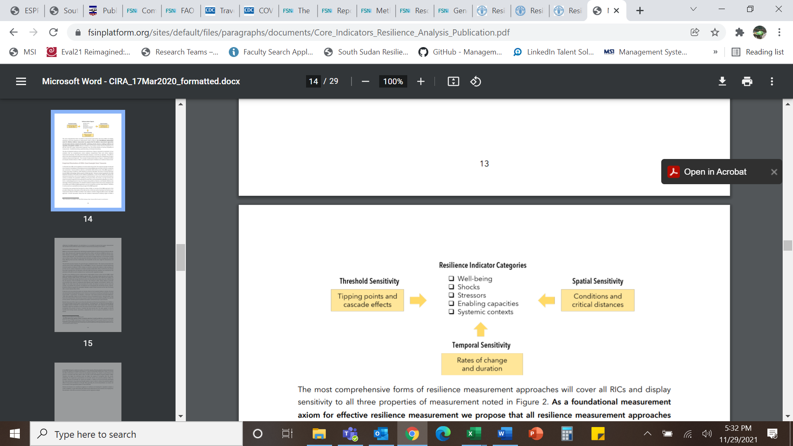

Their study proposes a measurement of resilient inclusive of well-being, shocks, stressors, enabling conditions and capacities, and systemic contexts (Constas et. al., 2020). Although this construct of resilience is not too dissimilar to TANGO model, it does provide further support for the capture of environmental factors, be these regarding the system or the individuals specifically.

Other conceptualizations of these relationships include the Rao et. al. (2020) diagram shown in Figure 2 and Béné et al 2016 in Figure 3. Rao and his colleagues examine the linkages between changing household characteristics and their risk management strategies – these all having differential outcomes at different scales.

Figure . Household Strucuture and Risk Management

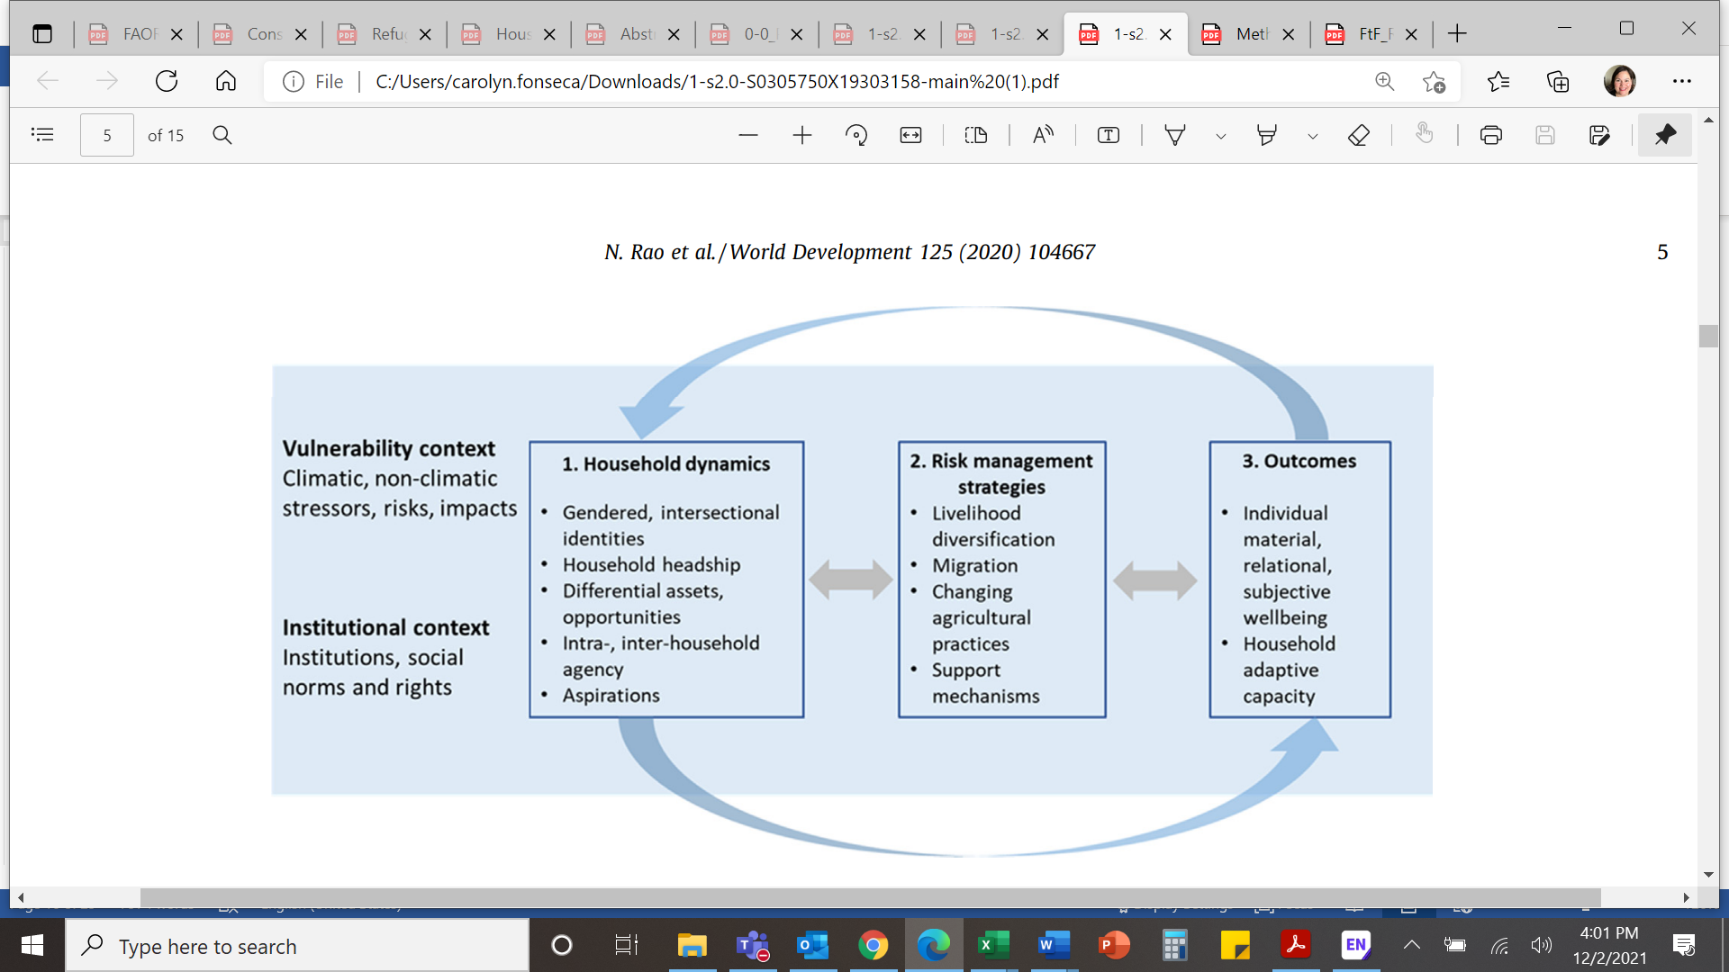

Source: Rao et al (2020), Figure 3.

Figure . Conceptual Framework of Resilience, Bene et al (2016)

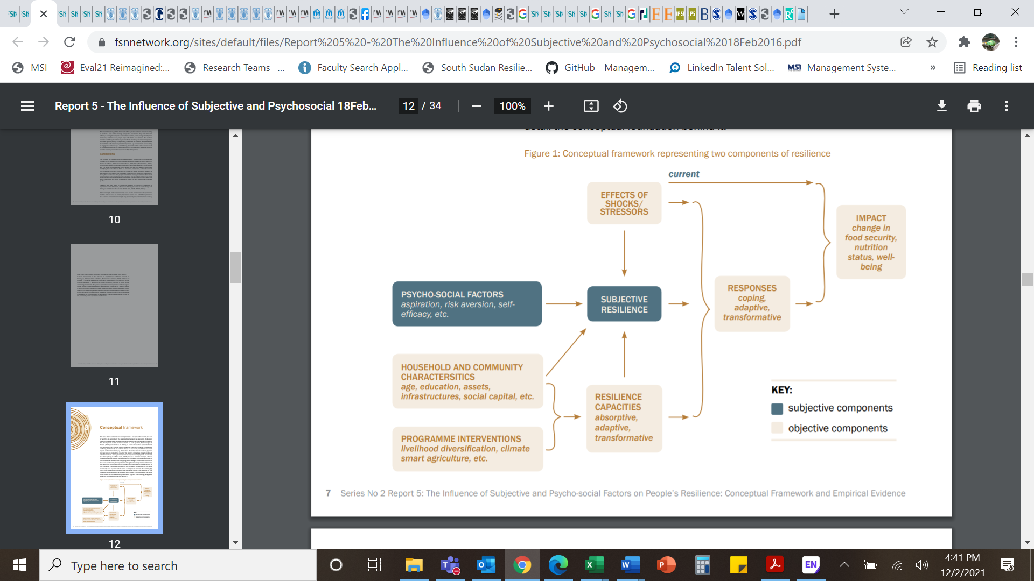

Source: Bene et al (2016), Figure 1.

Resilience studies have been done in Uganda and Tanzania (d’Errico et. al.., 2018), Niger (Béné, Riba, and Wilson, 2020), Ethiopia (Melketo et. al., 2021), Malawi (Murendo et. al., 2020), Palestine (Alinovi et. al., 2008; 2009), Gaza (Brück et. al., 2019), Central America (Sibrian et. al., 2021), and Bangladesh (Al-Maruf et. al., 2021; Bene and Haque, 2021). Various themes appear in the literature including resilience related to agropastoral and cross border issues (for Kenya Sudan Ethiopia and Uganda - FAO, 2019), conflict and resilience (Maxwell et. al., 2017; Brück et. al., 2019), and disasters with a focus on climate change and resilience (Jonnes and Tanner, 2017). Other emerging areas include discussions around resilience with respect to political capacities, equity, and justice (Ensor et. al., 2021a; Ensor et. al., 2021b) as well as connecting psychosocial factors to resilience (Béné et. al., 2019).

Measurements of resilience for South Sudan are limited due to the challenging environment. In the FAO 2019 cross border study, resilience values for South Sudan ranged between 19 (Maban) and 42 (Aweil East) with an overall sample average of the Resilience Capacity index (RCI) of 31. The study found males had higher resilience scores (33) compared to females (29). The FAO recently published their baseline study for South Sudan using the RIMA-II[12] approach (FAO, 2021). The FAO 2021 study found an overall resilience value of 35, with no significant difference between their control and treatment (35.2 and 35.3 respectively). However, they did find significant differences between men and women, with men having slightly higher capacity scores (32.6 and 36.7 respectively). The study focused on a few specific counties which showed variance in resilience capacity metrics.

“Among the counties, Ikotos and Yambio had the highest resilience capacities (41 and 40 respectively), followed by Torit (38), Ibba (35), Magwi (33) and Nzara, with a Resilience Capacity Index (RCI) of 30. Adaptive capacity and assets contribute most to the resilience capacity of the beneficiary households, while access to basic services had the least contribution to the RCI. Participation in multiple sources of income and cultivation of multiple crops were the most important determinants of adaptive capacity. Size of land cultivated and ownership of agricultural assets were the main drivers of the asset pillar.” FAO, 2021

The FAO (2021) study captured a Household Dietary Diversity Score (HDDS) score of size and found severe food Insecurity Experience Scale (FIES)[13] scores for most respondents. The primary sources of income for their respondents were the “sale of cereals, vegetables and other crops (93 percent), casual labour related to agriculture (36 percent) and casual labour related to non-agricultural activities (22 percent)” (FAO, 2021). When it came to responses around shocks, 42 percent stated crop failure and poor harvests, 36 percent said livestock diseases and death, 30 percent mentioned serious illness and death of household heads, and 26 percent stated unemployment and shortage of food within the household.

In summary, the measurement of resilience can include both tangible and intangible factors, for which the recent literature suggests the psychosocial components should be part of resilience calculations (Knippenberg, E., Jensen, N., & Constas, M., 2019). These, albeit difficult to capture, do affect the ability of a household to adapt to shocks and stresses. Additionally, quantitative data alone cannot paint a complete picture of the complexity of these resilience components. Social cohesion may measure the stated views of bonding and bridging for a household; however, this metric does not clarify whether these connections are equal for all household members. As shown in the FAO 2019 and 2021 studies, women and men appear to have different levels of resilience, and this in part could be due to these often abstract characteristics in a household regarding power distribution, community norms, and access to resources.

### Personal Agency



Growing empirical work suggests h**ousehold dynamics, perceptions, and views about the future, are linked to resilience** and the ability to adapt to future shocks (Béné et. al., 2016; Rao et. al., 2020). As stated by Béné et. al. (2016) and their resilience report for Feed the Future, donors are realizing the significance of **psycho-social factors** on individual/household/community resilience levels. The resilience metrics are now more complex with both traditional metrics (assets, livelihood strategies, social capital) as well as more subjective (and difficult to attain) indicators (risk perception, aspirations, motivations) (Béné et. al., 2016). Béné et. al. (2019) discusses how responses to shocks are not just influenced by influenced by individuals’ aspirations by also by “…collective level risk aversion, or sense of self-efficacy” (Jones and Tanner 2015; Clare et al. 2018; Béné et al. 2019).

“The emerging evidence from the field therefore stresses the need to include psycho-social factors and subjective measures in theories of change alongside economic and other traditional variables to build our understanding of what factors contribute to resilience at different levels. Related concepts that have gained traction in the climate change literature include the influence of cultural factors, aspirations, self-efficacy, well-being and attitudes toward innovation and learning...” (Béné et. al., 2016)

Many of these more abstract metrics reflect **“personal agency”** – an individual perceives himself/herself as the actor who can control the direction of their actions and wellbeing. USAID/South Sudan’s Mission PMP directly points to the critical role of aspirational thinking to cope with negative coping mechanisms. Due to time and budget, this literature review is focused only on aspirations, one of the two variables under the personal agency theme for this baseline study.

Household perceptions and power dynamics affect shape the decisions members make regarding the risks perceived and or shocks incurred (Rao et. al., 2020). **Aspirations** of an individual are directly linked to these factors. Although this section will focus on aspirations, the literature quite frequently discusses this theme in relationship to social cohesion, social norms, and risk perception. These issues are commonly interconnected and generally discussed together.

“In the context of adaptation, the idea of an aspirations window can give insights into why some people do not feel able to adapt when faced with multiple risks. Such a focus can also help understand drivers and processes of cooperation and conflict within households, and indeed communities” (Rao et. al., 2020; Ray, 2006)

Aspirations within a household influence the decisions to migrate, change crop/labor practices, and which strategies to implement to manage risk (Rao et. al., 2020; Ray, 2006; Béné et. al., 2019; Béné et. al., 2016). Ray (2006) describes the scenarios for very poor households stating they often aspire to attainable things – which the author calls an aspirations window. The drive to change is based on the gap between what is the individual’s current condition relative to the distance to what is attainable as perceived by them (Rao et. al., 2020; Ray, 2006). Rao et. al. (2020) conducted a study looking at data from five countries (Ethiopia, Kenya, Mali, Ghana, and India) as part of a CGIAR CAFS project[14].

A mixed methods approach was used to gather the data with samples per country ranging between 35-55 interviews and from 180-900 surveys. Findings indicated “changing aspirations were a critical driver of individuals and household responses but also an outcome of certain strategies”. Their work found aspirations to revolve around children, their education and welfare (Rao et al., 2020). This study highlighted the need to understand intergenerational aspirations – as the success of the prior generation can explain the rationale behind one household or community investing in certain strategies. The authors highlight that this can also work in the reverse direction where pursuit of some aspirations can lead to conflict.

“Improving understanding about individual or community resilience also requires accounting for more subjective elements, such as aspirations, expectations and motivations of individuals and households (Béné et al., 2016; Bernard & Taffesse, 2014; Jones & Tanner, 2015). Risk perception for instance, which is determined and influenced by cultural and other psycho-social factors, affects how people respond to shocks and stressors. ‘Risk perceptions are socially constructed with different communities predisposed to attend to, fear and socially amplify some risks while ignoring, discounting or attenuating others’ (APA, 2009: 26).” (Béné et. al., 2016)

Thus, research suggests households with **aspirations windows** inclusive of successful adaptation/resilience to certain shocks, maybe be more resilient, potentially making different decisions than those with different aspiration windows. The reverse would also apply, where communities without aspiration windows inclusive of being able to recover and adapt to shocks, may have lower resilient capacity as they may not implement specific adaptive strategies. This does not imply resilience is based solely on aspirations, nor that positive views of the future alone will lead to household’s wellbeing. As stated earlier, resilience is a complex issue for households, especially those under severe food insecurity, conflict, and stresses. The perceptions within a household of their connection to support and trust of their community (social cohesion), risk of conflict/shocks, and mental models (i.e., the lens through which they see the world based on beliefs/experiences), will all contribute to what strategies are viewed as options for that person/household.

The **perception of risk** plays directly into aspirations about the future or the potential of attainments, for example regarding children’s education. Wheaton’s (2021) South Sudan study discusses the perceptions of community-level risk comprised by individuals’ views of the likelihood of violent events occurring in their community.

“Risk perceptions are socially constructed with different communities predisposed to attend to, fear and socially amplify some risks while ignoring, discounting or attenuating others” (APA, 2009).

Perception, according to Wheaton (2021), can also affect individuals’ views of trust, such as trust in government services, and decisions (like whether it is safe to send children to schools), or if a person should interact with other community members. Her South Sudan study (conducted in partnership with UNICEF) found a direct and statistical relationship between perceived risk of violence and child enrollment (Wheaton, 2021). Risk perception by households often hit with the same shock or stress - a familiar event for which they may know how to address or for which they have endured – may have different views of the impact of a negative event. For example, a study in Bangladesh found households were more worried about tornados than flooding, even though flooding kills hundreds of people every year across the whole country compared to tornados which occur only in one very specific region of the country roughly every 100 years[15].

Other areas of research have studied **the effects of mental models** on the decision-making process in early warning systems, water, education, and health (Bostrom et. al., 2016). The results often suggest the options identified and or course of action taken (based on the defined options), reflect the lens through which respondents view problems. For example, an engineer might see a water scarcity issue as an infrastructure problem where not enough capacity is present in the water supply system; an engineer might suggest improving or adding additional pipelines to increase water quantity. Whereas a sociologist might consider the problem to be related to water rights and access and thus solutions available are likely to be focused on property rights, stakeholder access, and rules of equity. Therefore, views and aspirations of the future for any household will be influenced by their experiences, family/community views/norms, and the individuals own lens of the problem. As first stated, newer resilience models are encouraged to consider variables such as aspirations, by determining which question(s) best captures these views is still unclear.

The South Sudan Baseline survey study used the TANGO model to operationalize resilience which includes an aspirations index (TANGO, 2018). This model calculates shock exposure, resilience capacities, responses, and recovery; the resilience capacity dimension encompasses three dimensions. Multiple variables cluster under each dimension, with aspirations being one index under adaptive capacity (TANGO, 2018). Studies vary on which resilience variables items are included, as the model suggests the context of the sample and location will determine the appropriate variables selected. For more information about the TANGO model and dimensions see the section on shocks and stresses in this report as well as the methods section (Constas et. al., 2020; TANGO, 2018).

The aspirations index from the TANGO model is derived through six questions reflective of people’s aspirations and confidence to adapt to shocks/stresses/events. The six questions are:

A recent baseline conducted by the FAO for South Sudan used a different resilience model than TANGO; they used the Resilience Index Measurement and Analysis (RIMA) methodology (FAO, 2021). The variables in their baseline did not capture aspirations as part of their resilience construct. The MESP South Sudan baseline provides additional information through the inclusion of aspirations, social capital bonding and bridging, and other social norms/characteristics which influence perceptions of risk. This is turn can dictated how individuals or communities respond to these risks (Béné et. al., 2016).

Although these components in the TANGO definition of aspirations are robust and widely accepted, new studies discuss methodological requirements for capturing aspirations data. Often surveys are used to capture resilience data. Recent studies argue quantitative methods alone cannot fully capture the household views about their future and qualitative studies should be included (Ensor et. al., 2021).

### Social Norms



Studies for South Sudan have primarily captured tangible data around common household welfare measures like income/assets, knowledge/skills, and institution capacity/governance variables (FAO, 2021). In their quasi-experimental baseline study, the team using the RIMA II FAO resilience methodology, captured mostly tangible metrics (i.e., FIES food insecurity index, HDDS dietary diversity index, income sources, social capital, access to services, reported household shocks, and resilience capacity index). The data encompasses multiple counties across South Sudan but was limited in social variables.

Another FAO report which included South Sudan, Ethiopia, Uganda, and Kenya (FAO, 2019) found assets – specifically level of education of household members and diversification of sources of income to be determinant of resilience. Additionally, this study (FAO 2019) found those working in crops were more likely to be more resilient. What these FAO studies do not include are the effects of internal dynamics of a household and community on resilience.

To better understand the components of resilience for an individual, household, and or community, the literature recommends studies include more subjective elements **like self-esteem, risk perceptions, and adaptive preferences** (Béné et. al., 2016; Béné et. al., 2019). Béné et. al. (2019) discusses the importance of understanding psychosocial views, such as **attitudes about violence or conflict, gender roles, as well self-efficacy** (the belief in one owns capacity) to help explain resilience behaviors (Béné et. al., 2019). The study finds interventions on gender norms and household work distribution maybe help improve the ability of household’s resilience. Recent work by Rao et. al. (2020) suggested changes in household composition, gender roles, and other social norms can potentially affect the implementation of adaptive household behaviors. However, **the measurement of social variables, such as distribution of decision-making power within a household and community peer pressure to adopt specific attitudes about social behaviors, remains difficult to measure**.

For purposes of this literature review, the team will focus on studies which discuss three areas in social norms including SGBV, early marriage/bride price, and cattle raiding views. The team recognizes that other variables also encompass social norms, which could be further explored in future analysis of this baseline data. Finally, the literature and body of work around these topics is vast, albeit limited for South Sudan specifically. This literature review reflects the time and focus of this study; therefore, it is likely other key studies exist not included in this review.

“Our evidence suggests that while greater risks can drive conflictive behavior within households, with women often reporting lower subjective wellbeing, new forms of cooperative behavior are also emerging, especially in peri-urban spaces. Through this study, we identify entry points into enabling sustainable and inclusive adaptation behavior, emphasizing that interventions should work for both women and men by challenging inequitable social and gender norms and renegotiating the domains of work and cooperation to maintain overall household wellbeing” (Rao et. al., 2020)

Also, critical to note, that although the South Sudan baseline survey provides responses to social norms questions, it does not provide detailed information around the “why” for that response. For example, the literature might discuss various reasons for early marriage, with studies showing parents being concerned for the wellbeing (i.e., having enough to eat, for protection, for economic security, other) of their daughters, but the South Sudan Baseline was not able to gather qualitative data.

***Sexual and Gender Based Violence (SGBV)***

“Rape was reported to have been perpetrated against women and girls in sampled household by over one quarter of the respondents within a one-year recall period. Higher rates of reporting of rape, rather than other forms of GBV, indicate conflation of rape with the term GBV, and lack of recognition of other forms of GBV including child marriage and forms of IPV. • Bride price was used to formalize the majority of marriages among respondents (69.4%, n = 2,048). The study showed a strong causal link between the payment of bride price and the frequency of GBV in a relationship.” IOM, 2019

In 2019, IOM published a report of “gender-based violence knowledge, attitudes and practices survey in South Sudan”. This study found 75.2 percent of the respondents had experienced at least one kind of intimate partner violent event (which ranged from threats to forced sexual acts). Other GBV incidents reported included rape and assault with 46 percent reporting at least one incident of GBV against a female in the household within the last year. The complexity of GBV issues is highlighted in USAID’s South Sudan GBV and Prevention and Response Roadmap 2019 (USAID, 2019).

To address GBV, projects in South Sudan will need to take a holistic approach and integrate this important issue across all phases and types of activities. The scale and frequency of GBV represents a severe type of shock to a household and community. A household’s resilience capacity will likely be affected by GBV. This metric is often difficult to collect under any circumstance and is often under reported.

UNICEF (2021b) reported 25 percent of the sexual violence cases included a child victim. They found the increase in various shocks like floods and food insecurity were contributing to increased vulnerability of women and children to GBV. Additionally, UNICEF states social norms often reinforce the violence against women, set social stigmas preventing girls/women from seeking support, and often there are limited opportunities to report GBV.

***Early Marriage and Bride Price***

Oxfam’s 2019 report states for Nyal that up to 71% of girls marry before the age of 18, and 10% of girls and women are married before the age of 15. Early marriage and bride prices are common practices in South Sudan, often places with high levels of poverty and food insecurity are linked with early marriage (Oxfam, 2019; Pereira et. al., 2021; Quist, 2020a and b). However, studies find when girls are married off very young, they often are at greater risk for violence within their home by their partner and have higher incidents of death due to childbirth (Oxfam, 2019).

“Child, early and forced marriage has many devastating consequences: it increases girls’ risk of death or complications during pregnancy and childbirth in a country with one of the highest rates of maternal mortality in the world; it is one of the primary reasons why 76% of South Sudanese girls are out-of-school; and, it puts girls at greater risk of sexual, physical and emotional violence.”

(Oxfam, 2019)

When a girl marries young, they are also less likely to continue school; when households are hit with stresses affecting sources of income, uneducated girls are not able to contribute as much as educated ones (UNICEF 2021a). Girls with education have often the ability to read and thus help the house access resources, identify locations of support, and even when possible be involved in income generating activities themselves (i.e., selling products at the market). Experts also discuss higher rates of confidence in girls with education.

Figure . Effects of COVID and CHILD Marriage

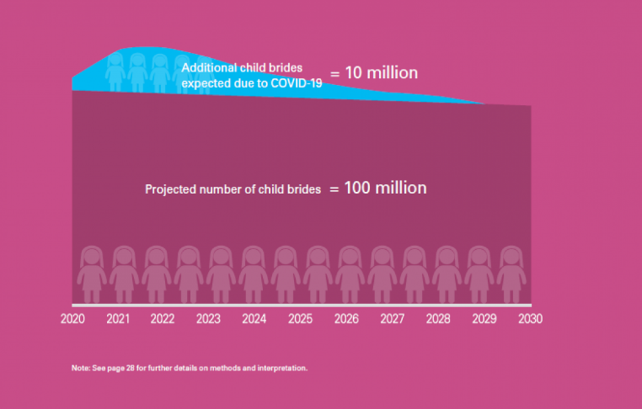

Source: UNICEF (2021a)

In South Sudan, women and girls face higher rates of food insecurity, less access to resources, and are often affected more negatively by shocks. During COVID, UNICEF (2021a) reported an increase in child marriage. Figure 5, taken from the UNICEF report on the effects of COVID and child marriage, shows the spike in the number of child brides between 2020 and 2022. UNICEF found these increases of child marriage and teenage pregnancies due to prolonged school closures, as well as higher rates in GBV due to “social norms perpetuating multiple forms of violence against women and girls” (UNICEF 2021a).

Resilience studies rarely disaggregate results within a household. When they do, they often limit this disaggregation to a comparison between men and women, often with much lower responses from female household members. Future studies of South Sudan household resilience should consider capturing the specific characteristics of other household members including how they address shocks within their household and outside. Because GBV is often something not easily shared or reported, careful data collection considerations should be taken to capture the effects of these violent incidences as they reflect often intangible shocks.

***Cattle Raiding***

Cattle raiding has been present in South Sudan for many decades and has increased with conflict (Maduk, 2020). Livestock, in particular cattle, is a primary source of income for most families, often used as a dowry for favorable marriages (Ajak and Demiryurek, 2021; Bithou, 2020). With a reduction in economic opportunities due to many decades of conflict and war, income generating options for young men are few. This often leads to cattle raiding as the way to violently gain wealth and as a vengeance tool (Quist, 2020a and b). With climate change, the pressure is exponential, as communities face drought and flooding reducing land for grazing and water access (IOM 2019; UNICEF 2021a; FAO 2021, Ward 2021). In November 2021, over 90 percent of all arable land was flooded with more than 500 schools closing (IPC 2021, UNICEF 2021a).

“In South Sudan agro-pastoralism is the main livelihood system in rural areas. Although agropastoralism involves both livestock rearing and crop production, a household’s financial capital is held in the form of livestock. Livestock also supply milk and other foods, and are sold to purchase cereals for food and meet other domestic needs. Poorer households aim to build their herds; this is the key and economically logical strategy for building their financial capital. Due to the seasonality of food production, milk is a critical food at specific times of year, when other foods e.g. cereals, are not readily available. Milk is an especially important food for young children, and pregnant and lactating mothers. Livestock is also important in South Sudan’s pastoralist and agrarian areas.” (Catley, 2018)

Cattle raiding is often a socially accepted behavior but has been shown to be a very damaging practice causing loss of life, reducing the efficacy of donor activities, and increasing the violence towards women/families (Ajak and Demiryurek, 2021). Markit (2021) found “the increasing need for bride wealth and the availability of small arms or light weapons were the major driving factors behind cattle raiding and child abduction among the three communities [the Dinka, the Nuer and the Murle communities in Jonglei State].” The findings suggested a decay in social cohesion for these communities contributing to increased illiteracy, displacement, poverty, and loss of property/life (Markit, 2021).

Security reports from PAX[16] (protection for civilians) across multiple counties indicate a general increased in guns, cattle raiding, and reduction in security (Quist, 2020a and b). The Jonglei report indicated survey results showed “more than two-thirds (68%) of respondents experienced at least one security incident over the last year, up from 45% in 2018…rates of cattle raiding have increased, from 26% of reporting cases in 2018 to 33% in 2020, making it the most frequently reported security incident in Jonglei.” Additionally, PAX reports (Quist, 2020a) showed flooding was widespread with devasting effects contributing to an increase in competition for limited recourses, pressure on intercommunal relationships, and reliance on local armed youth (specifically in Twic East and rural areas of Bor South).

“…cattle occupy a particular social position among these three pastoral communities who have viewed cattle as a sign of prosperity. As such abduction of children and cattle raiding has been rooted in the historical and social relations of the diverse communities inhabiting Jonglei State (Copnall, 2011). The incidence of tribal conflicts and child abduction have risen greatly since the signing of the Comprehensive Peace Agreement (CPA) in 2005 (Dalil, 2010) and post-independent South Sudan (Christopher, 2011).” Mayik, 2020

This was also supported by another study by Mayik 2020 who found tribal and ethnic tensions in the Jonglei state between the Dinka, Murle and the Lou Nuer was likely manifested by “cattle raiding, child abduction, revenge attacks, and threats of ethnic cleansing.” (Mayik, 2020). The article contends the increase in cattle raiding and child abduction happened after the Comprehensive Peace Process in 2005 and post-independence South Sudan (Mayik, 2020).

In contrast to Yonglei, the PAX report for Unity state showed a reduction in reported security incidents, but the findings were not even across the state (Quist, 2020b). However, the report suggested reliance on cattle for a bride price was still occurring and contributing to tensions within and between households “increasing cattle raiding and forced marriages” (Quist, 2020b). The literature highlights how community views, composition, and conditions are interrelated with cattle raiding behavior, often the by-product of deep rooted social norms. Although many efforts have been done to help reduce cattle raiding in South Sudan, such as peace talks or recommendations on the potential for agriculture extension services to mediate conflict (Ajak and Demiryurek, 2021), these have had mixed effects.

How might changes in household resilience relate with changes in cattle raiding behavior? Are households engaged in cattle raiding likely to have lower resilience conditions then compared to those who do not engage in cattle raiding? Because there is a lack of consensus around what constitutes resilience, and there is no one standard across all contexts, there is a gap in the empirical research on which components/variables/aspect are most important to changing resilience outcomes (Béné and Haque, 2021). Shocks and conflict exacerbate the availability of resources augmenting rivalries. Thus, cattle raiding may be more of an intermediary variable between shocks in a household’s capacity to adapt/absorb and transform – to be resilient. This specific causal pathway has not been extensively explored through empirical work in South Sudan.

“Implementing robust impact evaluation of resilience interventions is not yet well established (Béné et al. [2017](https://link.springer.com/article/10.1057/s41287-021-00399-9#ref-CR9)). Part of the challenge is that, although some progress has been made on what resilience is and how to conceptualise it—see e.g. Constas et al. ([2013](https://link.springer.com/article/10.1057/s41287-021-00399-9#ref-CR17)); or Ansah et al. ([2019](https://link.springer.com/article/10.1057/s41287-021-00399-9#ref-CR2)) for a recent review -, no strong consensus has yet emerged on how to measure (and, a fortiori, to assess) resilience interventions. There is an urgent need to develop more rigorous methods to measure and assess resilience interventions in the field (Béné [2013](https://link.springer.com/article/10.1057/s41287-021-00399-9#ref-CR5)).” Béné and Haque, 2021.

### Social Cohesion



As discussed in the earlier section on resilience, past studies identify social capital as tangible component in calculations of resilience. TANGO (2018) operationalizes social capital as an index comprised of **social capital bridging and bonding**. Bridging is defined as the how much support respondents feel they could get or give other individuals from outside of their community (TANGO, 2018). Whereas bonding, is how people feel within their community to give or receive support (TANGO, 2018). For the South Sudan Baseline, these two parameters of social capital imply the level of **social cohesion** for a household. The literature explores how social capital data is related to a household’s ability to recover and adapt to shocks – does social cohesion help household resilience?

Extensive work has been published supporting the relationship between positive outcomes between social capital and household participation in community groups as well as food security (Niles et. al., 2021; Misselhorn, 2009). Recent work by Niles et. al. (2021), found community and households social capital were positively related to higher households group membership and this in turn related to “…more than a 10% reduction in average months of food insecurity.”

Niles et. al. (2021) discussed the theoretical assumptions about the correlation between networks and improved resilience/adaptive capacity. Their paper takes a social network approach in their study to test this theory and findings highlight the value of respondents’ relationships as well as the layering effects of diverse networks (Niles et. al., 2021). The sample for their study included 13 countries including several South Sudan’s neighboring nations (Kenya, Tanzania, Uganda, and Ethiopia) as well as several from W. Africa and S.E. Asia. Their study found two types of networks to be associated positively with a decrease in food security – 1) brokered and 2) shared networks. Although their study was focused on agricultural systems, trying to understand the critical components for communities to adapt to climate changes, their findings point to both **layering and diversity of networks** in capturing significant resilience parameters. Empirical research may have difficulty capturing multiple layers of cohesion, both with respect to temporal and scale aspects, as these studies are expensive and often in conflict areas.

“In communities with fragmented and shared organizational networks, additional household group memberships is associated with consistent decreases in food insecurity, in some cases up to two months; whereas in brokered networks, reductions in food insecurity are only associated with membership in credit groups. These effects are confirmed by hierarchical random effects models, which control for demographic factors. This suggests that multiple scales of social capital—both within and outside the household—are correlated with household food security. This social capital may both be bridging (across groups) and bonding (within groups) with different implications for how social capital structure affects food security. Efforts to improve food security could recognize the potential for both household and community level social networks and collaboration, which further research can capture by analyzing multiple scales of social capital data.” (Niles et. al., 2021)

Although often the positive benefits of social cohesion are discussed, there are negative externalities which can result as mentioned by Niles et. al. (2021). Their paper states “…while social capital theory and research generally explore the positive relationships resulting from social capital, there is evidence that bonding social capital can also have negative outcomes especially when it concentrates power.” Bonding within a household or community can also create environments of exclusion; for example, women could be limited from accessing diverse food items within their household or attending support groups (i.e., accessing informal networks) in their community. Another example can be found between increased social bonding or bridging and a decrease in health outcomes as household members share limited food resources with their families and neighbors (Niles et. al., 2021). Although measurements of social capital are often commonly used in the resilience models, they rarely clarify to what extent are these cohesive links benefiting a household’s resilience, equally distributed within a household or between households/communities.

The social cohesion across a community (bonding) may permit additional sources of support when food is severely insecure. This in turn results in a higher capacity for households to be resilient to shocks and stresses, particularly short-term ones. Although resilience studies often include social capital as one of the more tangible metrics (Béné et. al., 2016), the models do not often capture the strength of the bonds (social capital bonding and bridging), thus the degree of trust. Vervisch, Valssenroot and Braeckman (2013) ethnographic’ s study in Burundi showed how “…social capital portfolios adapt to a protracted crisis…[with] the effect of changing livelihood policies, institutions, and processes”. Taking an actor-oriented livelihood framework, Vervisch et. al. (2013) presented a different perspective on social cohesion, discussing direction and bond depth as well as access. A household may have bonds with other members of the community, but this does not imply the access and or benefits from these linkages are strong and/or equal across members.

Figure . Social Capital, Standard Hypothesis Versus Adaptation Protracted Crisis

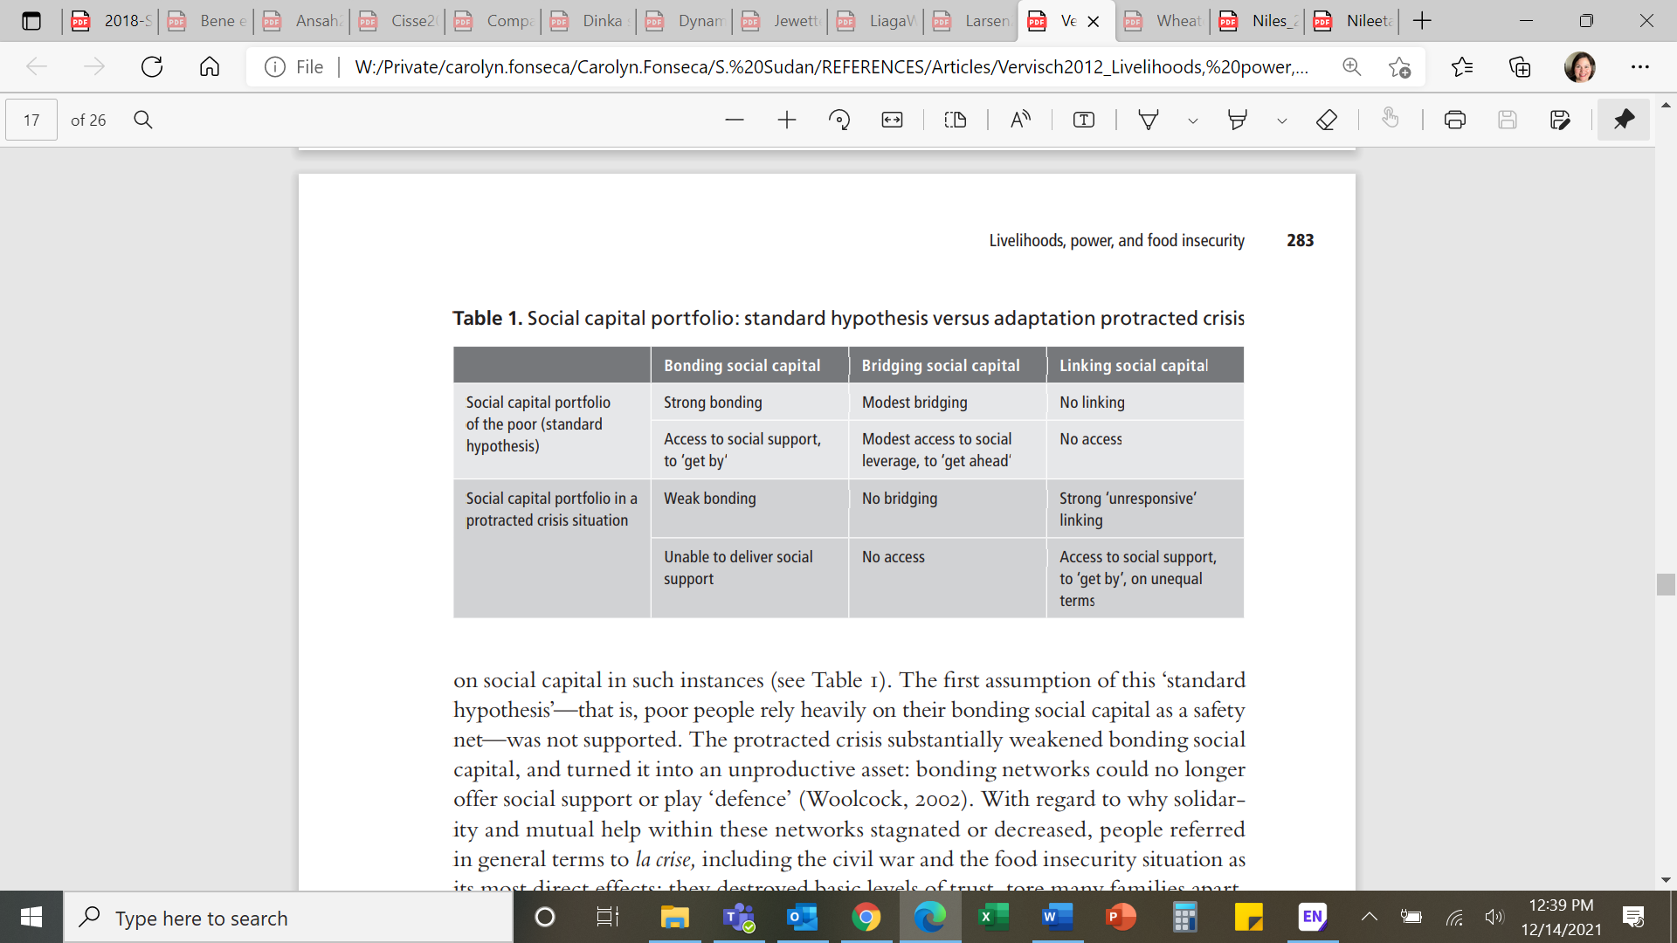

Source: Vervisch et al (2013), Table 1.

Social cohesion within a household and or community has been recently studies regarding COVID, as a significant shock on most households. For those families already under existing stress, much like many in South Sudan with consistent stressors like conflict, flooding, and cattle raiding, COVID was an additional factor to an already fragile community.

Jewett et. al. (2021) paper presents a robust review of the literature regarding the work to date on COVID and social cohesion. This review points to a need for any programmatic activity working towards community resilience involving social cohesion, must include an equity lens to ensure marginalized communities are not marginalized further. As stated by the researchers (Jewett et. al., 2021), social capital is the “most studied concepted related to social cohesion with the disaster recovery literature.” In their review they discuss the most common methods used to assess social cohesion (qualitative interviews), as well as through indices – like the Buckner’s index of cohesion[17] (Jewett et. al., 2021).

“Shock events uncover deficits in social cohesion and exacerbate existing social inequalities at the household, community, local, regional, and national levels…During a disaster, inequities in society are revealed. The identification of inequities and priority setting for intervention and aid benefits from strong social cohesion practices. These practices can include stakeholder engagement protocols, communication plans between government and the public, careful evaluation of government measures that affect public freedoms, and local–regional context. All these activities, and more, must center on marginalized groups including but not limited to women, children, indigenous peoples, racialized peoples, and people with varying abilities. Any protocols or interventions that seek to intervene in social cohesion and community resilience must do so with an equity lens that brings together all parties involved.” (Jewett et. al., 2021)

Additionally, the review finds limited large-scale empirical work where social cohesion is supported by qualitative studies to ensure the capture of diverse communities, conditions, and perceptions (Jewett et. al, 2021). Jewett et. al., 2021conclude that the social cohesion literature regarding disasters is clustered around factor which promote (e.g., government interventions, community-led recovery efforts, community building events) and those which impeded social cohesion (e.g., armed conflict, inequitable and uneven distribution of resources, lack of stakeholder engagement). Rao et. al. (2020) suggested in some urban and peri-urban environments new types of cooperative engagements are emerging – this could reflect new coping strategies to stresses and thus new types of cohesive behavior.

“Qualitative stories demonstrate the link between social cohesion and educational access, including explanations related to boys at risk of recruitment being stronger, while for girls, exposure to sexual violence is higher. Many more barriers are revealed for girls’ enrollment that reach far beyond the risk of sexual violence; some of these barriers include repressive cultural norms, household chores, early marriages, and lower value being placed on girls obtaining an education. Furthermore, local communities affirm that ultimately, they, the community, will decide who and who does not go to school. Thus, researchers’ consultation and engagement with community members and leaders become paramount in the process of designing, delivering, and evaluating the impact of education programs in conflict-affected settings. Additionally, fears in these settings are high, and perceptions of what is and is not possible are diverse.” (Wheaton, 2021)

Wheaton (2021) conducted a study in South Sudan with a sample of over 700 participants across multiple counties including NGOs, community leaders, households, and other stakeholders. This study highlited the power of community perception and the social dynamics and cohesion levels of South Sudanese families and their decisions around school attendance. Her study argues for development agencies to take a social cohesion lens using multi-sectoral programming for more effective outcomes.

### Shocks and Stresses



In 2021, South Sudan reported “biblical” flooding across most of the country. As of December 2020, IDMC reported more than 1,436,000 were internally displaced due to disasters (iDMC 2021). Although flooding and drought are not new types of stresses to South Sudanese communities (record flooding reported for 2020 with over 443,000 displacement events (ibid), the scale and length of these events in 2021 was compounded by the existing conflict (IDCM reported more than 271,000 conflict/violence events in 2020) and COVID. The **severity of these natural disasters led to of loss livestock and agriculture products**, both primary income sources for most South Sudan families. Thus, food prices increased and access to food decreased.

**South Sudan households reported severe food insecurity** for 2021 with over 1.4 million women/children suffering from acute malnutrition, and 7.24 million people faced acute food insecurity from April to July 2021 (USAID 2020, IPC 2021). Food insecurity was not the only significant stress in 2021. Donor groups reported increases in Sexual and Gender Based Violence (SGBV) events often including violence towards women by a partner, violence towards and abuse of children within a household, and violent incidents outside the home from increased conflict (i.e., cattle raiding, fighting, other) (IOM, 2019; OCHA, 2021; Kim et. al., 2020; Mercy Corps, 2018).

“Some 8.3 million people in South Sudan are estimated to be in need of humanitarian assistance in 2021. These include 8,000,000 nationals and 310,000 refugees and asylum seekers. This is an 800,000 increase in absolute numbers from the 7.5 million people in need in 2020. The increase in needs is largely driven by the rising food insecurity.” [The World Bank](https://www.worldbank.org/en/country/southsudan/overview#1)

In 2019, IOM conducted a survey capturing “gender-based violence knowledge, attitudes and practices survey in South Sudan”. The results outline the high percentage of rape, violence, and abuse across vulnerable populations often within a household and by family members (i.e., spouse).

Figure . Experiences and Perceptions of Violence and Safety in South Sudan

Source: IOM, 2019.

OCHA’s recent Humanitarian Response Plan Report for 2021[18] further discussed the types of stresses and shocks South Sudan communities are facing. **More than two-thirds of all South Sudan is in need of humanitarian assistance** due to the persistent **conflict** and extensive **flooding**.

The resilience literature discusses the various factors which are associated with more resilience households - how are families coping with these shocks/stresses, and what types of coping strategies are families implementing to overcome these? A report by Mercy Corps, discusses how communities are the first respondents in a crisis, and not usually the donor groups (Mercy Corps, 2018). Thus, having strong social connections permits a more enabling environment during times of crisis and post-shocks (Kim et. al., 2020).

“More than two-thirds of the South Sudanese population and some 300,000 refugees2 and asylum seekers in South Sudan are in need of some form of humanitarian assistance and protection in 2021, as the country continues to experience the cumulative effects of years of conflict, a surge in sub-national violence, unprecedented flooding and hyperinflation, further compounded by the COVID-19 pandemic. The lack of durable peace and limited investment in basic services impedes many people’s ability to move towards sustainable development.” OCHA, 2021

### Food Security



Food insecurity is a **prevailing condition for most South Sudanese** households and a complex issue related to conflict and shocks (Brück et. al., 2019; FAO, UNICEF, WFP, and WHO, 2021; Lokosang et. al., 2014). The Food and Agriculture Organization of the United Nations (FAO) places South Sudan amongst the top 10 most insecure countries in the globe showing more than 60% of the population (7.2 million people) classified in Crisis (IPC 3 or above[19]).

Although some data exists for South Sudan, it is often limited to averages for the county or across the country. Recently, the FAO presented data at the county level for South Sudan in two studies, 2019 and 2021 (FAO 2019 and 2021). In both reports, South Sudan was rated as having severe food insecurity. FAO 2021 reported 68 percent of all counties were rated as “serious” or worse between November 2020 and March 2021; most counties were in acute food insecure either as in a state of emergency and/or famine.

“Conflict is the root cause of food insecurity in South Sudan. It causes massive internal and cross-border displacement, preventing households from engaging in typical livelihood activities, and inhibits economic growth by hampering the extraction of oil and disrupting markets and trade routes. As a result, income-earning opportunities are limited, and the Government’ earnings are very low, which has led to hyperinflation.” FAO, 2019

The literature highlights factors **exacerbating food insecurity** including household resilience affected by conflict and shocks (Brück et. al., 2019; FAO et. al., 2021; Guyu and Muluneh, 2015; Maxwell et. al., 2017). A 2019 study demonstrated households found resilience capacity - required to resist food insecurity declined among Gazan households because of the conflict (Brück et. al., 2019). This was mainly due to a “reduction of adaptive capacity, driven by the deterioration of income stability and income diversification” (Brück et. al., 2019). Their study found conflict actually increased the use of “social safety nets expressed in the form of cash, in-kind or other transfers that were received by the households) and access to basic services (mainly access to sanitation) for the households exposed to the conflict.”

Although Brück et. al. (2019) found no statistical relationship between conflict and food security for households in Gaza (even though they were close to the border conflict), their study indicated resilience – adaptive capacity, the ability to recover from shocks – was affected by the conflict which thus affected food security.

Another study looking at the **connections between vulnerability and food insecurity** suggested policy responses should be focused on two areas, 1) improving social safety nets to ensure food access and 2) enhancing productivity attacking the root causes of food insecurity – at least in the case of Palestine (Alinnovi et. al., 2008; Alinovi et al, 2009). d’Errico and his team (2018) looked at the relationship between resilience and food security, finding a positive relationship between these two variables for both countries, Tanzania and Uganda. In this study, the “most important component for household resilience was adaptive capacity, which in turn depended on the level of education and on the proportion of income earners to total household members.” (d’Errico et. al., 2018). Their article provides a very useful summary of the literature measuring and testing the relationship between household resilience and food security. This study also found that adaptive resilience metric mitigated the negative effects of shocks (d’Errico et. al., 2018).

“This was mainly due to a reduction of adaptive capacity, driven by the deterioration of income stability and income diversification. However, the conflict actually increased the use of social safety nets (expressed in the form of cash, in-kind or other transfers that were received by the households) and access to basic services (mainly access to sanitation) for the households exposed to the conflict. This finding may be related to the support provided to households in the Gaza Strip by national and international organizations after the end of the conflict… From a policy perspective, the case of the conflict in the Gaza Strip demonstrates that immediate and significant support to victims of conflict can indeed help restore resilience capacity” (Brück et al., 2019)

Food insecurity is often measured through a series of questions asking respondents to recall food consumption across a specific time. The Food Insecurity Experience Scale (FIES), an index that measure the severity of food insecurity calculate through a series of yes/no questions around whether the person had enough to enough to eat, skipped a meal, ran out of food, went hungry and other similar questions. This metric/indicator – with a scale between 0 and 8 where zero denotes no food insecurity issues and 8 reflects the most severe conditions. Individuals are asked to recall their experience for the last 12 months. FAO 2021 measured FIES for South Sudan and found their score to be 6.4. This represented over 78 percent stating they were worried about not having enough to eat, 69 percent said they had skipped a meal, and 71 percent stated their household ran out of food (FAO, 2021).

**Changes in food security reflect multiple factors** including conflict conditions, natural disaster events (i.e., floods, droughts), and economic conditions (Constas et. al., 2020; d’Errico et. al., 2018; FAO, 2021b; FAO et. al., 2021; Idris, 2018). Food security relates to both access to food as well as the nutritional content of those food items (Cordero et. al., 2021). Some communities are closer to roads and infrastructure improving the chances of acquiring/accessing food as well as increased diet diversity (Nandi et. al., 2021). Resilience models can include a dietary diversity metric, often the Household Dietary Diversity Index (HDDS) (FAO, 2021b; Gina et. al., 2013; Gibson et. al., 2017).

The common issue with both the FIES and the HDDS food security variables is related to the recall time for both, 12 months for FIES and 24 hours for HDDS. When respondents are asked to recall food conditions across these two timeframes they might remember inaccurately, the food items they recall may reflect a particular day (not reflective of the week or overall conditions to food access), and the respondent may be providing a socially desirable answer. Other factors can also affect the scores including seasonality, data collection issues, humanitarian aid conditions, respondent type (i.e., women vs. men, children vs. adults), and levels of disaster/conflict (Kennedy et. al., 2013; FAO, 2021b, FAO, 2016).

“Historically, women are often assigned as primary caregivers to children and elderly family members – even though such traditional gender roles have been challenged by the empowerment of women. For instance, women’s economic advancement, increased level of education and decision-making power. These reasons, together with prevailing gender norms,11 continue to cause women to be more socially vulnerable, which in turn, impacts the quality of their diet (Clark et al., 2020; Kassie et al., 2020; Komakech et al., 2019; Oxfam, 2019). For example, in some parts of Africa and Asia, it is customary for women and men to eat separately (WFP, 2019). Women may eat second or last, after they have served food to other family members (den Hartog, van Staveren and Brouwer, 2006). In Uttar Pradesh, India, when food is scarce women give up their share of food in favour of men and children, which is accepted practice and justified by the need to put the interest of their families first (WFP, 2019). These practices mean that other household members consume good quality and nutritious food (e.g. animal source foods), to the detriment of women. Therefore, adequacy of household dietary diversity within a population may mask the fact that some women are consuming diets that are monotonous and insufficient for meeting their daily nutritional needs. On the other hand, when women’s diets are diverse, it is likely that the other members of the families are also consuming diverse diets, considering the priority given to them.” Kennedy et. al., 2013

### Conclusion

The literature capturing and measuring resilience and its connection to household food security, social capital, aspirations, social norms, and shocks/stresses has been growing (Béné et. al., 2019; Ensor et. al., 2021; Maxwell et. al., 2017). However, studies highlight the issues with both the frameworks and models being applied. First, there is still a challenge to measuring resilience on-the-ground (Ensor et. al., 2021).

The TANGO model was built to permit flexibility around what should be collected for the calculation of resilience – reflective of the local context; this flexibility also means there is no standardized applications in each country. Although the literature recommends the inclusion of psychosocial variables as critical factors influencing household resilience, these remain difficult to capture with existing methods, the most used being household surveys. Qualitative approaches are more likely to yield valuable data around the complexity of household dynamics, yet these often are expensive and for conflict environments often non-permissive methods.

To provide a more comprehensive metric of South Sudan’s food security landscape, these are potential options for future data collection efforts:

* Although the HDDS and FIES indexes are used commonly in USAID projects to assess food security conditions of development communities, these have limitations. The literature identifies some of these and suggest ways to address them empirical through design and data collection strategies.
  + ***Recommendation***: 1) collect variables on satiation, food consumption quantity, and track across multiple seasons; 2) conduct interviews with diverse households both food secure and insecure in both urban and rural areas; 3) ensure the questions regarding dietary diversity are specific to women as well as men – current literature suggests specific questions for women different that in the HDDS index, related to childbearing nutritional needs.
* Baseline data collected a significant number of social norms variables. However, these do not provide the rich information to understand household power dynamics, including women’s views of risk and ability to influence adaptation strategies.
  + ***Recommendation***: future data collection should include qualitative data such as interviews and focused groups to capture complex household dynamics not easily done through surveys. Various aspects can be explored through qualitative methods including: 1) identification and comparison of mental models for household members, whether these difference between men and women, older and younger members; 2) capturing information about household perceptions on risk, strategies to address the different types of shocks/stresses, and gender roles
* Scholars discuss social bonding capital and how it might vary with ethnicity, gender, and age. Rao et. al. 2020 found for their Namibia sample for minority groups to have stronger bonding as compared to non-minority groups.
  + ***Recommendation***: Exploring this dynamic in South Sudan may also yield unique differences as it relates to youth, women, and urbanicity. Women report lower levels of subjective wellbeing and the Rao et. al. (2020) study finds new types of cooperative behavior emerging especially in urban/peri-urban locations. In conflict or places with high levels of shock, that might often increase pressure to migration or cause displacement, women are taking on new roles to support their families. Social norms, changes in women’s aspirations for marriage or views about their roles or needs to change roles are not well understood in the context of South Sudan.
  + ***Recommendation***: conduct qualitative studies with youth and women of diverse ages to better understand the drivers of gender roles, aspirations, and changing social parameters.

1. The Mission used several priority factors (see USAID Strategic Framework 2020-2023) to select these target areas, including historical food insecurity (through the Integrated Food Insecurity Phase Classification (IPC) System), presence of a USAID partner, projected high returnee rates, and Food for Peace (FFP) target location. In selecting these counties, the Mission also sought to include areas with a propensity toward conflict, areas under government and under opposition political control, and diverse areas covering different regions/ethnic groups. The baseline focused on capturing data for these thirteen critical counties.
2. RIMA – Resilience Index Measurement and Analysis II
3. Integrated Food Security Phase Classification (IPC), also known as IPC scale created by the FAO is used to classify the conditions of a country/county. This standardized scale integrates food security, nutrition, and livelihood information into a statement about the nature and severity of a crisis and implications for strategic response.
4. Using survey item 504, Do you know of any national or international agency doing humanitarian work?
5. There are 16 foods. Multiple items for meats and vegetables are collapsed into single categories, resulting in 12 items.
6. Comparing the incidence of shocks against a combined measure of incidence and severity of shocks, the results are largely the same. The only disparity is that an increase in the price of agricultural inputs ranks high in the incidence of shocks, but is not perceived as a severe shock.
7. A related measure could be perception of the government of South Sudan, which relates to the mission’s special objective of limited support to the government of South Sudan, and the possibility of strengthening direct engagement in the event the government takes positive steps in addressing drivers of conflict and improving the quality of governance. Household perception of the government legitimacy could provide evidence in support of increased government-to-government engagement.
8. This is the average effect based on a linear probability model. The predicted output in Figure 6 is based on a logistic model that allows for different effects on food insecurity based on different values of resilience capacity. The average effects are roughly equivalent, but the logistic model does a better job of describing the sensitivity of the mitigating effect of absorptive resilience capacity across the full range of values.
9. The inclusion of shocks and conflict in the analytical model would hope to sufficiently identify those areas most in need. However, given that one would not expect early warning systems to genuinely increase food insecurity, it seems more likely that there are environmental conditions not included in the analytical model that help determine those areas most in need, and the absence of these conditions are creating the positive association between the presence of early warning systems and higher levels of food insecurity.
10. This results in a scale that faithfully reports the severity of a shock as it was reported by households, but note that it does not necessarily report the severity of a shock in general. To see how the severity of shocks rank against each other, one would need to review the reported severity of a shock among only those who report experiencing the shock.
11. The Mission used several priority factors (see USAID Strategic Framework 2020-2023) to select these target areas, including historical food insecurity (through the Integrated Food Insecurity Phase Classification (IPC) System), presence of a USAID partner, projected high returnee rates, and Food for Peace (FFP) target location. In selecting these counties, the Mission also sought to include areas with a propensity toward conflict, areas under government and under opposition political control, and diverse areas covering different regions/ethnic groups. The baseline focused on capturing data for these thirteen critical counties.
12. RIMA – Resilience Index Measurement and Analysis II
13. https://www.fao.org/policy-support/tools-and-publications/resources-details/en/c/1236494/
14. CGIAR Research Program on Climate Change, Agriculture, and Food Security (CCAFS).
15. MSI study conducted for USAID – Performance Evaluation of USAID-NASA SERVIR
16. A project with support from the Netherlands.
17. Defined by Jewett et. al., 2021 as an index reflective of the “psychological sense of community, neighborhood attraction and neighboring”.
18. https://hum-insight.info/plan/1013
19. Integrated Food Security Phase Classification (IPC), also known as IPC scale created by the FAO is used to classify the conditions of a country/county. This standardized scale integrates food security, nutrition, and livelihood information into a statement about the nature and severity of a crisis and implications for strategic response.